City of Melbourne | 
30.10.23

Transforming Franklin Street
Engagement Summary Report

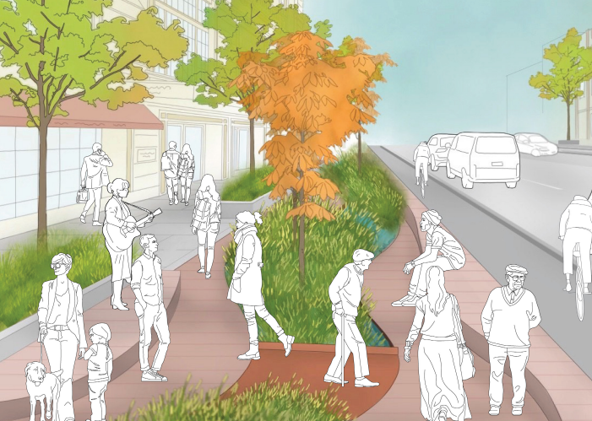
Giving every person a voice.
Capire Consulting Group
The Commons,
Wurundjeri Country
36-38 Gipps Street,
Collingwood VIC 3066
(03) 9285 9000
info@capire.com.au
capire.com.au

Capire acknowledges
and deeply respects the Wurundjeri people and
the Traditional Owners
of the Victorian land.


Privacy  Capire Consulting Group and any person(s) acting on our behalf is committed to protecting privacy and personally identifiable information by meeting our responsibilities under the Victorian Privacy Act 1988 and the Australian Privacy Principles 2014 as well as relevant industry codes of ethics and conduct.  For the purpose of program delivery, and on behalf of our clients, we collect personal information from individuals, such as e-mail addresses, contact details, demographic data and program feedback to enable us to facilitate participation in consultation activities. We follow a strict procedure for the collection, use, disclosure, storage and destruction of personal information. Any information we collect is stored securely on our server for the duration of the program and only disclosed to our client or the program team. Written notes from consultation activities are manually transferred to our server and disposed of securely.  Comments recorded during any consultation activities are faithfully transcribed however not attributed to individuals. Diligence is taken to ensure that any comments or sensitive information does not become personally identifiable in our reporting, or at any stage of the program.  Capire operates an in-office server with security measures that include, but are not limited to, password protected access, restrictions to sensitive data and the encrypted transfer of data.  For more information about the way we collect information, how we use, store and disclose information as well as our complaints procedure, please see www.capire.com.au or telephone (03) 9285 9000. |  | Consultation  Unless otherwise stated, all feedback documented by Capire Consulting Group and any person(s) acting on our behalf is written and/or recorded during our program/consultation activities.  Capire staff and associates take great care while transcribing participant feedback but unfortunately cannot guarantee the accuracy of all notes. We are however confident that we capture the full range of ideas, concerns and views expressed during our consultation activities.  Unless otherwise noted, the views expressed in our work represent those of the participants and not necessarily those of our consultants or our clients.

VERSION | AUTHOR | AUTHORISED | DATE
1.1 | Bec Yandell and Abbey Mag | Kathleen Webster | 06/09/2023

Contents
1. Introduction 4
1.1. Report purpose 5
1.2. Limitations 5
2. Engagement approach 6
2.1. Methodology 6
3. Participation 8
4. Key findings 11
4.1. Precinct One: Stewart Street to Elizabeth Street 11
4.2. Precinct Two: Elizabeth Street to Queen Street 14
4.3. General design feedback 17
4.4. Future engagement opportunities 18
5. Next steps 19
Appendix A: Survey 20
Appendix B: Out-of-scope feedback 28

Introduction
City of Melbourne is proposing to create a new link between the heart of the CBD and the Queen Victoria Market along Franklin Street, paving the way for the landmark Gurrowa Place development.
In August 2023, City of Melbourne shared concept designs for the Transforming Franklin Street project (the project) with the community and stakeholders to seek their feedback.
Ultimately, this project aims to better connect Flagstaff Gardens, the Queen Victoria Market precinct and the Gurrowa Place development to the new Metro Tunnel station. The project concept design is divided into two precincts for consultation purposes (see Figure 1).
The first precinct is to improve the Franklin Street streetscape design between Stewart Street and Elizabeth Street. Once complete, this precinct will connect to the new Metro Tunnel State Library Station at the Swanston Street end of Franklin Street via a linear open space and improved active transport options.
The second precinct is to improve the Franklin Street streetscape design between Elizabeth Street and Queen Street. This precinct aims to improve future traffic and streetscape movements.
Adjoining the second precinct, is the removal of the Franklin Street roundabout. This element is currently in the detailed design phase. The community feedback collected for the roundabout removal area related to how City of Melbourne can manage construction to minimise impacts.
The concept designs used to collect feedback on the proposed Franklin Street design are provided in Figure 2 and Figure 3.

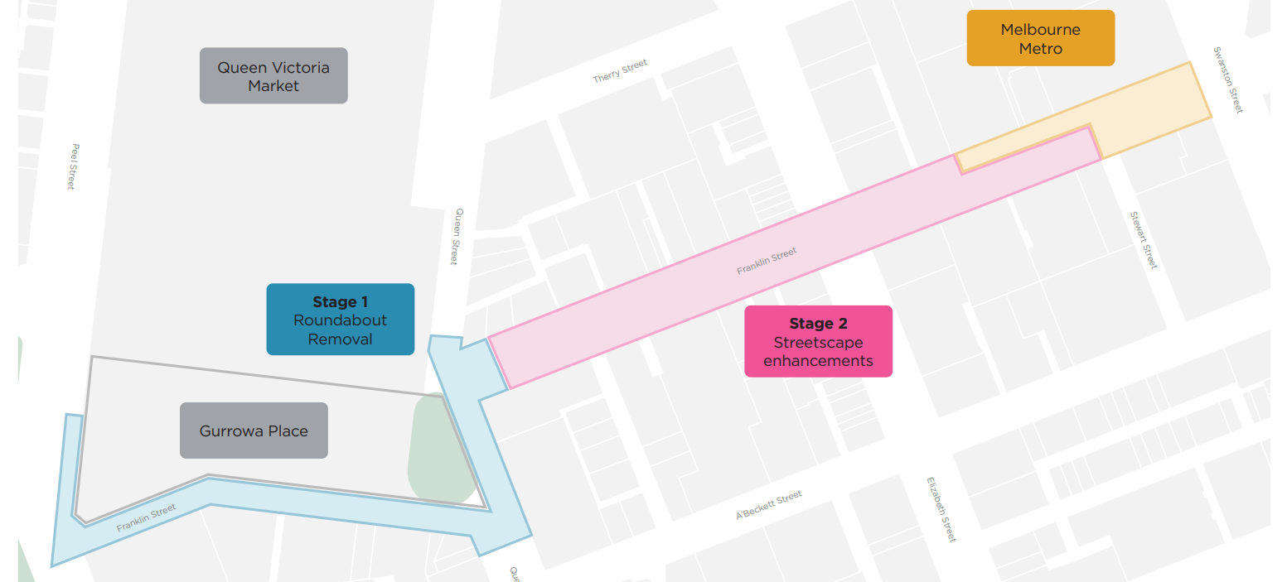
Precinct 1

Precinct 2

Figure 1. Project precincts for consultation

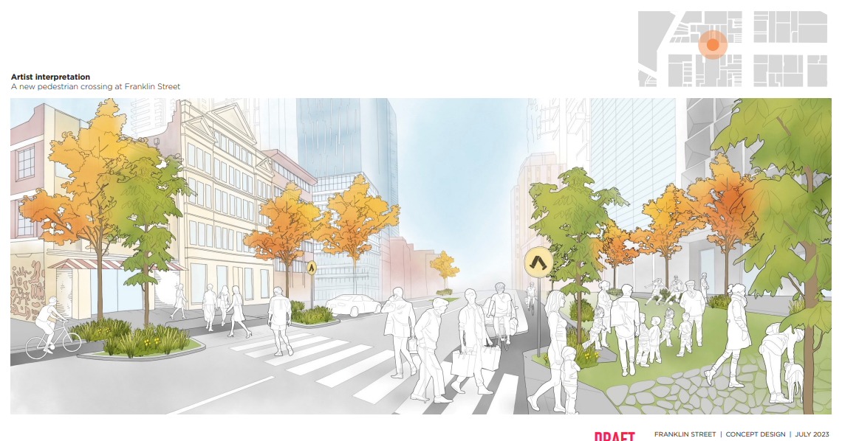
Figure 2. Draft artist impression of a new crossing at Franklin Street (July 2023).

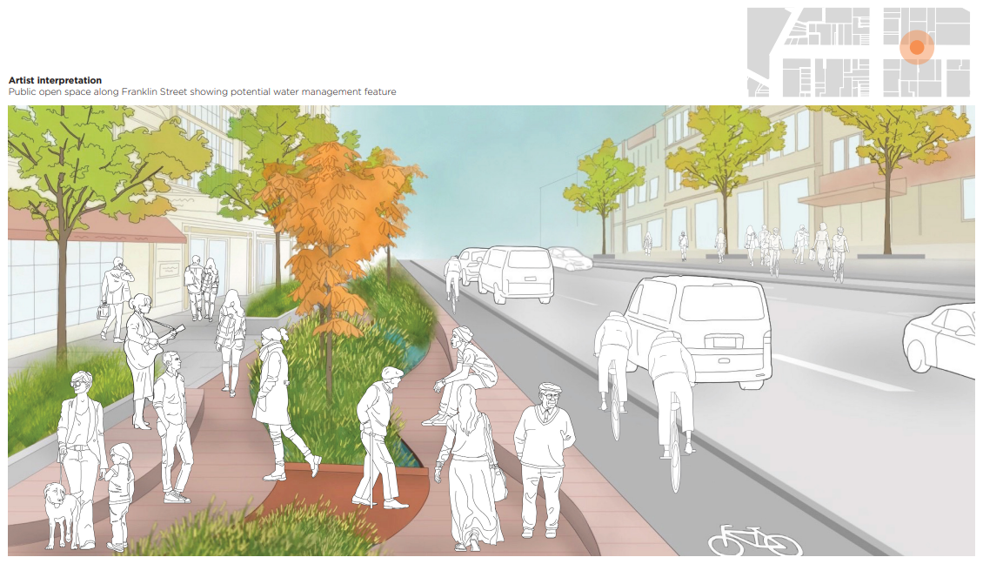
Figure 3. Draft artist illustration of the linear public open spaces along Franklin Street (July 2023).

Report purpose
This report summarises the engagement approach taken to collect community feedback on the project between Wednesday 12 July and Wednesday 23 August 2023. It highlights the stakeholders that City of Melbourne heard from during the engagement period and the key themes raised in feedback, which will be used to inform the detailed designs.

Limitations
While every effort was made to maximise the engagement period’s success, it is acknowledged that some limitations and constraints exist.
- The launch of the major City of Melbourne and Lendlease project at Gurrowa Place within six weeks of the Transforming Franklin Street engagement period launch may have taken priority for some community members.
- Respondents pointed out similarities between the survey questions for precinct one and precinct two. Consequently, comparatively fewer answers were received for precinct two. Some respondents simply noted ‘as above’.

Engagement approach
Engagement activities for this project aimed to update the community and stakeholders on the proposal for Franklin Street, explain how this project fits in with the wider precinct plans, and collect feedback on how to improve the Franklin Street streetscape design. While the removal of the roundabout had already been confirmed before engagement began, City of Melbourne asked how disruptions from the construction of this precinct could be minimised.
A range of promotional, communication and engagement tools were used to reach stakeholder groups, including Queen Victoria Market business traders, market visitors, near neighbours and general CBD pedestrians.

Methodology

Promotions and communications
The following methods were used to promote the project:
- Participate Melbourne webpage was a central location for all public information about the project. It introduced the project concept design; promoted the consultation events; hosted the survey, the frequently asked questions, and a downloadable draft concept plan consultation pack; and provided information about how this project links to the wider Queen Victoria Market precinct projects. The webpage is available at participate.melbourne.vic.gov.au/transforming-franklin-street
- A consultation pack of concept designs was developed to demonstrate the existing conditions and current proposals. This pack provided imagery to support completion of the survey and participation in the walking tours and pop-up events.
- Posters promoting that the project was open for feedback were displayed in key locations throughout the project area during the engagement period. This poster included a QR code to the webpage and directions to complete the online survey.
- Postcards promoting the project, including how to contact the team and provide feedback, were used throughout the engagement period. Postcards included a QR code to the webpage and directions to complete the online survey. To support accessibility, translated postcards provided information in key community languages identified for the project area.
- Social media (organic and paid) promoted the project and encouraged people to provide feedback.
- Online news articles were published on the Participate Melbourne webpage to promote the start and conclusion of the engagement period.
- Targeted invitations were sent to Queen Victoria Market business traders, inviting them to attend a walking tour.
- Flyers were used to provide information on the concurrent Gorrowa Place project launch and where to find more information about this project.

Engagement activities
The following engagement activities were used to collect community and stakeholder feedback.

Survey
An online survey was open for the duration of the engagement period. The survey prompted respondents to provide feedback on the types of experiences they would like to have in each key location of the design. The findings from this survey are summarised in Section 4: Key findings.

walking tour
Walking tours provided participants with a detailed briefing from the City of Melbourne design team about the onsite concept designs. Participants were guided to key locations within the Transforming Franklin Street project area, where they were provided with targeted information. Opportunities to ask questions were provided throughout the sessions.
Participants were encouraged to complete an online survey to collect their feedback at each location. For those with detailed feedback, the City of Melbourne design team offered to workshop ideas onsite after the walking tour had concluded.
Walking tours for three different groups were held at the following times:
- Tuesday 25 July 2023, 3:30pm to 5:30pm – Queen Victoria Market businesses and traders
- Saturday 29 July 2023, 10am to 12pm – Near neighbours and general public
- Saturday 12 August 2023, 10am – 12pm – General public

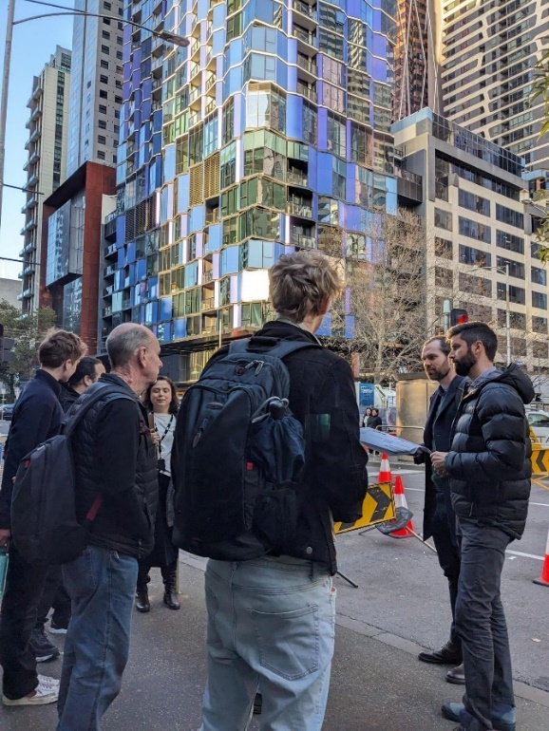  Figure 4. Transforming Franklin Street walking tours | 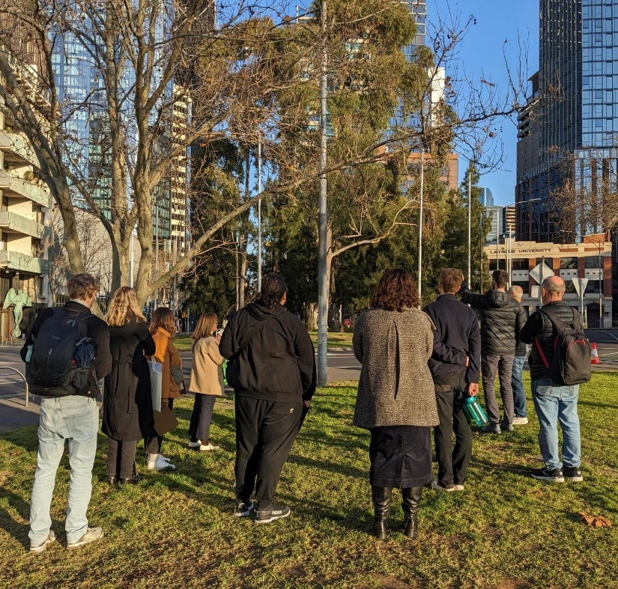

pop-up events
Pop-up events were used to capture the views of people who are time-poor and not typically engaged. They were held in high-foot-traffic locations within the project area to maximise the diversity of participation. Pop-up events were combined with targeted doorknocking of local businesses to provide them with information directly.
During each event, a poster of the project was displayed and staff handed out printed materials directing people to complete the survey online. People were incentivised to complete the survey on the day using native seedlings as gifts. The seedling species were selected to match the proposed vegetation in the Franklin Street concept designs.
Pop-ups were held at the following times and locations:
- Saturday 15 July 2023, 11am to 1pm – Queen Street, Queen Victoria Markets
- Saturday 5 August 2023, 11am to 1pm – Queen Street, Queen Victoria Markets
- Tuesday 15 August 2023, 10am to 12pm – Elizabeth Street and surrounds (intercept survey and doorknocks)
- Saturday 19 August 2023, 11am to 1pm – Queen Street, Queen Victoria Markets

Participation
The following participation was recorded for the Transforming Franklin Street engagement period.

 |  | 
250  surveys completed | 35  walking tour participants across three events | 110  pop-up participants (approximately)  across four events

Age
Figure 5 shows the age range of survey respondents. Most survey respondents were aged between 20 and 49 years. About one third of respondents were aged between 30 and 39.

Figure 5. Age of survey respondents in years (number of responses to question = 247)

Gender
Figure 6 shows the gender of survey respondents. Notably, more than half of respondents identified as male (56 percent), while over a third identified as female (37 percent). Non-binary and gender diverse respondents represented three percent of total respondents. The remaining four percent indicated that they would prefer not to say or responded with ‘other’.

Figure 6. Gender of survey respondents (number of responses to question = 243 )

Representation
The survey asked respondents to select any diverse community groups they identify as belonging to. Almost 40 percent of respondents did not identify with any of the following groups. Figure 7 illustrates that the most represented groups were those born overseas (30 percent), followed by those who identify as LGBTIQ (23 percent).
Figure 7. Identities of survey respondents (number of responses to question = 237)

Which of the following best describes your connection to this City of Melbourne project?
Figure 8 outlines survey respondents’ connection to the project. The majority of survey respondents live near Franklin Street (51 percent), followed by those who visit the market (24 percent). Business owners and workers on or close to Franklin Street (including Queen Victoria Market traders) were not highly represented, comprising less than seven percent of the survey respondents.

Figure 8. Connection to the City of Melbourne (number of responses to question = 249)
Figure 9 shows the location of where respondents live, work, own a business, study or visit. The majority of responses related to living/working/studying in or visiting the CBD (54 percent). This was distantly followed by Carlton, with only seven percent.

Figure 9. Locations of where survey respondents live, work, own a business, study or visit (number of responses to question = 250)

How did you hear about this engagement?
As outlined in Figure 10, the majority of respondents heard about the engagement through a Participate Melbourne alert (37 percent) or word of mouth (33 percent). A smaller proportion of respondents received a letter in the mailbox (14 percent) or heard about it through the QVM renewal newsletter (seven percent).

Figure 10. Percentage (%) of utilised communication tools (number of responses to question = 233)

Key findings
This section summarises feedback from the survey, walking tours and pop-up events under the following themes:
- Precinct one: Stewart Street to Elizabeth Street
- Precinct two: Elizabeth Street to Queen Street
- General design feedback
- Future engagement opportunities.

Precinct One: Stewart Street to Elizabeth Street
Survey respondents were asked to rank a series of (16) statements about precinct one based on their level of importance (Not at all important; Low importance; Neutral; Somewhat important; Very important). A summary of the ranking is detailed below (Figure 11).
Of the rankings, the three top-identified statements of importance for respondents were: ‘I can see plants and trees and feel connected to nature (35 percent); ‘I feel safe and can easily find my way around at all times of the day’ (16 percent); and ‘I can easily get around and know where to cross the road safety’ (seven percent).
To better understand the rationale behind respondents’ votes, they were asked to provide supporting commentary. Respondents felt safety and security was a top priority for precinct one. Respondents had described the current precinct as an area void of ‘natural elements’ and said that it catered to on-road traffic, a sentiment shared by many. The area was also described as ‘a little unsafe, dark and like it’s not designed well for pedestrians.’
To restore a sense of safety, security and community, respondents had suggested that Franklin Street be ‘as green as possible’ and that by re-introducing trees and nature, the ‘quality of life’ for some respondents would be improved. Respondents emphasised the importance of a new design, encompassing a shared space that allows for an easy flow of movements irrespective of the mode of travel, with a preference for foot traffic and cycling.
Walking tour feedback heard that some residents living near the Franklin Street and Queen Victoria Market roundabout experience impacts from noise carrying across from the warehouses or during special events, such as the Fringe Festival. While these residents would enjoy the enhancements to the streetscape, this needs to be balanced with concerns about noise, public use of alcohol and the potential to attract rough sleepers.
Below are samples of verbatim feedback from survey respondents.

Plants, trees and connection to nature
‘Currently, it’s a large area with very little accessible shade and area to rest’ – Survey respondent
‘Melbourne needs to “green” its streets. This means trees that provide shade and change with the season’ – Survey respondent
‘This segment of the city particularly is void of natural element, it’s desperate for some greening and seasonal interest’ – Survey respondent
‘When there are trees on the streets, I feel more comfortable walking. They provide shade, fresh air, and cool the area’ – Survey respondent
‘Nature is critically important to mental health but also a sense of connection to country and environment, which is lacking in the current urban landscape’ – Survey respondent

Safety and navigating the space at all times of the day
‘It’s important for people to feel safe at all times of the day, I have seen questionable people roaming around at night’ – Survey respondent
‘…this area of the city can feel a little unsafe, dark and like it’s not designed well for pedestrians’ – Survey respondent
‘…the number of assaults in the inner city seems to be increasing, and safety to allow residents to walk around at all hours is very important to me’ – Survey respondent
‘…feeling safe allowed me to enjoy myself and provides freedom to stroll around and appreciate the community’ – Survey respondent

Efficiently navigating the precinct and knowing where to cross safely
‘Swanston street end of Franklin St has been narrowed significantly due to Melbourne Metro construction zone’ – Survey respondent
‘…it should be easier for pedestrians to cross over to access the Queen Vic market’ – Survey respondent
‘I want to have easy car access in and out of my apartment’ – Survey respondent
‘convenient traffic and road’ – Survey respondent
‘As a pedestrian the precinct is currently hostile to me. Open space and more crossing opportunities would enable me to move around more easily, especially between QVM and other parts of the city’ – Survey respondent

Figure 11. Percentage (%) of feedback related to precinct one (number of responses to question = 245)

Figure 12. Percentage (%) of top three areas of importance for precinct one (number of responses to question = 243)

Precinct Two: Elizabeth Street to Queen Street
The second precinct is to improve the Franklin Street streetscape design between Elizabeth Street and Queen Street. Survey respondents were asked to rank a series of (16) statements about precinct two based on their level of importance (Not at all important; Low importance; Neutral; Somewhat important; Very important).
The ranking for precinct two somewhat mirrors the first ranking for precinct one. A summary of the ranking for precinct two is highlighted below (Figure 13).
Of the rankings, the three top-voted areas of importance were: ‘I can see plants and trees and feel connected to nature’ (28 percent); ‘I feel safe and can easily find my way around at all times of the day’ (16 percent); and ‘I can easily get around and know where to cross safely’ (ten percent).
A limitation noted prior was the similarities of survey questions for precinct one and two. This was a limitation also noted by respondents; consequently, responses were fewer for precinct two than precinct one. Respondents chose to indicate their earlier responses to this section, with ‘see previous comment’ as a survey response.
To avoid repetition of the earlier discussion, this section will instead focus on the emerging top three areas of importance for precinct two, which were: ‘I can use the space when it’s hot’ (eight percent); ‘My customers and I can access my business easily’ (seven percent); and ‘My kids feel safe and can enjoy some fresh air and sun’ (five percent).
Respondents emphasised the importance of climate mitigation and adaptation designs in response to climate change impacts. The main concern expressed for both precinct designs was the urban heat island effect. Respondents highly regarded earlier suggestions for designing a green space.
Below are examples of common responses to this sentiment.

Using the space when it’s hot
Respondents would like the space to be better designed for hot days.
‘Currently, it’s a large area with very little accessible shade and area to rest. This is now apparent on hot days’ – Survey respondent
‘During hot days, leafy green spaces are good places to escape the heat. Trees with lush foliage and a dense canopy’ – Survey respondent
‘More public space that is useful on hot days is only going to become more important as the climate changes – Survey respondent

Easy navigation for businesses and their customers
A common preference shared by traders occupying precinct two was a design consideration that doesn’t hinder their ability to continue to provide services and bring in current and future customers. Respondents expressed their frustration as business owners, having felt like they were being pushed out.
Respondents requested design considerations that allow for easy access to one’s business via the road, more road-street connection for those travelling by car, short- and long-term parking spaces, and an easy flow of traffic between all users of the precinct. Business traders requested that car parking access be retained for market customers doing large shopping trips.
Traders shared concerns that protected bike lanes will impact market stallholders’ abilities to load and unload efficiently (for example, use of forklifts and heavy machinery to load and unload).
Respondents raised concerns about additional traffic in the local area due to new residents moving in and additional navigation challenges during construction.
Below are some of the common responses to this sentiment.
‘Being a small business owner in the city, the rents are quite high, but accessing my business and having customers access my business has become harder and harder as the council reduces places to park and roads to travel on, post COVID I have noticed a massive drop in people traffic and has led to lower sales, I may consider leaving Melbourne CBD all together if this continues as it is just not financially viable’ – Survey respondent
‘Many of my customers require a car to see me, many are elderly, disabled, or busy business people who need on-street parking and easy wide road connections to come to my business, since the limitation of road networks and reduction of parking spaces I have noticed a considerable decrease in business’ – Survey respondent
‘You need to consider residents, tradesmen will not work in the city because of the parking. You need to consider the businesses, how do the restaurants get their deliveries, they already take lots of car spaces while doing their deliveries’ – Survey respondent
‘Short term parks perhaps for the few businesses that are still remaining??’ – Survey respondent
One concern raised at a walking tour was that changes in the streetscape design will result in cars ‘rat running’ through nearby streets and therefore moving the problems elsewhere.

A safe place for families and kids to enjoy
Feedback was received about design considerations with kids and families in mind. Respondents emphasised that reducing motor vehicle traffic and focusing more on a design that considers walkers and cyclists will lead to a safer environment for families with younger children. Currently this area is described as a ‘busy street’ with ‘too many motor vehicles and non-motorised vehicles zapping around’ and ‘delivery trucks and over-size SUVs’, which contributes to the city feeling dangerous for pedestrians.
‘I believe children deserve more spaces in the city to engage with nature, play and be safe’ – Survey respondent
‘this area is definitely not for kids – don’t see a lot because of how dodgy the area is. Transforming it into a kid friendly space would change the perception of it being dodgy’ – Survey respondent
‘being nearer to QVM, more family orientated space like play areas are important to me’ – Survey respondent
‘If it’s safe for kids that means it should be safe for everyone and will be a friendly, welcoming environment’ – Survey response

Figure 13. Percentage of feedback related to precinct two (number of responses to question = 244)

Figure 14. Percentage of three top areas of importance for precinct two (number of responses to question = 243)

General design feedback
This section focuses on the other design ideas for the new Franklin Street linear public open space. Given the responses, the feedback has been grouped into three separate themes: parking, bike infrastructure and seating.

Parking
There was a mixture of responses when it comes to parking. Some respondents saw the need to retain and introduce more spaces for car parks, especially for business owners, customers and visitors to the market who don’t live around the area.
However, other respondents suggested a total removal of available space for car parking. These respondents would favour use of bikes, e-scooters, e-bikes, Ubers and taxis.
‘I would suggest we allocate less storage for cars (remove the street parking completely) and narrow the lanes and introduce more traffic calming to keep the traffic slow’ – Survey respondent
‘No no-street car parking; vehicle lane for emergency vehicles and bikes/scooters only’ – Survey respondent
‘parking for business owners so that I can continue to shop as I do’ – Survey respondent
‘I live on Franklin Street, trying to renovate apartment or getting any tradesman is exceptionally difficult because there is nowhere to park’ – Survey respondent

Bike infrastructure
Feedback in relation to bike infrastructure relates to the need for a greater emphasis on a design consideration that prioritises cyclists and bike amenities. Respondents have expressed that the lack of bike parking in the area is a significant deterrent to bike-riding. Suggestions included creating a Queen Victora Market bike park, increasing bike paths and bike lanes, and separated parking.
‘I’d like to ensure the bike paths are as safe and age accessible as possible’ – Survey respondent

Seating
Feedback under this category relates to suggestions of a need to introduce more seating for Franklin Street, Queen Victoria Market and its surrounding areas. Respondents suggested a variety of seating options, including seating and retaining walls that play with levels and movable outdoor seats.
‘Melbourne themed seating … like sitting on a cheese seat, fish seat, open library books or a Trams seat’ – Survey respondent
‘Life-size Tram Artwork with seating in it’ – Survey respondent

Preference for certain plant species
Feedback was received about the specific types of plants and trees respondents wanted to have in both Precincts: a non-preference of gum trees and dry grass. Respondents stressed that the purpose of this vegetation is not just to beautify the area but to provide shade and a cooling place for rest, especially during the hot season.
Suggested vegetation included autumn trees that change with the seasons and large canopy shade trees.
Other feedback noted that while vegetation is a significant factor for pedestrians and market goers, it can hinder and threaten construction workers by reducing visibility and access for operations vehicles – such as the forklifts and trucks required to operate the markets.

Future engagement opportunities
Adjoining the second precinct, is the removal of the Franklin Street roundabout. This element is currently in the detailed design phase and feedback collected will be used to help minimise impacts from construction.
As expressed in Figure 15, the three top areas of need-to-know information for respondents in relation to changes to Franklin Street and the roundabout were:
- Information about disruptions during construction (59 percent),
- Changes to bus and/or tram routes (43 percent)
- Information about residential and visitor car access and parking (28 percent).
Feedback relating specifically to the roundabout focused on the need to keep it. It was strongly expressed by respondents that the removal of the roundabout would lead to a lack of safety and security for pedestrians. The roundabout currently acts as a method to control traffic flow. Its removal would take away the right of way for pedestrians in favour of cars.
Responses under ‘Other’ included:
- Access for deliveries, for moving in and out, and for taxi/Uber pick-ups
- Public access to the City’s detailed designs and amenities
- More information about the consideration of circular economy
- Accessible parking for people with disabilities
- Construction impacts to surrounding roads and streets surrounding the precincts.
Figure 15. Count of number of responses for different information needs (number of responses to question = 184)

Next steps
This round of engagement for precinct one and precinct two was based on the concept design phase. The next step will be to develop the detailed designs for these two precincts. Feedback from this report will be considered by the design team during development of these detailed designs.
These engagement findings will also be shared with parallel Queen Victoria Market precinct consultation projects happening at a similar time – for example, the Gurrowa Place project and the Queens Corner Building and Market Square project.

- Survey

Transforming Franklin Street Survey

Share your feedback on the draft concept design for the streetscape transformation in Franklin Street. Consultation closes 23 August 2023.
We want to hear your feedback about the project which will provide more open space for the growing community and improve safety and accessibility for all road users.
The Franklin Street transformation project proposes:
- 1250m² of open space for residents, workers and visitors to enjoy.
- Turning four lanes of traffic into two, maintaining access for motorists in both directions.
- Better connections for people moving between the CBD and Queen Victoria Market.
- More trees and plants, providing 40 per cent more coverage and helping to create a cooler environment.
- Improved safety for the community with new pedestrian crossings, lighting and reduced traffic flow.
- Stormwater flooding management with draining upgrades and water sensitive urban design solutions.
The transformation of Franklin Street was part of the Queen Victoria Market Precinct Renewal Master Plan, and is co-funded by City of Melbourne and the Department of Transport and Planning through the Transport and Amenity Program (TAP).
Your feedback will help us to finalise the design of precinct two. There are opportunities to include lawn, garden beds, trees, water sensitive urban design and places to sit, play and discover.

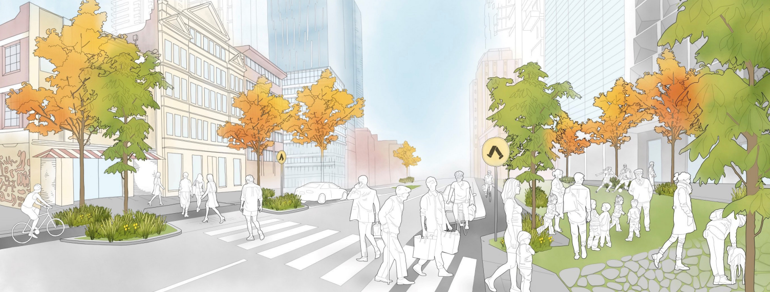

Franklin Street Precinct 1
Stewart Street to Elizabeth Street

Precinct 1

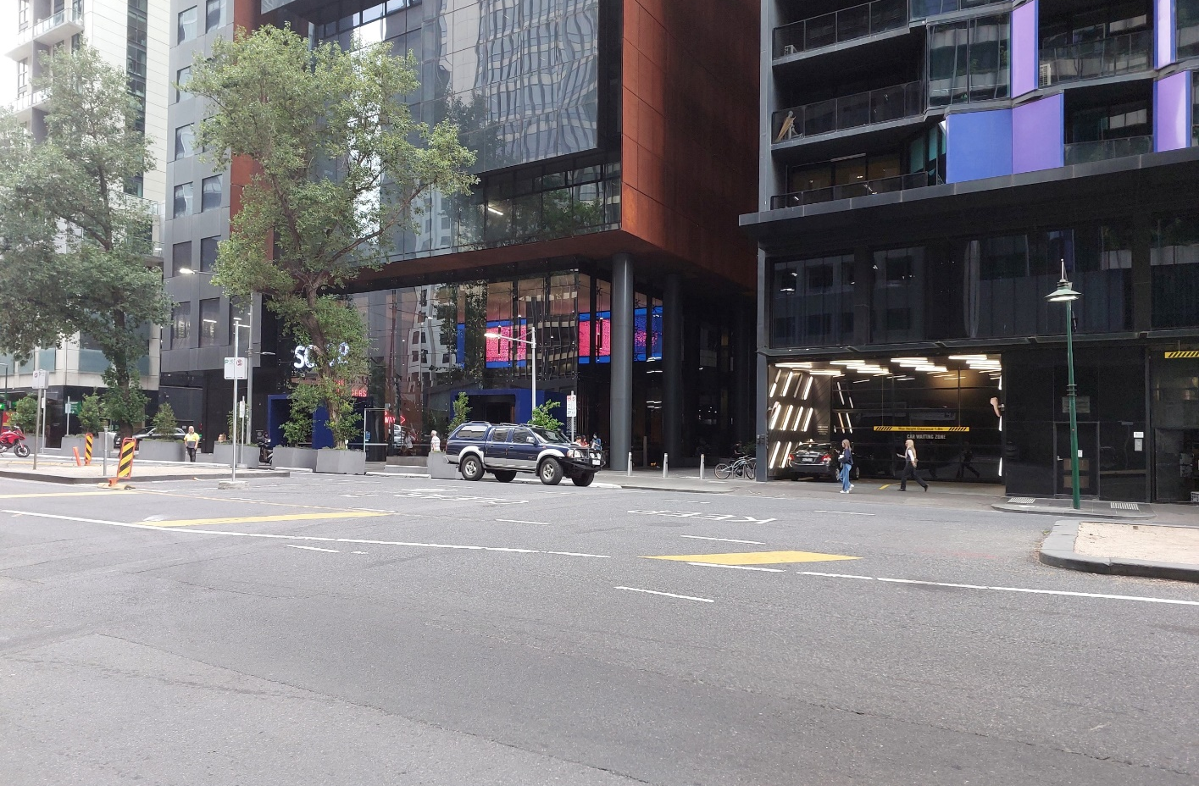
Figure 1. Current state of Franklin St Precinct One

- Think about how you might like to use the Precinct One (Stewart Street to Elizabeth Street) space on Franklin Street and rate the following statements based on how important they are to you, from not at all important (or low priority) to being very important (or high priority).
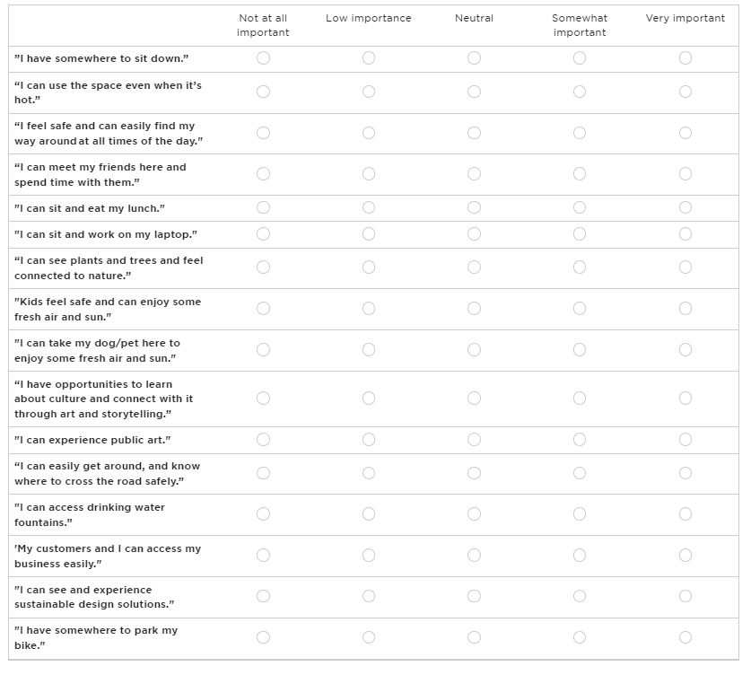
- Of the statements above, please mark with a star the ONE that is most important to you.
- Why is this most important to you?
Franklin Street Precinct 2
Elizabeth Street to Queen Street

Precinct 2

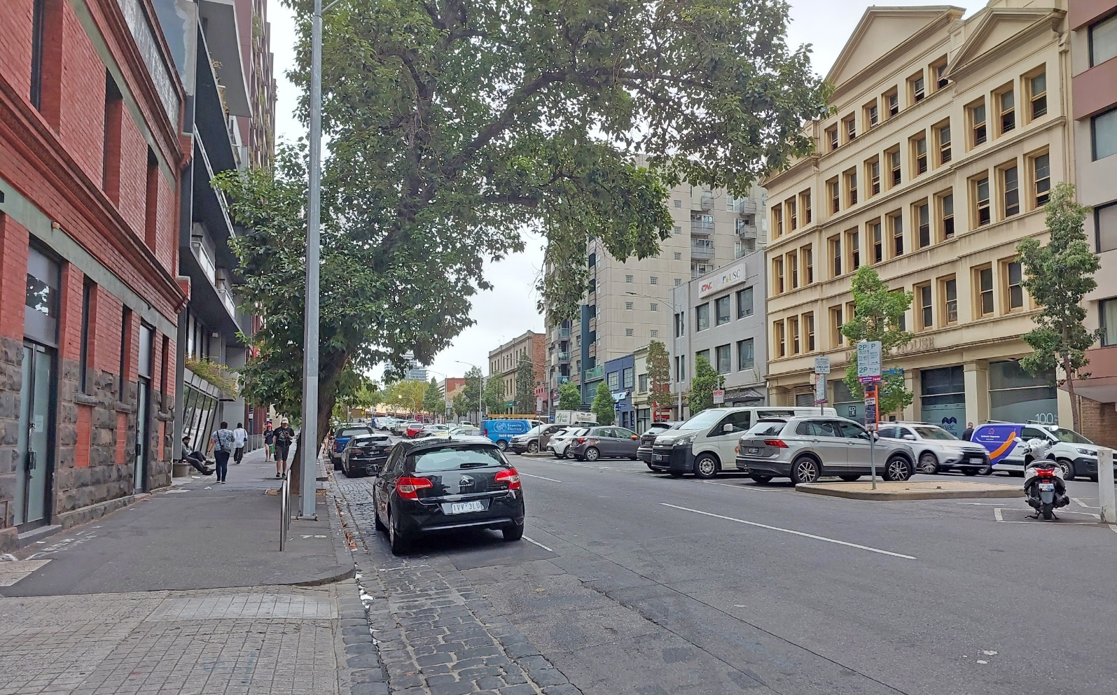
Figure 2. Current state of Franklin St Precinct Two
- Think about how you might like to use the Precinct Two (Elizabeth Street to Queen Street) space on Franklin Street and rate the following statements based on how important they are to you from not at all important (or low priority) to being very important (or high priority).
- Of the statements above, please mark with a star the ONE that is most important to you.
- Why is this most important to you?
- Do you have any other design ideas for the new Franklin Street linear public open space you’d like to share with us?
- What else do you need to know about the changes to Franklin Street including the roundabout?
- Business deliveries and loading
- Residential and visitor car access and parking
- Rubbish collection
- Utilities and services access
- Changes to bus and/or tram routes
- Disruptions during construction
- Other (please specify)

- Is there any other feedback you’d like to share with the project team?

- A little bit about you
The following questions are about you. By telling us a bit about you, we can make sure that we're hearing from different voices.
Your answers will be de-identified for analysis, and we won’t share your data with any other party.
You may choose the option for 'Prefer not to say' for question you do not wish to answer.
What is your age? | - Under 15 years  - 15-19 years  - 20-24 years  - 25-29 years  - 30-34 years  - 35-39 years  - 40-44 years  - 45-49 years  - 50-54 years | - 55-59 years  - 60-64 years  - 65-69 years  - 70-74 years  - 75-79 years  - 80-84 years  - 85-89 years  - 90+  - Prefer not to say
How do you describe your gender? | - Female  - Male  - Non-binary/gender diverse  - Prefer not to say  - I use a different term -____________________________
Do you identify with any of the following?  Select all that apply. | - Aboriginal  - Torres Strait Islander  - Person with a disability  - Carer  - LGBTIQ+  - Speak a language other than English at home  - Born overseas  - International student  - Prefer not to say
Which of the following best describes your connection to the City of Melbourne project? | - I live near the Market Square or Franklin Street (within 2km)  - I visit the market  - I have come here for an event e.g. Fringe Festival  - I am a worker  - I own a business  - I am a student  - I am a visitor  - Prefer not to say  - Other (please specify)
How did you hear about this engagement? | - A letter in mailbox  - Poster  - Postcard  - At a City of Melbourne facility  - Participate Melbourne alert  - Footpath sticker  - QVM renewal newsletter  - Word of mouth
Based on your connection to this project, where do you live/work/own a business/study/visit? | - Carlton (3053)  - CBD (3000)  - Docklands (3008)  - East Melbourne (3002)  - Kensington (3031)  - North Melbourne (3051)  - Parkville (3052)  - Southbank (3006)  - South Yarra (3141)  - West Melbourne (3003)  - Fishermen’s Bend  - Other ________________________________

- Privacy Statement:
The City of Melbourne has created a central repository (the Knowledge Bank) of survey responses for City of Melbourne staff members to support future project and policy development. Information that personally identifies you, including your name and contact details, will be excluded from the Knowledge Bank. You may to choose to provide demographic details in your survey response which will assist the Council to better understand your response. The demographic details you provide will be accessible to City of Melbourne staff members via the Knowledge Bank. Please ensure you do not provide any other information in your survey response that could identify you or others. The City of Melbourne is committed to protecting your privacy. For more information on how Participate Melbourne will collect, use and disclose your information, please ensure you have read the Participate Melbourne Privacy Statement. I confirm that I have read the privacy statement and that I am over 16 years.

I agree to the privacy statement

- Out-of-scope feedback

Several respondents provided feedback during the engagement period that was out of scope. This feedback has been summarised below, due to the interconnections between each of the projects within the Queen Victoria Market Precinct.

Impact of future landscape design and high-rise developments
Respondents shared strong opinions about the apartment buildings in the Franklin Street area. These opinions related to decreasing the number of high-rise apartments currently in the area and those planned for the future.
Towers were suggested to be no more than twenty storeys to avoid overshadowing. Some mentioned that the height and bulk of the buildings may block view lines to the market area. There were also concerns about the additional car parking required for new apartment building residents.
It was pointed out that the relationship between City of Melbourne and Lendlease posed a conflict of interest and incompatibility; this comment was not expanded on.
There was also concern that new tenants in the apartment buildings (international students and affordable housing tenants) would be unlikely to be customers at the markets.

Future engagement opportunities
There is a desire for businesses and traders to be kept informed about the overall precinct visions and plans going forward – for example, hours of trading and the types of trades envisaged. Local businesses are still recovering from the negative impacts that COVID-19 had on their business operations, and this needs to be factored into decisions.
A common sentiment shared among tradespeople and business owners was a request for meaningful engagement from the City of Melbourne. Respondents want to be provided with communication about the ‘end game’ for all projects planned or underway, to help them understand the overarching drivers and vision. This open communication, as expressed, will aid in the development of their long-term business model.

Ideas for the future of market square
Suggestions included:
- Embrace the market atmosphere across the whole precinct – including the intersection with traders and Queen Victoria Market management.
- Add a playground with lots of trees.
- Add more drinking fountains in the precinct.
- Add spaces for pets to roam, especially during the hot season.
- Requests for more multicultural products to be available at the Queen Victoria Market, and innovations in general for the market space to attract a diverse customer base.
- Managing the increased number of unhoused people, with some people feeling unsafe due to this situation.
- Activate the square outside of market times.
- Suggestions to rename Queen Victoria Market to ‘Naarm Market’ and remove the John Batman statue from its current position, due to the significance of the burial area.
Capire Consulting Group
The Commons,
Wurundjeri Country
36-38 Gipps Street,
Collingwood VIC 3066
(03) 9285 9000
info@capire.com.au
capire.com.au

Capire acknowledges
and deeply respects the Wurundjeri people and
the Traditional Owners
of the Victorian land.

