
City of Melbourne
Creative Strategy
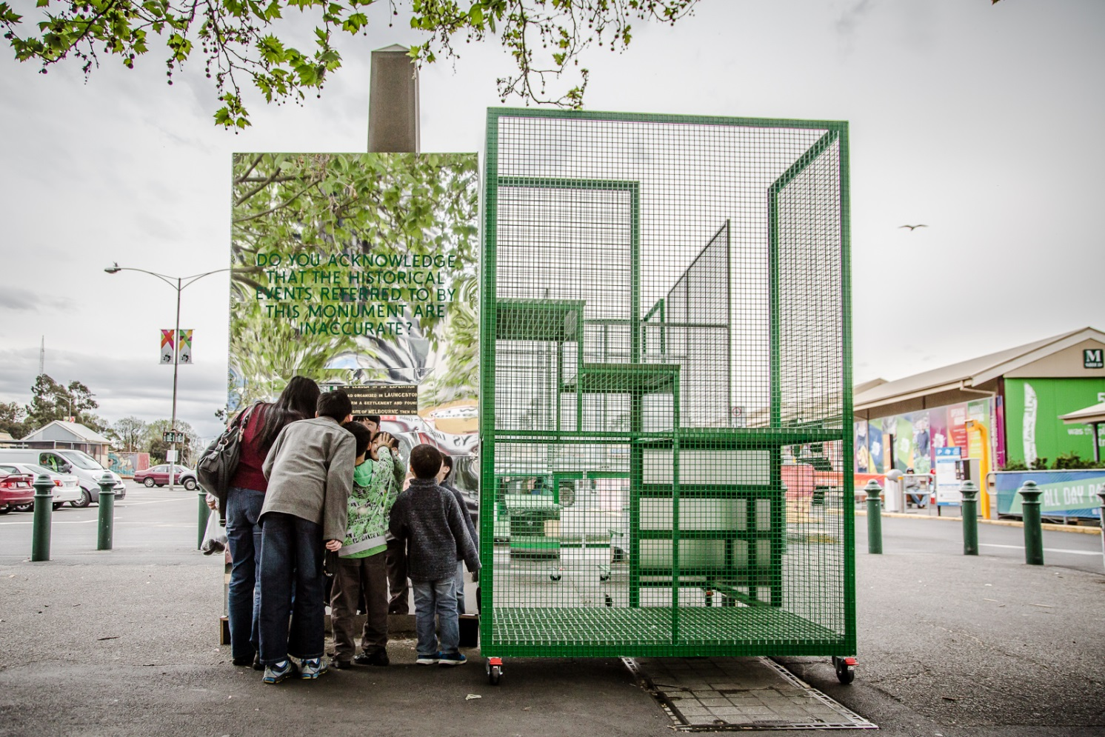
Contents
Context 4
Melbourne – a city that can’t stand still 4
How to thrive in a world of change 4
Our roadmap to a bold, inspirational future 5
Why creativity? Work, wandering and wellbeing 5
Case Studies 6
Creative Disciplines 6
Creative practice applied to city goals 7
A creative city 7
A prosperous city 7
A deliberative city 7
A city managing change 7
A city that cares for its environment 7
A city for people 7
Case Study 7
Dusseldorf Metro, Germany, 2016 8
Context 8
Process 8
Outcomes 8
Lessons 9
Last word 9
Case Study 9
Te Oro, New Zealand, 2015 9
Context 10
Process 10
Outcomes 11
Lessons 11
Last word 11
Strategy 11
A provocation for all Melburnians 12
If Melbourne were the world’s most creative city, what approach would we take to this challenge? 12
Our creative strategy month by month 13
Appendices 14
Measuring creativity 14
Melbourne’s Creative Strategy on a page 15
The Provocation 15
If Melbourne were the world’s most creative city, what approach would we take to this challenge? 16
Creating new connections 16
Place art at the start 16

Context

Melbourne – a city that can’t stand still
Every month thousands of people arrive in Melbourne to forge new lives for themselves. They come from all over Australia and all over the world, drawn by the city’s reputation as a great place to live.
Melbourne strives to be bold, inspirational and sustainable. It values knowledge, innovation and good design. It builds public places with the people of Melbourne in mind.
And Melbourne is a highly creative city. It overflows with live music, performances, public talks, festivals and events. People show up rain, hail or shine. Threaten the future of live music, for instance, and people will rally in their tens of thousands to defend it. Walk down any main road or laneway day or night and creativity is out and proud in the clothes people wear, the galleries, bars, cafes and shops, architecture, street design and street life.
But Melbourne is not alone. We live in a global age – and a mobile and highly competitive one. Other cities recognise the desirability of creativity and are snapping at our heels.
Hong Kong is investing billions on its West Kowloon Cultural District, Singapore more than $500 million on its Esplanade, Adelaide more than $200 million on a contemporary art gallery. Today there are 29 UNESCO cities of literature – in 2008 when Melbourne joined the network, there were only two.
If Melbourne is to retain its edge as a creative city it cannot stand still.

How to thrive in a world of change
The city Melburnians know and love is changing at an unprecedented pace.
Our population is growing rapidly, accounting for the vast majority of Victoria’s population growth this decade and much of Australia’s.
In Melbourne, more than 40 per cent of people are born overseas and one third speak a language other than English. The city’s resident population is highly transient, with a high turnover including many young people and students.
Melbourne is a magnet for knowledge workers, who account for about 66 per cent of the workforce. Manufacturing has declined and 40 per cent of Australian jobs are likely to be automated over the next 10 to 20 years.
Climate change is resulting in more very hot days in the city and less but more intense rainfall that places pressure on our drains and floods our roads. Scores of high-rise developments are transforming the fabric of the city. Mammoth public transport and road construction projects are disrupting our streets. Digital innovation, which brought us Uber and O-bikes and heralds the arrival of driverless cars, is changing, well, everything.
And while many in our city are thriving, others risk being left further behind as cost of living pressures grow and people are priced out.
To help us understand, interpret, navigate and thrive amid this world of change, Melbourne is looking to the people who throughout time, across the globe, have always helped society make sense of the world around them – to creative people of all kinds, from artists, musicians and performers to industrial designers, scientists and poets.

Our roadmap to a bold, inspirational future
Melbourne is no stranger to rapid change. Our city’s enthusiasm and capacity to create and evolve has brought many of the benefits we enjoy today – high-quality public spaces, greener streets and buildings, vibrant laneways, fewer cars, more places to wander and secrets to explore.
These have not come about by chance. The city has been guided by decades of carefully thought through strategies that imagined the Melbourne that could be and systematically stepped out how to make that vision a reality.
As we approach the close of the second decade of the 21st century, Melbourne is looking again to the future and creating a new suite of strategies to steer us through the third decade and beyond.
These strategies are designed to work as an integrated and united network, to help us continue to develop bold, inspirational and sustainable approaches to managing transport, climate change, urban planning and other critical challenges and opportunities.
Central to them all will be a shared understanding and approach to harnessing Melbourne’s incredible creativity and putting it to use for the city and its citizens. This approach will build on the solid foundations of the Arts Strategy 2014–17, embedded now in our daily work, and will invite creative practitioners of all kinds to play a critical role in Melbourne’s future.
The creative strategy also will provide context and guidance for a host of related documents, existing and planned, that outline our intent in relation to particular disciplines of creative practice.
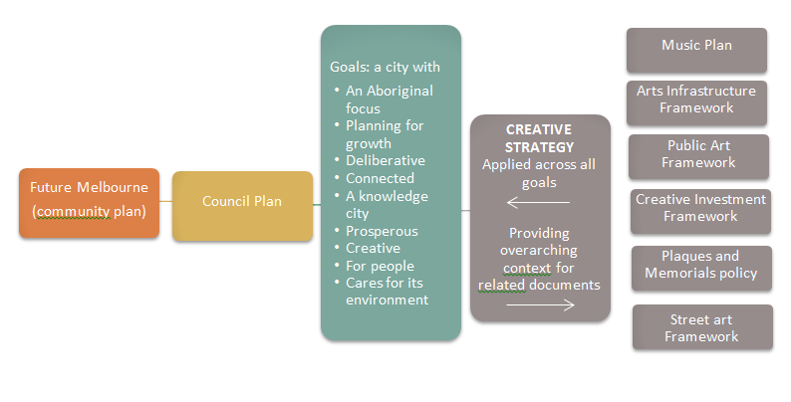

Why creativity? Work, wandering and wellbeing
Across the globe, the way people live, the choices they have, their challenges and their joys are being transformed.
Advanced robotics, autonomous transport and machine learning are bringing ever-faster transformations.
The World Health Organisation (WHO) estimates more than one-third of skills considered important in today’s workforce will have changed within five years. Some jobs will disappear, others will grow and jobs that don’t exist today will become commonplace.
A WHO report, The Future of Jobs, asked chief human resources and strategy officers from leading global employers what the shifts would mean for employment. They ranked creativity the third most important skill required for jobs in 2020. This follows other reputable surveys also placing creativity in the top 10 – some even in first place.
Cities that foster creativity in their resident populations not only position themselves for the jobs of the future but attract the world’s travellers.
It is little wonder the cities that regularly top creativity league ladders – London, Paris, Berlin, New York – are eternally popular with visitors.
In Victoria, with Melbourne as its capital, cultural tourism is worth more than $1 billion each year and is predicted to be worth $1–$2 billion annually from Chinese visitors alone by 2025.
Creativity plays an equally vital role in social cohesion and wellbeing.

Case Studies

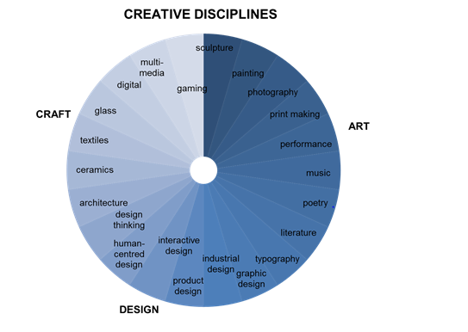

Creative Disciplines
We know from First Nations people and those who study ancient civilizations that throughout history creative people have always helped others understand and draw meaning from the world around them.
Creativity is a behaviour; its practice takes many forms. It allows people to explore ideas, connect with one another and participate in conversations larger than themselves.
It stimulates ideas, insight and delight and enriches existence. It connects us to our past, to today and leads the way to a shared future.
To demonstrate seminal, inclusive and expansive creativity in action, the City of Melbourne has collected examples from far afield and close to home that relate to the goals set out in Future Melbourne, a community plan that sets out the long-term aspirations of Melburnians.
These case studies, some of which are referenced below, showcase many creative disciplines, from architecture and street performance to activities that bring traditional paintings out from the galleries and into the streets.

Creative practice applied to city goals

A creative city
Traditionally museums are housed in impressive buildings in significant locations that require people to travel distances to visit. Berlin’s Public Art Lab flipped this experience by inviting artists to create mobile museums that could travel to their audiences. The resulting mini museums, which travelled between cities, transformed the atmosphere of each space in which they were located and made readily available to all citizens the assets they own.

A prosperous city
The transformation of an obsolete elevated train line in New York into an international tourism attraction more than 2km long is known the world over as a demonstration of the power of creativity and community engagement to drive urban renewal and prosperity.

A deliberative city
The Queen Victoria Market precinct is much loved by Melburnians and opinions are divided on its future direction. Rather than hide from contentious perspectives, in 2016, as part of the Council’s Biennial Lab program, artists built a 24-hour radio station and for 9000 minutes everything they ate, drank, wore, discussed or interviewed was sourced at the market.

A city managing change
In 2015 the Turner Prize, Europe’s most prestigious contemporary visual art award, was bestowed on Assemble, a collective of mainly architects, for their Granby Four Streets urban regeneration project. Judges praised them for using art, design and architecture to offer alternative models to how societies can work and for showing how artistic practice can shape urgent issues.

A city that cares for its environment
Refuge is a five-year City of Melbourne project – led by artists, working with emergency management experts and communities – that explores and builds resilience in the face of climate disasters such as floods, heatwaves and pandemics. Through annual simulated emergencies, all involved look deeply at the implications and consider with new insight how cities plan for the future.

A city for people
Between 2001 and 2008 the City of Melbourne invited artists to develop temporary works of art responding to a laneway of their choosing. The enormously successful Laneway Commissions program is now credited with playing a significant role in the revival of central Melbourne. Today laneway culture is as synonymous with Melbourne life as a great cup of coffee.

Case Study

Dusseldorf Metro, Germany, 2016
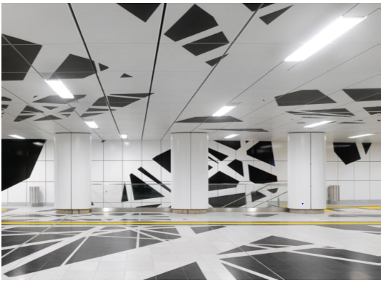

Context
Düsseldorf Metro is the largest public transport project completed in Düsseldorf for 20 years. Consisting of a 3.4 kilometre subway tunnel and six new stations, each artistically unique, the project connects the city’s eastern and southern districts and involved 15 years of planning and construction. The result is an exciting combination of new technology, architecture and art that make the project one of the most dynamic, user friendly subways in Europe. Given Düsseldorf’s relatively small population of 600,000 people, some commentators were surprised that Germany’s first ‘art on the underground’ project took place in the city. However, Düsseldorf has a long and proud artistic history, with all artists working on the project having links to the city’s Kunstakademie, a renowned art school dating back to 1762.

Process
One of hallmarks of Düsseldorf Metro was genuine, long term cooperation and respect between engineers, architects and artists that led to a strong interdisciplinary approach and widely praised artistic outcomes.
The project was overseen by Darmstadt-based consultancy, netzwerkarchitekten and artist Heike Klussmann, who won a two-stage EU-wide architecture competition. Together they developed the concept of a metro tunnel as an ‘underground continuum’ similar to a giant snake as it slips through the earth, widening at each station before continuing on its path. The aim was to create a direct visual connection between each station and the city, and whenever possible, bring daylight down to track level. These long views not only aid passenger wayfinding but create a greater sense of security, while countering the feeling of being in a confined space. A key part of the original proposal was to maintain an overall identity for the line while allowing for diversity in the design of individual stations. During the initial stage, 16 artists were invited to come up with a basic station concept, which was then taken further in stage two. Five artists were ultimately selected to work alongside Heike Klussmann and the architects, each on their own station.

Outcomes

The most impressive aspect of Düsseldorf Metro is the way art and architecture come together. “It’s hard to know where the engineering begins and the art ends,” says artist Thomas Stricker. Although there other examples of underground art projects, two factors make Düsseldorf stand out – a complete lack of advertising and a common architectural language. Following its official opening, The Guardian reported the “new metro represents a rare moment when people who never usually interact – city bureaucrats, engineers, architects and artists – created something bigger than themselves” while The New York Times called the project “Art and magic in a German Metro”.
Spaciousness, clarity and generous sightlines between stations and concourses are a key feature of the project and the decision to ban advertising creates a purely spatial, immersive experience. At Pempeiforter Strasse station, Heike Klussmann uses graphic black-and-white designs to dazzlingly effect that run over the ceiling and floor of the station, halting or unravelling, depending on the geometry.
At his station, Ralf Brög provides three scenarios – ‘theatre’, ‘laboratory’ and ‘auditorium’, each of which emits alternating acoustic impulses and sound bites while Ursula Damm uses aerial views of Düsseldorf in the entrance of her station. A giant LED wall overlooking the concourse displays real-time footage of pedestrians overlaid with geometric structures that respond to passenger movement. At Graf-Adolf- Platz, Manuel Franke creates an immersive journey where sweeping layers of green rock strata accompany passengers down to the concourse and combine hand-painting with laminated security glass. Meanwhile Thomas Stricker conceives his station as a space ship lined with six screens that offer 3D views of planets like a ship’s bridge. The feeling of other-worldly travel is enhanced by the station’s angled walls and panoramic windows.

Lessons
Uniting the artwork is an understanding it is not intended for a gallery but aimed at people on the move. Each work is designed to slow people down and generate calm. Lack of advertising helps the architecture and art respond to each to other, and influences how people experience the space. Visits to the artists’ studios by city officials were important to take them on the same journey as the project team. As the artists had to use new and unfamiliar materials, a life-size mock-up of every station was built in a decommissioned tunnel to test how the materials performed on site. Unlike many projects, the architects didn’t just find ways of realising what the artists had dreamed up. Everything was decided together.

Last word
Düsseldorf Metro is a public space that allows people to be people, not consumers. It is all about the art and the space, and takes people wherever their imagination can lead.

Case Study

Te Oro, New Zealand, 2015
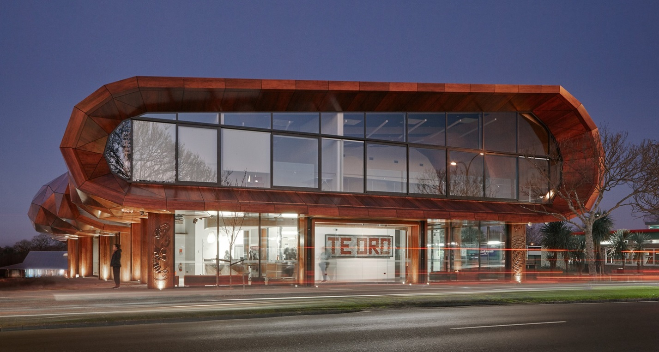

Context
Te Oro is a music and arts centre in Glen Innes, Auckland, that was developed over 20 years with local Māori people. It is a testament to the community’s persistence and passion.
A multi-purpose space, the centre was designed as a place for young people and the local community to come together to perform, practice and celebrate their culture.
The seed for Te Oro was planted in 1995 when the first workshop was held with the Glen Innes community to explore the idea of an arts centre. A long period of research into community needs followed, which eventually resulted in a design concept and funding from the local Maungakiekie- Tāmaki board of Auckland Council.

Process

Co-creation was at the centre of the design process from the beginning. The design team worked closely with local iwi, Ngāti Pāoa, from early discussions pre-brief, throughout the development process and up to final delivery. The dual concepts of preservation and evolution were central to the overall project.
A key aspect of Te Oro was working with local knowledge holders as well as master carvers and weavers who informed the final design. Glen Innes sits between Taurere (Mount Taylor) and Maungarei (Mount Wellington) and is next to Te Wai o Taiki (Tāmaki River).
The name Te Oro was gifted to the building by the Ngāti Pāoa who have lived on the land and surrounding area for hundreds of years. It refers to the humming reverberations created by wind as it passes through the ancient crater chambers of Maungarei.
Working in collaboration, architect Lindsay Mackie of Archimedia and artists Bernard Makoare, Martin Leung- Wai and Petelo Esekielu, developed a concept for Te Oro that saw the building as a grove of trees under which communities could gather, shelter, share knowledge and express their culture and creativity. From this concept came Te Oro’s signature roof form, a floating geometric ‘leaf canopy’ that sits atop a series of ‘timber trunks’. Historically the grove of trees or ‘uru’ is a response to remnant karaka uru trees on nearby Taurere and an important part of local story telling.
Te Oro is made up of three two-story pavilions linked by a naturally lit circulation space. The first pavilion houses two large dance studios and working areas while the second contains a double height 394 seat performance space, digital editing suite and recording studios. The final pavilion houses fine arts workshops for jewellery making, whakairo (carving) and painting.
As well as Te Oro’s physical form, there are six community driven artistic elements of the project. These include soundscapes, whakairo and kōwhatu (stones), a logo and branding, tukutuku (traditional wall mounted woven panels) and a metaphorical Manaia (a stylized figure that binds everything together).
Each creative group was empowered to direct their piece, the stories they told and the artists they used. The six installations tell different stories about the same place from different perspectives. They honour everyone’s voice but none is heard above the other.
The overall brand for Te Oro was inspired by distinctive Māori taniko and tukutuku weaving patterns that are highly mathematical and precise. Gridded horizontal and vertical rods set the foundation for the work while the physical process of creating tukutuku, and the act of binding the material symbolises the reciprocity of people working together.

Outcomes

Since opening in 2015, Te Oro has been a resounding success by clearly reflecting its community through a strong connection to local cultural history yet providing opportunities for this cultural expression to evolve.
The process of engagement undertaken to realise Te Oro’s final design was complex, time consuming and sometimes difficult but it allowed for the development of a rich, meaningful and nuanced building in an area that historically lacks social and cultural infrastructure.
An interesting, sophisticated piece of architecture, Te Oro sets a new standard for Māori community buildings by not succumbing to easy or cheap options and resourcing appropriately.
Over the last three years Te Oro has helped many young people connect with their culture through new forms of expression and technologies. The centre’s vision is to inspire new generations of creative practitioners and contribute to the creative economy of wider Auckland.

Lessons
Respect for Indigenous culture, art practice and a flexible, multi-layered engagement process was central to Te Oro’s success.
Relationship building with the local community took time but delivered rich, meaningful creative outcomes.
Co-creation with key knowledge holders provided opportunities for strengthening and reinterpreting local cultural expression sometimes using modern materials, technologies and methodologies.
Working with cultural leaders to engage the community at key junctures was important to keep the project on track and relevant.

Last word
Te Oro demonstrates how a community facility can work equally for Māori people and the broader community while staying out of the shadows of the mainstream.

Strategy
A provocation for all Melburnians
Looking at case studies from close to home and around the world led the City of Melbourne to contemplate: what if these were not occasional projects but business-as-usual. Imagine the potential transformation of city life if creative processes and projects such as these were just the way our city managed every-day opportunities, challenges and change. Imagine if we placed art at the start, harnessing the full potential of our creative practitioners and applying their thinking city wide, at civic scales, integrating it into the very fabric of the city and its long-term vision.
So in thinking about our own creative approach, the City of Melbourne has arrived not at a ‘vision statement’ but a provocation that is grounded in principles understood by Aboriginal and Torres Strait Islanders and ancient civilisations whereby art is not a product or a service but, rather, it informs how the world is and how to be.
We will engage creative practitioners of all kinds to work with subject experts on compelling city opportunities and challenges that relate to the nine goals Melburnians have set for their city:
- A city with an Aboriginal focus
- A city planning for growth
- A deliberative city
- A connected city
- A knowledge city
- A prosperous city
- A creative city
- A city for people
- A city that cares for its environment

We will ask:

If Melbourne were the world’s most creative city, what approach would we take to this challenge?
- Where would we start?
- What would we do differently?
- How would we behave?
- How can creative thinking deliver extraordinary results?
- What processes would we follow?
- What would we produce?
- What would we measure?

Month by month, year by year, over a decade, by issuing our provocation we intend to support the systematic transformation of our city through bold, inspirational, sustainable creative thinking that draws on the remarkable and expansive expertise of our creative community.
These approaches could take all manner of shapes and sizes. They might be beautiful, thought provoking, funny, disturbing or all of the above. Their number could vary year to year. Those involved will be as diverse as Melbourne itself. Their individual impact could be highly visible or more subtle but, for our city that can’t stand still, collectively they will make a profound contribution to our ongoing transformation.
In the process, we will develop the capability of our creative practitioners to apply their skills to a city-sized canvas while demonstrating to city decision makers the power of a creative lens to make infinite possibilities visible.
At the heart of this is the idea of creating new connections:
- Across everything the city does
- Between disciplines
- Between public and private organisations
- Between city and its communities
- Between creative practice and civic scale
- Between experiences
- Between aspirations and reality

Through this approach Melbourne will draw on the full potential of its extraordinary creative community to benefit all who live, work and visit here, our people will develop skills the future demands and our experiences with be shared with others the world over.

Our creative strategy month by month
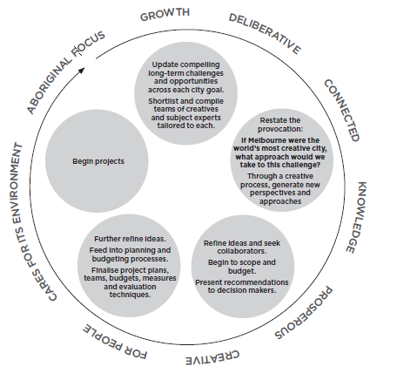

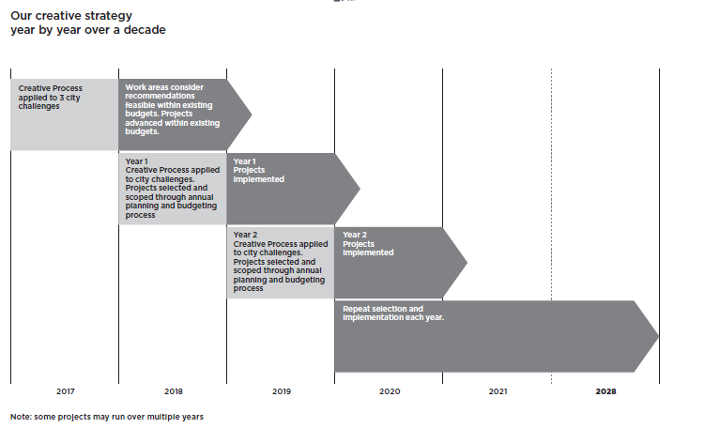

Appendices

Measuring creativity
It is notoriously difficult to measure the impact of creative input.
How, for instance, do you measure the impact of an average city experience compared with an inspirational one?
It is understandable that many have resorted to measuring economic rather than cultural outcomes – more visits, more spending, more businesses. But what about more or better ideas, increased feelings of wellbeing, a greater sense of belonging?
To understand the impact of our strategy, we are developing a range of measures.
These will include standard ones such as the number of problems tackled, the projects undertaken and the number of creative people involved.
However we also will go deeper, by looking at the outcomes derived from of all of this activity and the impact it has on the people closely involved, the people of Melbourne and the city generally.
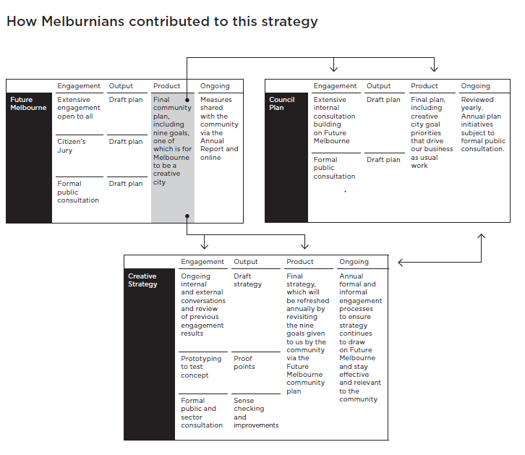

Melbourne’s Creative Strategy on a page
Melbourne is internationally renowned as a creative city – but so are many cities. And snapping at their heels are scores of others, each recognising the power of creativity to express a city’s identity, draw people in, create a sense of connection and belonging and transform the economy. These days, creativity in its broadest sense is a highly sought after commodity and the cities with creativity at their core are the ones that prosper.
To harness its full potential, creativity needs to be integrated into the very fabric of the city and its long-term vision – not as an add-on but right at the start, when contemplating the changes and challenges ahead of us. We have an extraordinary creative community with a critical role to play in creating a great city for everybody.
In thinking about our own creative approach, the City of Melbourne has arrived not at a ‘vision statement’ but a provocation that is grounded in principles understood by Indigenous and ancient civilisations whereby art is not a product or a service but, rather, it informs how the world is and how to be in it.
We will engage creative practitioners of all kinds to work with subject experts on compelling city opportunities and challenges that relate to the nine goals Melburnians have set for their city.

The Provocation
We will ask:

If Melbourne were the world’s most creative city, what approach would we take to this challenge?
- Where would we start?
- What would we do differently?
- How would we behave?
- How can creative thinking deliver extraordinary results?
- What processes would we follow?
- What would we produce?
- What would we measure?

Creating new connections
- At the heart of this is the idea of creating new connections:
- Across everything the city does
- Between disciplines
- Between public and private organisations
- Between the city and its communities
- Between experiences
Between creative practice and civic scale
Between aspirations and reality

Place art at the start
Month by month, year by year, over a decade, by issuing this challenge we intend to support the transformation of our city through bold, inspirational, sustainable creative thinking that draws on the remarkable, expansive expertise of our creative community.
Using the city as its canvas, this approach will allow Melbourne to place art at the start, drawing on the full potential of its extraordinary creative community to benefit all who live, work and visit here and sharing our experiences with people the world over.
This is our creative strategy
For more information, contact City of Melbourne
on 03 9658 9658 or melbourne.vic.gov.au/arts

