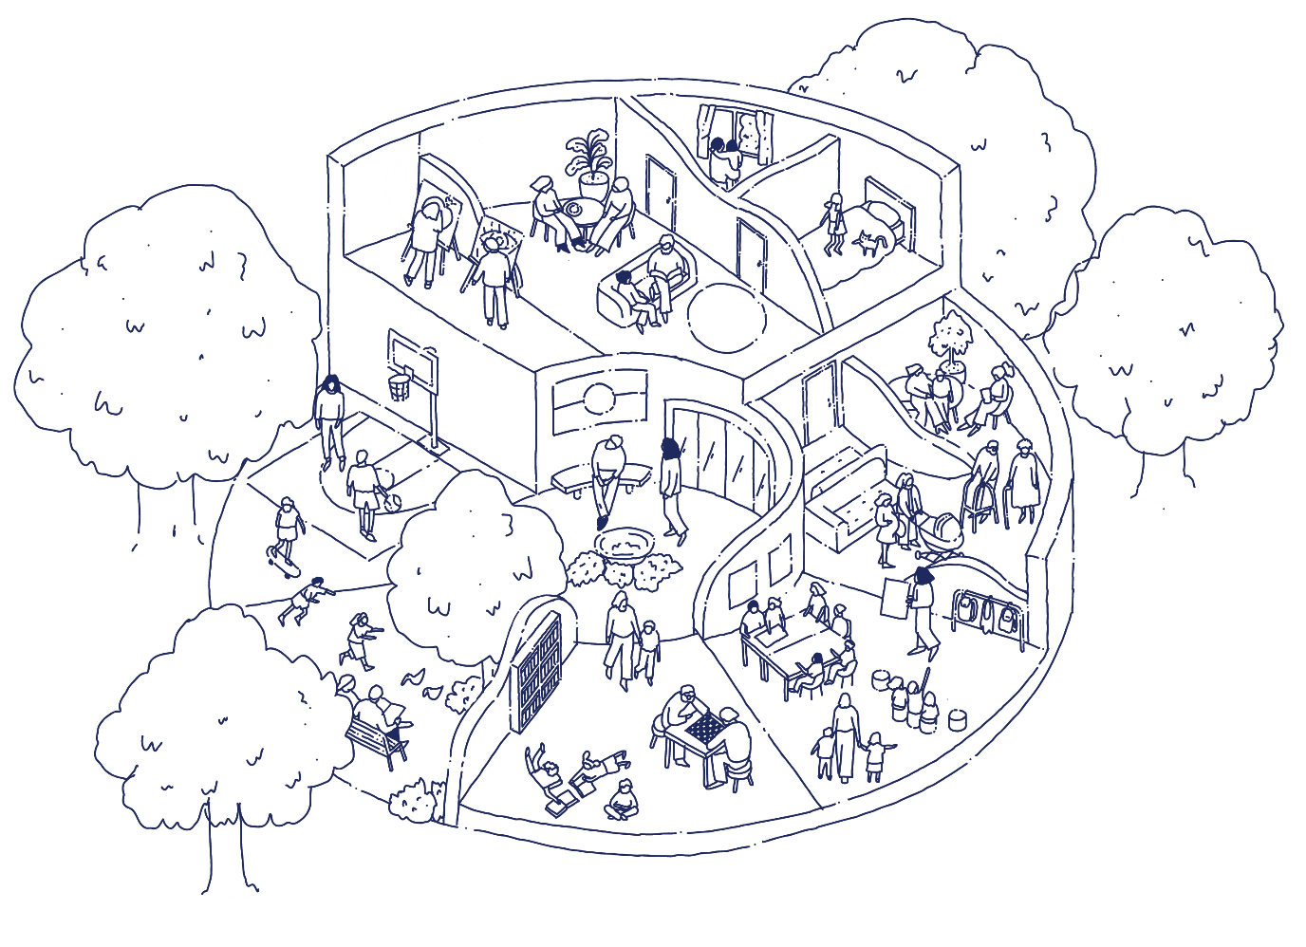


Draft

Community Infrastructure Plan
2025–35
December 2025
Acknowledgement of Traditional Owners

The City of Melbourne respectfully acknowledges the Traditional Owners of the land we govern, the Wurundjeri Woi-wurrung and Bunurong / Boon Wurrung peoples of the Kulin and pays respect to their Elders past and present. We acknowledge and honour the unbroken spiritual, cultural and political connection they have maintained to this unique place for more than 2000 generations.

We accept the invitation in the Uluru Statement from the Heart and are committed to walking together to build a better future.

Contents
Executive summary 5
PART A: Strategic context 7
1 Introduction 8
1.1 Purpose 8
1.2 What is community infrastructure? 8
1.3 What is our role? 12
1.4 Developing the Plan 13
1.5 Implementing the Plan 15
2 Vision and principles 16
3 City of Melbourne context 18
3.1 Demographic snapshot 19
3.2 Trends and strategic drivers 21
3.3 Existing community infrastructure 22
4 Community infrastructure needs 33
4.1 Health and wellbeing 34
4.2 Education 35
4.3 General community 36
4.4 Arts and culture 37
4.5 Aboriginal and Traditional Owner 38
4.6 Sport and recreation 39
4.7 Affordable housing and homelessness services 40
4.8 Open space 41
PART B: Meeting community infrastructure needs 42
5 Municipal initiatives 43
6 Local area planning 44
6.1 North-west 45
6.2 North-east 47
6.3 South-west 49
6.4 South-east 51
6.5 Central city 53

List of tables
Table 1: Community infrastructure categories and types of spaces 9
Table 2: City of Melbourne's role 12
Table 3: Demand profile example and definitions 33
Table 4: Health and wellbeing demand profile 34
Table 5: Education demand profile 35
Table 6: General community demand profile 36
Table 7: Arts and culture demand profile 37
Table 8: Aboriginal and Traditional Owner demand profile 38
Table 9: Sport and recreation demand profile 39
Table 10: Open space demand profile 41
Table 11: Municipal initiatives for improving our community infrastructure network 43

List of figures
Figure 1: Community infrastructure that we will plan and provide over the next four years 6
Figure 2: Benefits of community infrastructure 8
Figure 3: City of Melbourne owned and managed community infrastructure 11
Figure 4: City of Melbourne's integrated planning and reporting framework 13
Figure 5: Developing the Plan 14
Figure 6: City of Melbourne context 18
Figure 7: Local areas within the City of Melbourne 22
Figure 8: Existing community infrastructure in the north-west 24
Figure 9: Existing community infrastructure in the north-east 26
Figure 10: Existing community infrastructure in the south-west 28
Figure 11: Existing community infrastructure in the south-east 30
Figure 12: Existing community infrastructure in the central city 32
Figure 13: Planned projects in the north-west 46
Figure 14: Planned projects in the north-east 48
Figure 15: Planned projects in the south-west 50
Figure 16: Planned projects in the south-east 52
Figure 17: Planned projects in the central city 54
Figure 18: United Nations Sustainable Development Goals 55

Executive summary
The Community Infrastructure Plan (the Plan) guides how the City of Melbourne will plan and deliver community infrastructure to 2035. From libraries and galleries to parks and recreation centres, our community infrastructure is fundamental to supporting local identity, community resilience and the health and wellbeing of our neighbourhoods.
As the City of Melbourne grows, we need innovative ways to meet community needs while responding to rising costs, limited space and changing needs.
The demand for community infrastructure is growing faster than what we can deliver on our own. While we may not be able to meet all needs, the Plan helps us make the most of what we already have, work in partnership, think creatively and invest wisely to have the greatest benefit for the most people.
Part A of the Plan defines community infrastructure and provides a strategic framework, including Community Infrastructure Principles, that gives clear direction for how we make decisions, prioritise investment and encourage better use of existing spaces.
Part B of the Plan shows how we’ll meet community infrastructure needs to 2035. It includes three key approaches:
- Municipal initiatives that apply to the entire network of community facilities. These initiatives aim to improve how we use, manage and fund community infrastructure across the City of Melbourne.
- Planned projects in our local areas over the next four years. Each project defines our role, whether we are responsible for planning, providing, partnering, facilitating or advocating. Figure 1 shows the eight projects where we are providing upgrades or new community infrastructure, and nine projects where we will progress planning for community infrastructure, over the next four years.
- Ideas for consideration in future planning for our local areas. These ideas will be considered in future community infrastructure planning, and will inform long-term financial and asset planning.

The Plan will be reviewed every four years, to inform our integrated planning and reporting framework. Planned capital projects will be reviewed and reported annually as part of Council’s planning and budgetary process.
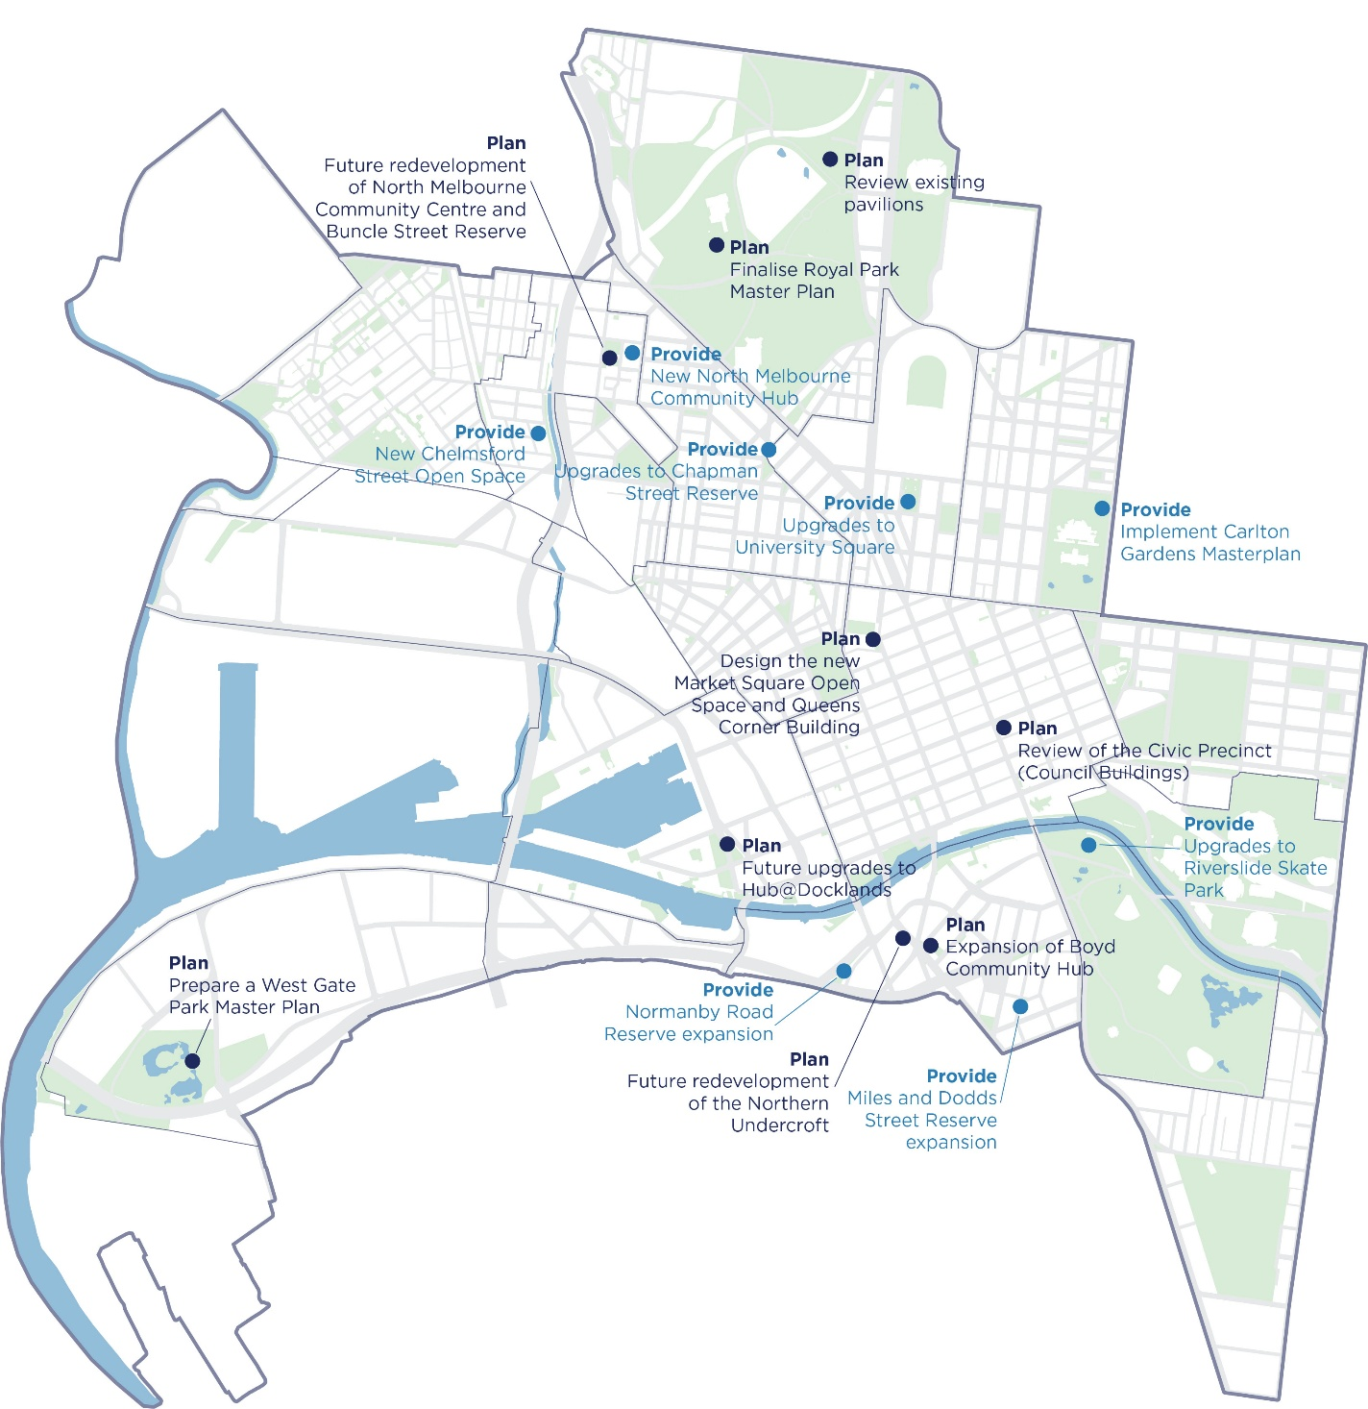
Figure 1: Community infrastructure that we will plan and provide over the next four years

PART A: Strategic context

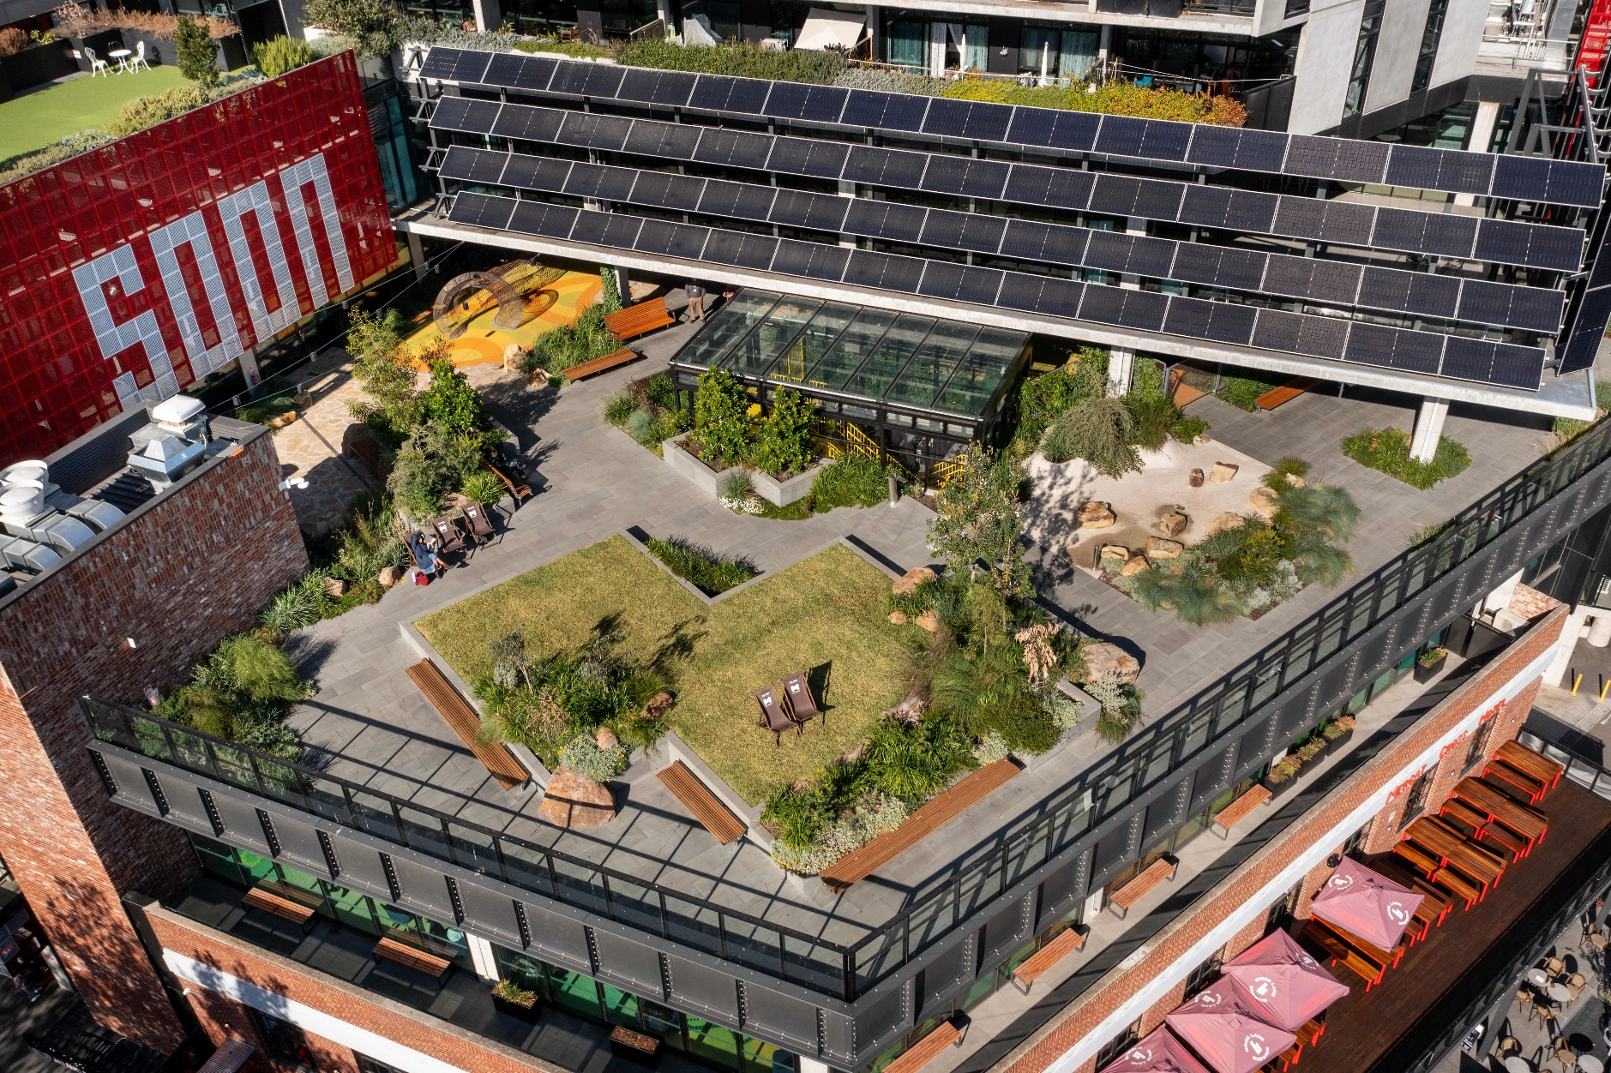
Image: narrm ngarrgu Library and Family Services

Introduction

Purpose
The Community Infrastructure Plan (the Plan) guides the planning and delivery of community infrastructure across our municipality. It ensures a fair and evidence-driven approach to maintaining and enhancing the community infrastructure network for the entire community, including those who live, work, study, visit and do business in our municipality.
The Plan has been informed by Australian, Victorian and City of Melbourne policy and legislation, as well as the United Nations Sustainable Development Goals. This is described in Appendix A: Policy context.

What is community infrastructure?
Community infrastructure is the backbone of a thriving, inclusive city. Community infrastructure means spaces where people can use services, join programs and take part in activities to learn, stay healthy and feel supported and connected. Figure 2 shows the many benefits of community infrastructure.
Figure 2: Benefits of community infrastructure

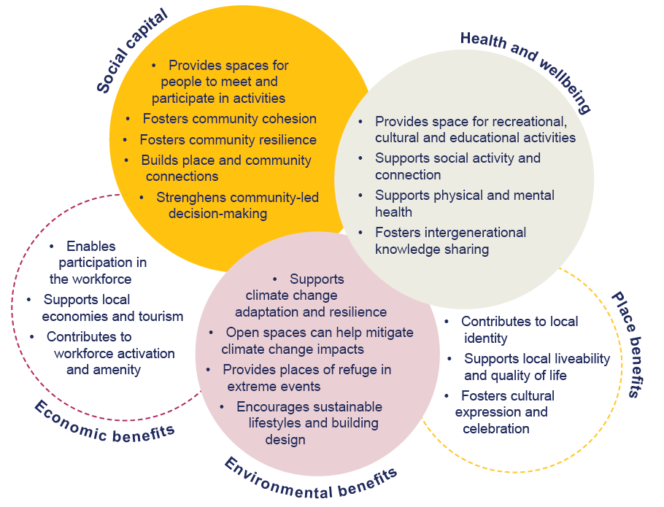

Community infrastructure categories
The Plan focuses on community infrastructure owned and managed by the City of Melbourne and where we play a role in delivery. These generally fall into eight categories, as shown in Table 1.
Other community infrastructure, such as hospitals, crisis accommodation, law courts and residential aged care form a critical part of the community infrastructure network and are mostly managed, delivered and funded by other levels of government or the private or not-for-profit sectors. Existing community infrastructure within the City of Melbourne is shown in Figure 3.
Table 1: Community infrastructure categories and types of spaces
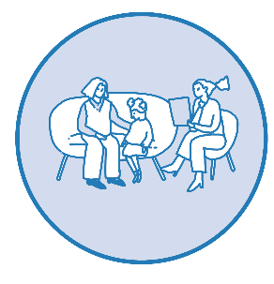 | 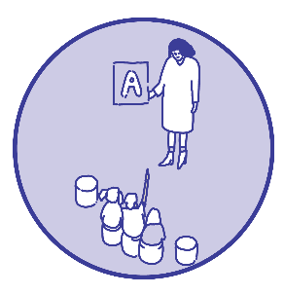 | 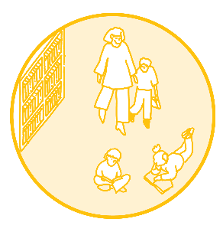 | 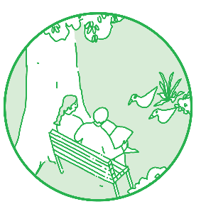
Health and wellbeing | Education | General community | Open space
Maternal and child health  Family services  Space for older people  Space for young people  Space for community health services | Long day care  Kindergarten  Playgroup  Toy library  Primary school  Secondary school | Community kitchen  Community garden  Makerspace  Library  Community space  Neighbourhood house | Capital city  State  Regional  Municipal  Neighbourhood  Local  Small Local
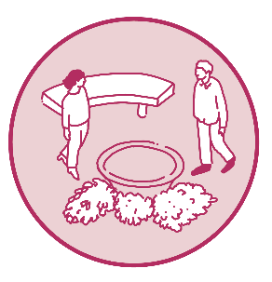 | 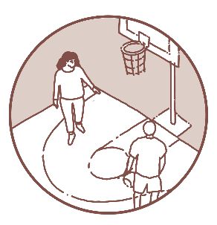 | 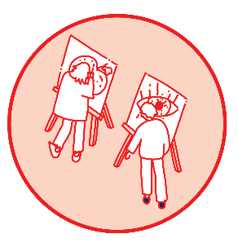 | 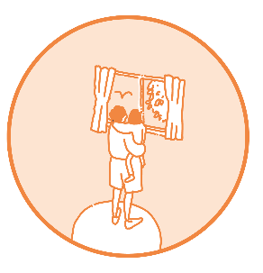
Aboriginal and Traditional Owner | Sports and recreation | Arts and culture | Affordable housing and homelessness
Spaces for Aboriginal or Aboriginal-focused organisations and services  Ceremonial | Organised sport  Community pavilion  Aquatic centre  Recreation centre  Boating facilities  Unstructured sport | Performance  Exhibition  Production | Public housing  Community housing  Subsidised market housing  Space for homelessness support services  Transition housing

Community hubs
The Plan refers to the individual spaces that make up community infrastructure, however these spaces are often co-located within a facility that delivers multiple services and offerings, referred to as a ‘community hub’. This arrangement makes it easier for the community to access a range of activities and programs and can be a more cost-effective way to operate facilities and deliver services. Community hubs:
- may be a single building or several buildings close to each other that share resources.
- provide multi-purpose spaces used by a variety of community organisations, agencies and groups or individuals on a semi-permanent and / or casual basis.
- encourage the design and development of community facilities as part of other neighbourhood centres such as retail precincts, plazas and squares.
- support flexibility in use as community needs, technology and service delivery change.
The Plan encourages community hubs as the primary infrastructure model for responding to future needs.
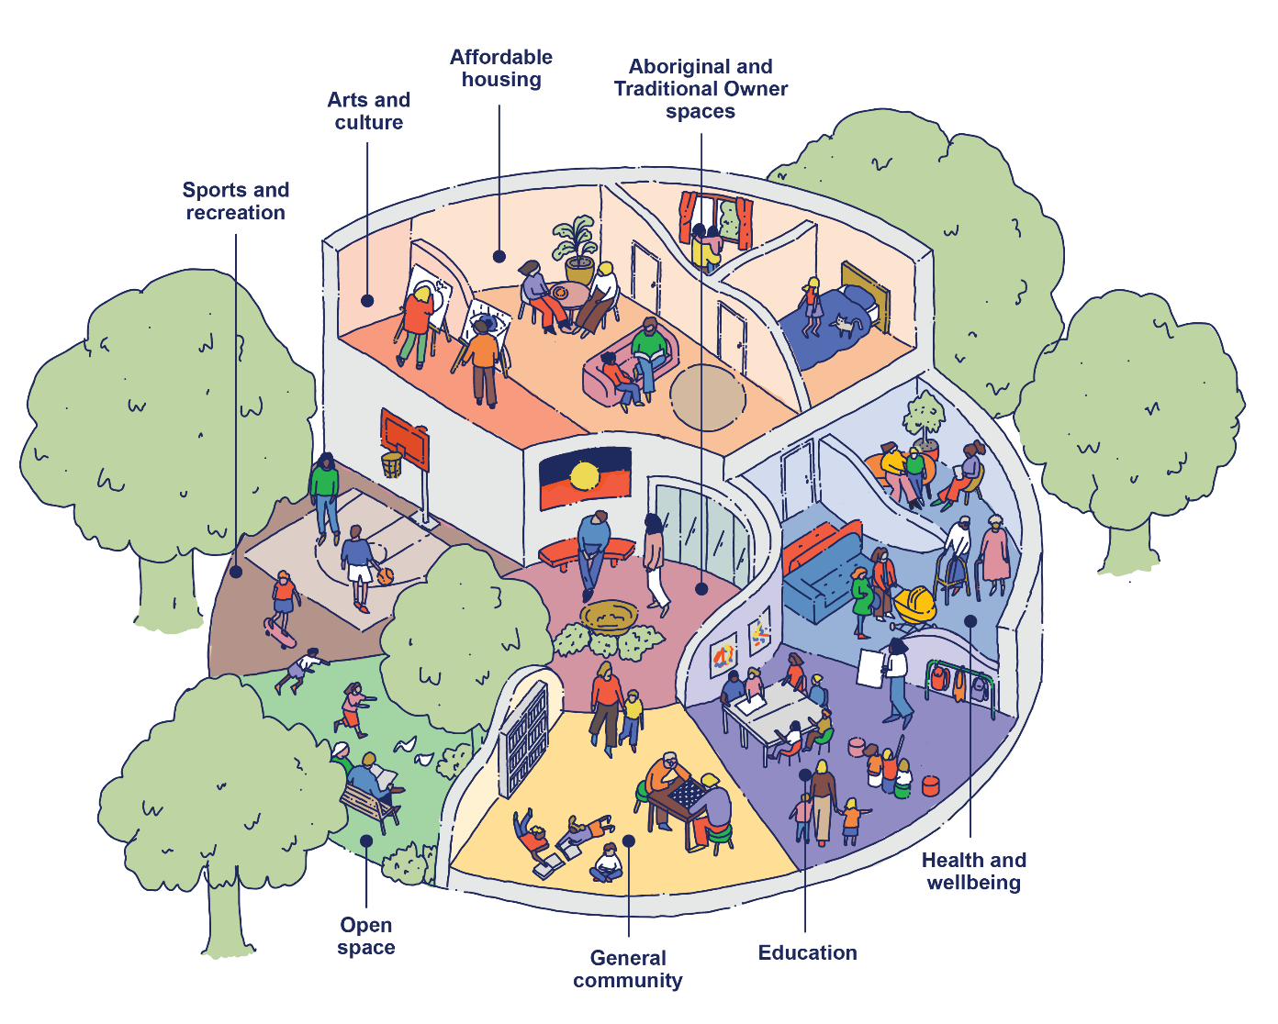

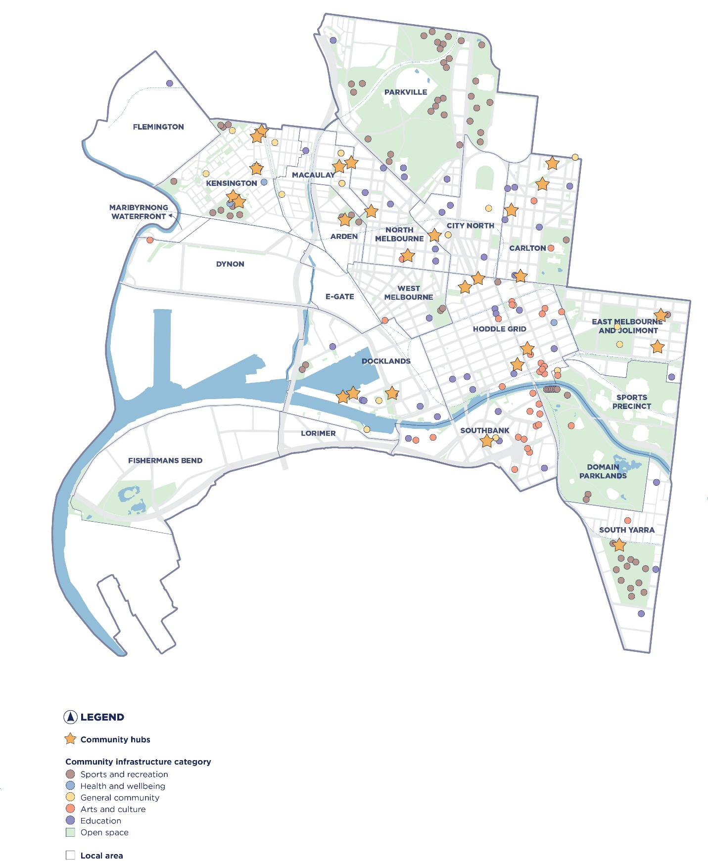
Figure 3: City of Melbourne owned and managed community infrastructure

What is our role?
The City of Melbourne has many roles in delivering and maintaining our community infrastructure network, as described in Table 2. Factors that shape what we do, include:
- Government requirements. We coordinate our service delivery and community infrastructure provision and work with neighbouring councils to respond to government policy and legislation. Other levels of government influence our role by partnering and funding opportunities and directing service delivery responsibilities.
- Other service providers. Local specialist and non-government organisations provide programs and spaces where City of Melbourne or other government services are limited or less able to respond.
- Market conditions and private sector. Where the private sector delivers services and spaces, our role may reduce. Conversely, where alternative service provision is limited and unable to respond to community needs, we have a more direct role.
- Changing community needs. Evolving community priorities including use of existing services, future users and supporting community to find spaces for their own programs.
Table 2: City of Melbourne's role
Our role | Description
Plan | We plan and design community infrastructure, undertake research and set the long-term vision for our municipality.
Provide | We construct, operate and maintain a network of community infrastructure, and deliver a range of services.
Partner | We work with others through leases, contributions, grants and partnerships.
Advocate | We advocate to other levels of government and stakeholders for the best outcomes for our community.
Facilitate | We regulate development, broker partnerships and connect people with spaces.

Developing the Plan

Integrated planning and performance framework
The Plan sits within our broader integrated planning and performance framework, as an endorsed strategy (see Figure 4). This framework supports decision-making across the long term (10+ years), medium term (4+ years) and short term (1 year).
Reflecting this structure, the Plan takes a long-term view of community needs, guided by the Melbourne 2050 Vision (M2050 Vision). It identifies gaps in community infrastructure, outlines future opportunities to meet demand and informs financial and asset planning to guide investment decisions.
In the medium term, the Plan sets out key projects and activities to be delivered over the next four years to implement the Council Plan, Asset Plan and Financial Plan.
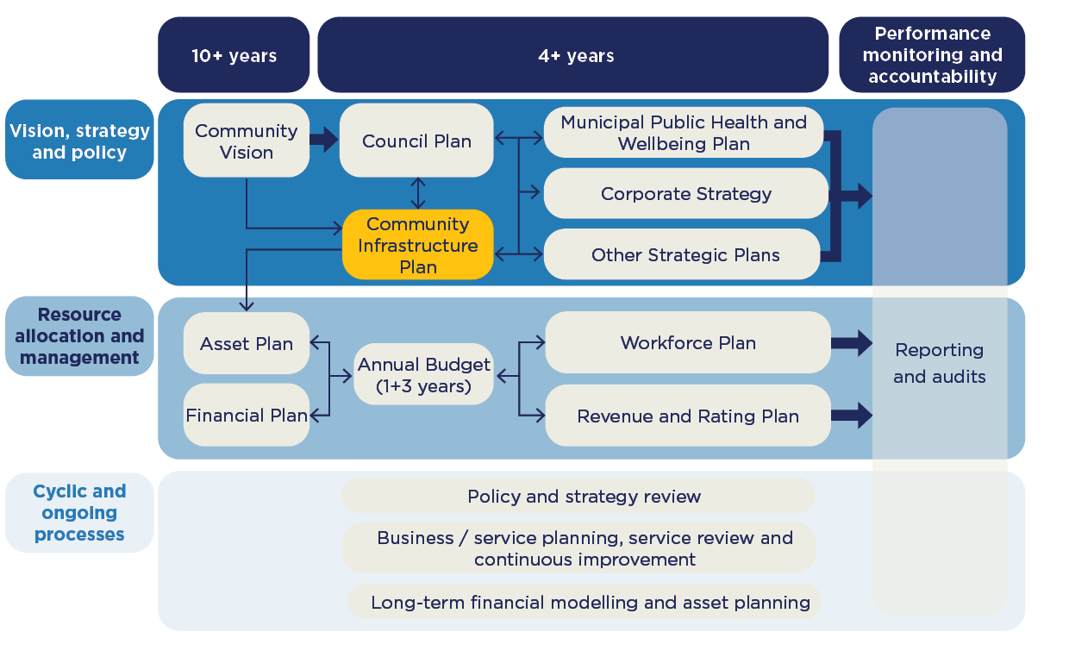
Annual business and capital works planning support delivery and ensure ongoing progress toward our long-term goals.
Figure 4: City of Melbourne's integrated planning and reporting framework

Development phases
The Plan was developed over six phases as shown in Figure 5.
Figure 5: Developing the Plan

Needs assessment
The Plan is underpinned by the Municipal Community Infrastructure Needs Assessment (needs assessment). The needs assessment is an independent assessment prepared by Cred Consulting in 2024. The needs assessment analysed the current supply, and existing and future demand for community infrastructure to 2043, based on our forecast population. The needs assessment is tailored to the City of Melbourne’s context, including role, service delivery and population standards that reflect our capital city context. Community infrastructure need represents the number of spaces required to support community activities, services and programs. This need is determined by:
- provision and planning standards for each community infrastructure type.
- demographic characteristics and forecasts for residents and workers.
- the location of existing City of Melbourne-owned spaces and, subject to data availability, spaces provided by others.
- the performance of existing spaces for community use.
- service standards and delivery models.
- community priorities and preferences.

Engagement
The Plan has been informed by analysis of community and stakeholder feedback, including on the M2050 Vision and Council Plan. Engagement activities included the M2050 Summit, Youth Roundtable, First Nations Roundtable, People’s Panel, and an online survey. Appendix B summarises M2050 Vision and Council Plan engagement outcomes relevant to community infrastructure.
Consultation on the draft Plan will occur between December 2025 and February 2026.

Implementing the Plan
Municipal initiatives and planned projects will be delivered through our business and capital works planning over the next four years.
Ideas for consideration in future planning will be explored by applying the Community Infrastructure Principles alongside community priorities and Council’s strategic priorities. The ideas that are determined to have the greatest benefit will be evaluated through a more detailed project planning and assessment process. This will help inform long-term financial, resource and asset planning.
The Plan will be reviewed every four years. Initiatives and planned projects will be reviewed and reported on annually as part of our planning and budgetary process.

Vision and principles
The Melbourne 2050 (M2050) Vision is:
“Liveable Melbourne, growing stronger together.”
The M2050 Vision reflects a shared aspiration for a future where people thrive together, supported by places that foster belonging, wellbeing and opportunity. Community aspirations underpin the vision, including that we “deliver for everyone,” meaning we design our city for equity, dignity and connection: to improve housing, health and wellbeing – no matter your life stage, cultural background, gender, ability or financial position.
Community infrastructure plays a vital role in realising this vision. Facilities such as libraries, early years hubs, arts and cultural centres, parks and recreation spaces are essential to social connection, learning, creativity and inclusion. They strengthen local identity, support placemaking, and reflect the diverse stories of the communities that live, work, play and do business in the City of Melbourne.
The Plan is shaped by five principles that ensure our community infrastructure is planned, delivered and managed in a way that aligns with the eight underlying aspirations of the M2050 Vision.
Principle | How we will achieve this | Aspirations
Integrated  We will create connected, multi-purpose community spaces that celebrate local identity and work together as a unified network. | - Deliver community hubs that bring services together to improve experience and operations.  - Spread community infrastructure across our municipality so that everyone can access the services they need. ​  - Pursue design excellence through buildings that connect to the public realm, local identity and history.  - Plan transport and community infrastructure together, from the local to municipal scale, recognising our role as a capital city. | A city for people  Building on our foundations
Equitable  We will ensure everyone can access welcoming, inclusive community infrastructure close to home, at every stage of life. | - Focus investment on reducing social and gender inequity and supporting communities experiencing disadvantage.  - Design spaces that are safe, inclusive and accessible for all ages and abilities and reflect the diversity and unique needs of our communities.  - Use community priorities and data to guide decisions and meet needs.  - Recognise Country and language in the design, naming and location of community infrastructure to support cultural continuity and connection. | Delivering for everyone  Grounded in First Nations knowledge and culture
Adaptive and sustainable  We will design flexible, future-ready infrastructure that makes the most of existing resources and supports a healthy environment. | - Create spaces that can adapt to changing needs, technologies and climate.  - Make the most of existing assets before building new.  - Prioritise shared spaces that support different and multiple uses over time.  - Design infrastructure that is fossil fuel free, climate resilient and supports biodiversity. | Green and alive  Leading on climate action
Financial stewardship  We will invest responsibly in infrastructure that delivers long-term value and is supported by sustainable funding and resource planning. | - Leverage external funding opportunities and strategic partnerships.  - Invest in projects that deliver lasting social, environmental and economic benefits.  - Plan for full lifecycle costs, including maintenance and operations.  - Proactively secure land to meet future community needs through ownership or partnership. | Back ambition and champion innovation  Optimistic leadership
Strategic governance  We will make transparent, evidence-based decisions that empower communities and align with our broader goals. | - Pursue innovative governance and delivery models that engage community, stakeholders and external partners.  - Align community infrastructure planning with our broader policies, planning and processes.  - Gather data and information that allows us to evaluate our network and the effectiveness of our decisions.  - Focus on community infrastructure we are the best placed to deliver, supported by advocacy and partnerships. | Back ambition and champion innovation  Optimistic leadership

City of Melbourne context
The City of Melbourne is the urban, cultural and commercial centre of Victoria. Sitting at the head of Port Phillip Bay and along the banks of the Birrarung–Yarra River, the City of Melbourne borders seven inner-city local governments (Figure 6). The municipality encompasses the central city, established inner urban neighbourhoods and rapidly transforming urban renewal areas.
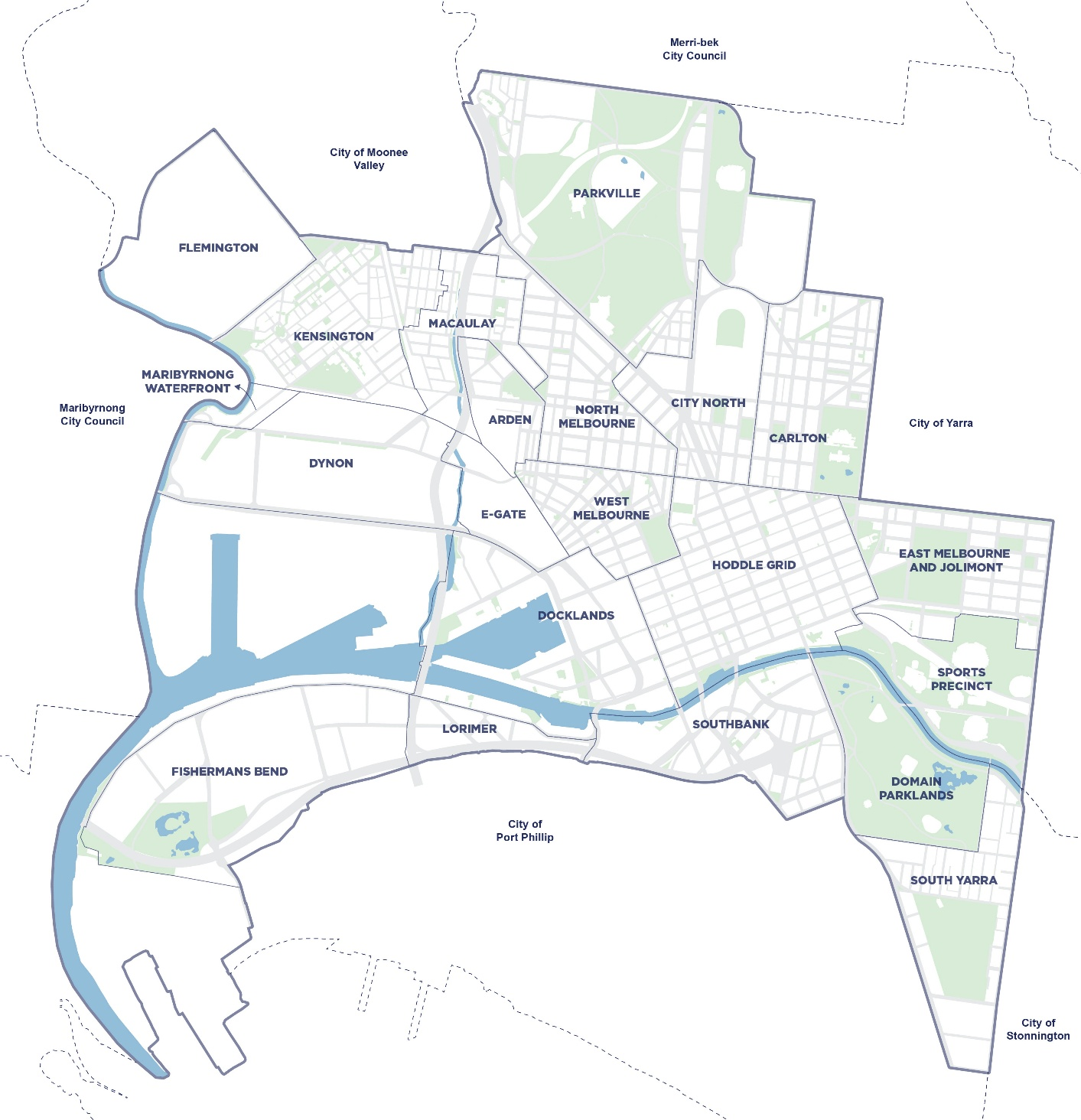
The City of Melbourne’s residential population is forecast to grow by almost 115,000 people over the next 20 years to an estimated 292,134 by 2043. The worker population is expected to grow from 493,143 in 2023 to 672,059 by 2043. As the capital city, at the heart of Greater Melbourne, home to more than five million people, our daily population swells with visitors who come for study, work, travel and leisure.
Figure 6: City of Melbourne context

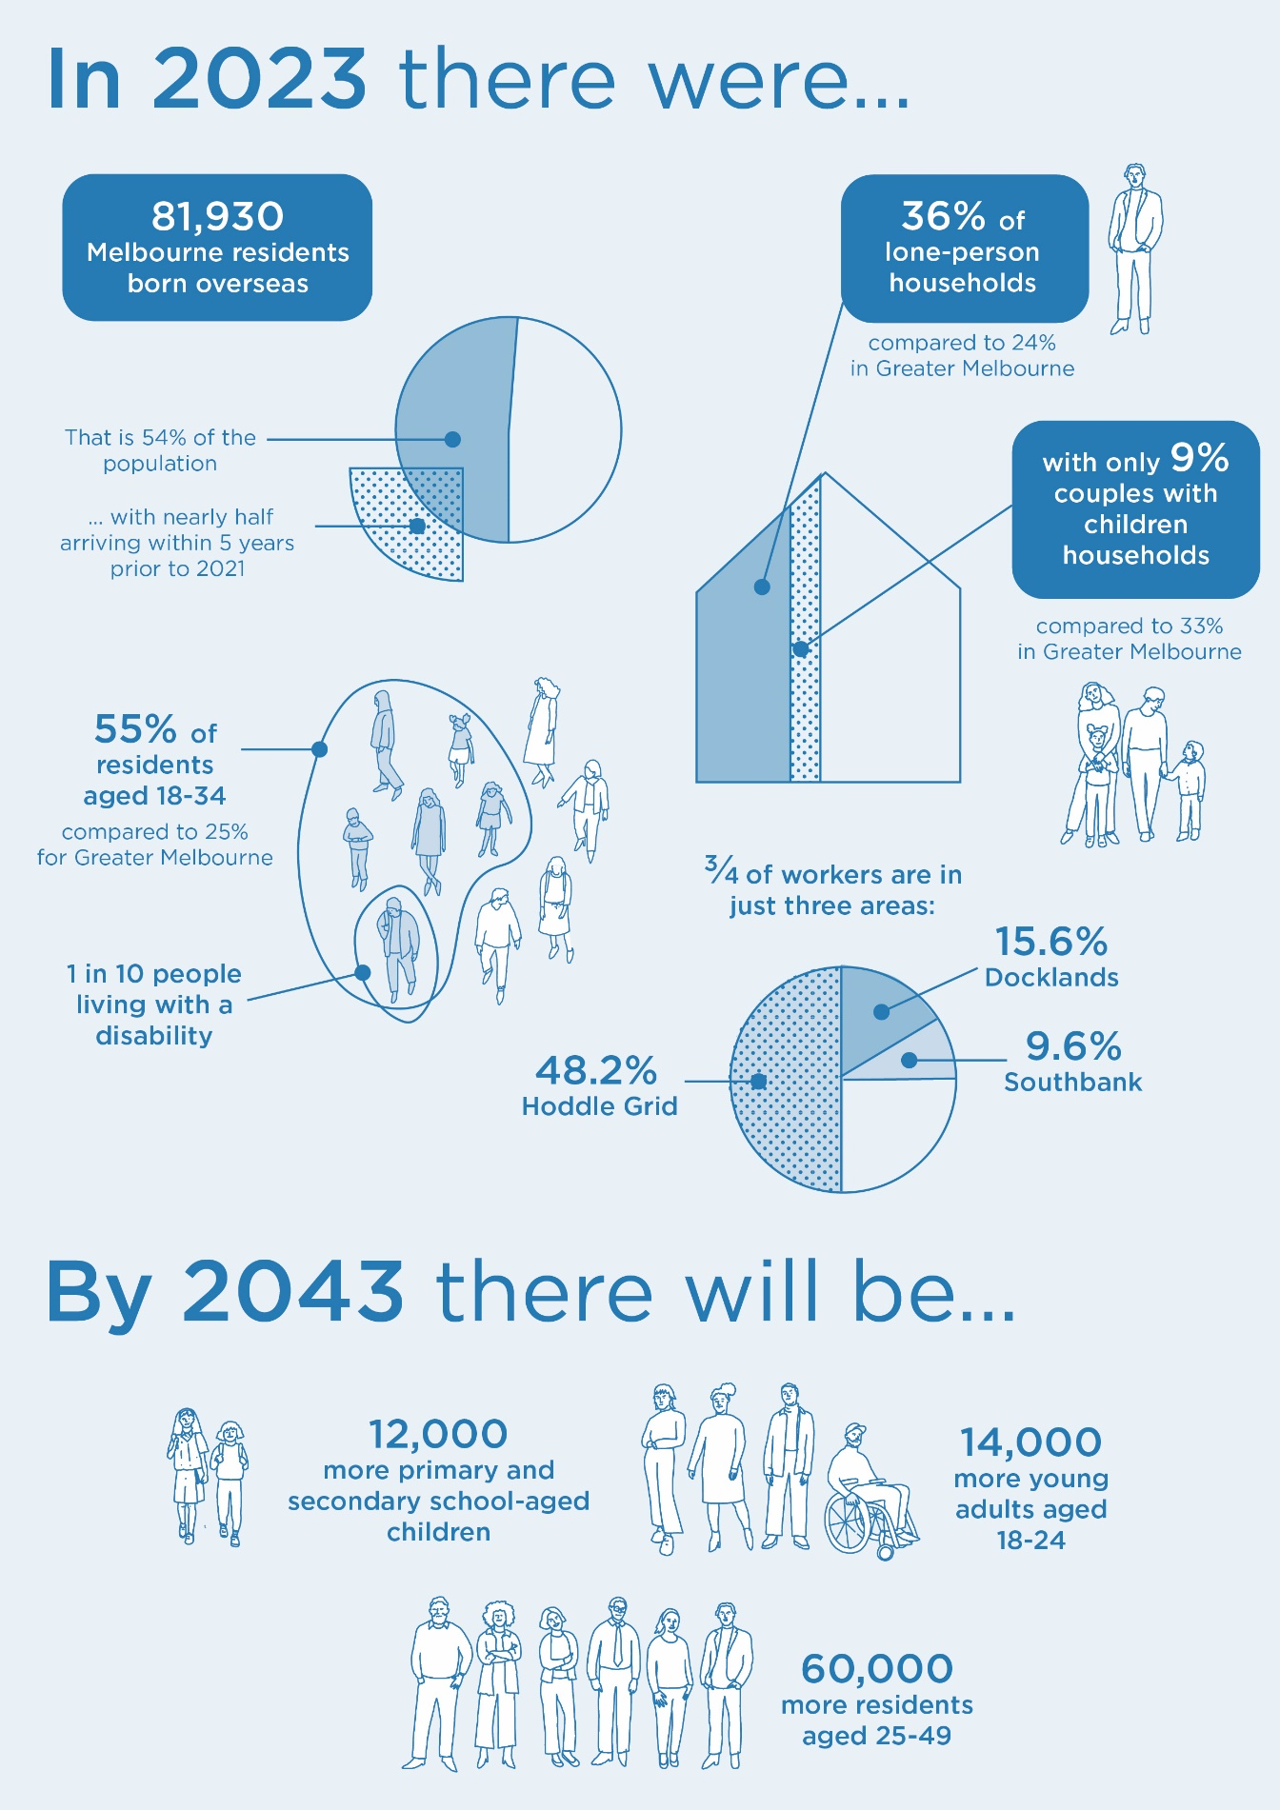
Demographic snapshot

Health and wellbeing
- In 2024, 64 per cent of the community indicated that they could access the City of Melbourne services and support they need.
- Participation in sports and exercise is on the rise, but less than half of our community meet the recommended amount of physical activity each week. Females and young adults aged 18 to 34 exhibit even lower levels of physical activity.
- Almost 1 in 2 (48.2 per cent) residents indicated that they have experienced food insecurity in the last 12 months, and almost a third are skipping meals or eating less.
- Rates of homelessness and those at risk of homelessness are higher than 10 years ago, and the City of Melbourne estimates that the number of rough sleepers is also rising.
- An estimated 8573 households have an unmet need for affordable housing in our municipality. This represents 12.1 per cent of all households compared to 6.1 per cent for Greater Melbourne.
- Satisfaction with feeling a part of the community is declining, with all age groups except those aged 25 to 34 recording a drop in their average satisfaction between 2018 and 2024.

Trends and strategic drivers

Land constraints
The City of Melbourne faces significant challenges in finding suitable land for community infrastructure. Available land is limited, often expensive, or already developed. This means we need to rethink how we deliver community infrastructure. Solutions include combining different services in shared spaces, making better use of underused areas, and designing flexible, multi-purpose buildings. Urban renewal areas present both opportunities and challenges – they can support larger facilities to meet regional needs like open space, recreation and schools, but require careful planning to make sure community infrastructure provision keeps pace with the growth in residents and workers.

Climate resilience and sustainability
Our city is already experiencing the impacts of climate change, with higher temperatures and more frequent extreme weather events. It is essential that community infrastructure and the networks that connect it, like streets and drainage systems, are designed and located to withstand these challenges, ensuring long-term sustainability and safety. Community facilities often play a vital role in responding to health and environmental risks, providing safe spaces during emergencies, helping to manage flooding, and keeping our city cool.

Fostering collaboration and partnerships
Delivering community infrastructure is a shared responsibility across local, state and federal government, the private sector, and community groups. While planning is becoming more collaborative, it can also be complex, with roles and responsibilities shifting over time. Recent examples include government reforms in early years and aged care sectors. We are committed to working closely with all stakeholders to ensure community infrastructure is delivered efficiently and meets the needs of our residents.

Changing community preferences
Community needs and expectations are always evolving. For example, there is growing demand for makerspaces, increased participation in sports by women and greater interest in informal recreation. People also want facilities that are open longer and better reflect how they live and work in the city. Listening to the community and continuously improving service delivery will allow us to adapt our community infrastructure to better respond to community needs.

Financial constraints
Over the past decade, government funding for community infrastructure has not kept pace with rising costs. Rate capping and increasing expenses for construction and maintenance continue to put pressure on local government budgets. At the same time, the need to renew and expand our ageing assets limits the funds available for new projects. As a result, we are exploring more innovative and cost-effective ways to deliver community infrastructure, such as public-private partnerships, developer contributions, and integrating commercial spaces to help offset ongoing costs.

Towards community hubs
There is a growing movement towards creating community hubs – places where multiple services and activities are brought together in one location. Hubs are a more cost-effective way to deliver services and operate facilities, while also providing a destination or central gathering place for the community. This approach is more efficient, encourages social connection, and supports partnerships and resource sharing between different services. Community hubs can attract a diverse range of users, improve access to facilities, and make it easier to coordinate supporting services like public transport.

Existing community infrastructure
This section describes existing community infrastructure in local areas across the City of Melbourne.
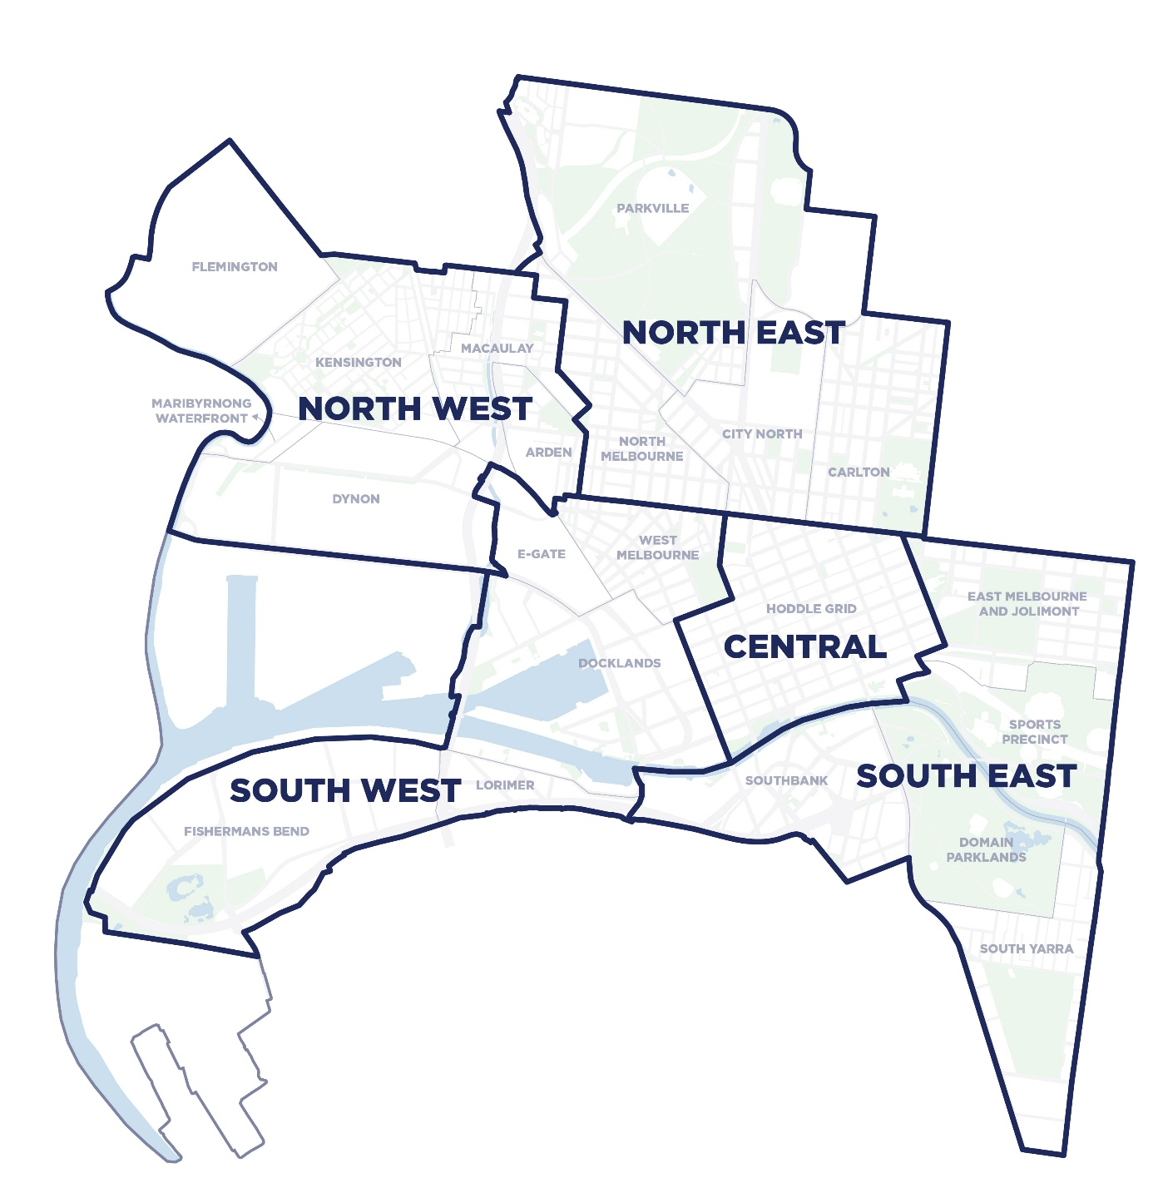
Figure 7: Local areas within the City of Melbourne

North-west
Local area |  | 2023 | 2043 | Change (%)
Kensington | Residents | 11,547 | 16,871 | +46
Kensington | Workers | 1977 | 3300 | +67
Macaulay | Residents | 3537 | 9688 | +174
Macaulay | Workers | 3026 | 7847 | +159
Arden | Residents | 449 | 8112 | +1707
Arden | Workers | 1969 | 9179 | +366
The north-west is undergoing significant transformation, with the urban renewal of Arden and Macaulay underway and the future renewal potential of the Maribyrnong Waterfront and Dynon. Parts of the area are well connected by public transport, including three train stations and tram route 57. The area will benefit from the opening of Arden Station, which will support major development in the Arden precinct.
Community infrastructure in the area includes the Kensington Community Aquatic and Recreation Centre, North Melbourne Community Centre, Kensington Town Hall and JJ Holland Park.
The north-west is generally well serviced by existing aquatic and recreation facilities, however there is demand for additional open space, and land for organised and unstructured sports. A secondary school is also needed.

Kensington
Kensington is expected to grow gradually and has a higher proportion of young children compared to the rest of the municipality. This is creating pressure on early years services, which are already nearing capacity. While the area has a good mix of City of Melbourne and non-government community infrastructure, many facilities are not fit-for-purpose, with limitations in access, size and function. There is also a need for more maternal and child health services, creative spaces, and better access to library services.

Arden
Arden is set for major change, with thousands of new residents and workers expected by 2043. In the short term, this growth will drive demand for early years services, while the medium term will see the need for a primary school, family services and a range of community spaces. The Arden Structure Plan outlines how these needs will be met, including funding mechanisms, and highlights Arden’s potential to support surrounding neighbourhoods.

Maribyrnong Waterfront and Dynon
Maribyrnong Waterfront and Dynon are currently industrial areas but have long-term potential to accommodate large open spaces and broader community infrastructure needs. These areas will require further planning and investigation to determine their future role.

Macaulay
Macaulay, a historically industrial precinct, is experiencing rapid change, particularly along Macaulay Road. Current infrastructure generally meets short-term needs, with some demand for early years services. However, most community infrastructure is east of Moonee Ponds Creek, leaving a gap in provision for residents and workers in the west. The City of Melbourne is delivering new projects such as the North Melbourne Community Hub and Chelmsford Street Open Space to address gaps. The Macaulay Structure Plan identifies future projects to improve access to services and meet growing demand.
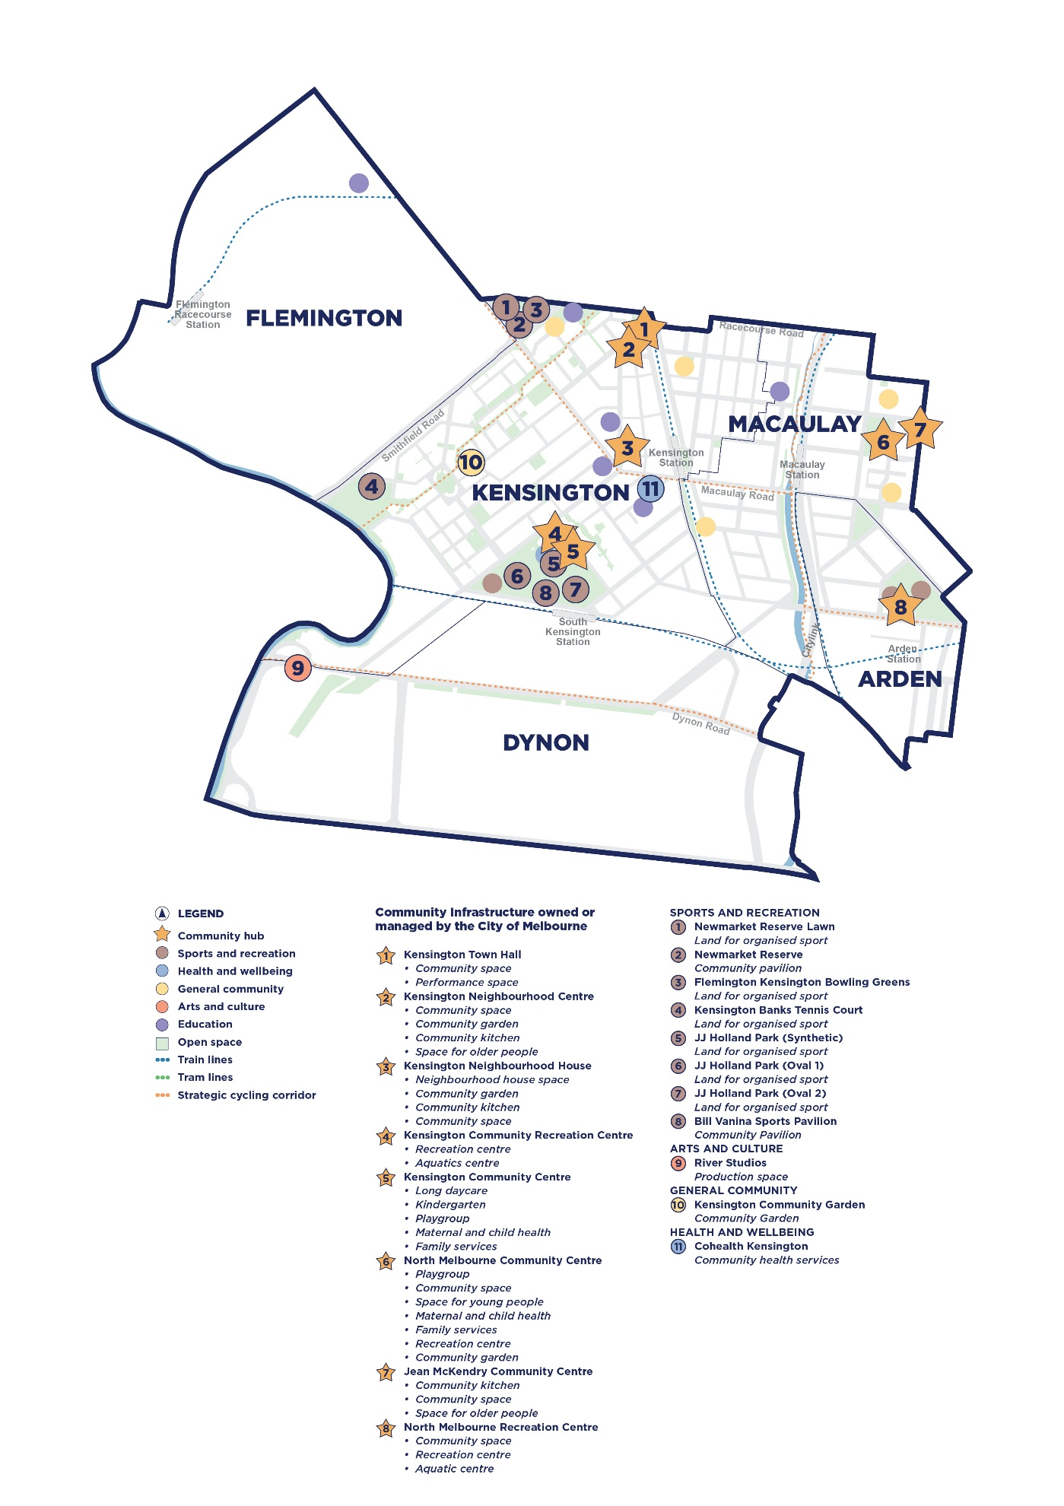
Figure 8: Existing community infrastructure in the north-west
Local area |  | 2023 | 2043 | Change (%)
Parkville | Residents | 6816 | 9207 | +35
Parkville | Workers | 11,377 | 12,145 | +7
North Melbourne | Residents | 9077 | 13,082 | +44
North Melbourne | Workers | 3141 | 4870 | +55
Carlton | Residents | 13,901 | 19,030 | +37
Carlton | Workers | 8832 | 12027 | +36
City North | Residents | 13,202 | 19,503 | +48
City North | Workers | 32,722 | 45,793 | +40

North-east
The north-east includes Carlton, North Melbourne, Parkville and City North. It is expected to experience steady development and growth. The area is well connected by public transport, with tram routes and the Upfield train line providing access to the central city and northern suburbs. The opening of Parkville Station will improve access to City North and parts of Carlton, supporting increased development and activity.
The north-east is home to major health, education and sporting institutions as well as important arts and cultural venues. This offers opportunities for partnerships to deliver additional community spaces. The area has access to several aquatic and recreation facilities, including Carlton Baths, however the quality and suitability of these facilities vary. Open space and land for sport is concentrated in the northern part of the area, leaving gaps in provision closer to the central city.

Parkville
Parkville is defined by Royal Park, which offers a wide range of recreation opportunities and will be guided by the Royal Park Masterplan. The area has a higher proportion of older residents, particularly in the north-west, where aged care facilities are located. This part of Parkville is less connected to the rest of the municipality and lacks flexible, bookable community spaces. In the short term, there is a need for early years and family services spaces.

Carlton
Carlton is a well-known and vibrant neighbourhood with a large student population due to its proximity to RMIT and the University of Melbourne. It is generally well serviced by community infrastructure, but by 2043 there will be demand for additional performance and production spaces, community gardens, and a small community space. These needs could be met by improving how existing spaces are used and ensuring they are fit-for-purpose.

City North
City North is a hub for health, education and innovation, and has the highest concentration of students in the municipality. People aged 18 to 24 make up nearly half the population, and this trend is expected to continue. The area will also see a growing worker population, projected to reach over 45,000 by 2043. There is short-term demand for community infrastructure across all categories, especially early years services and flexible spaces for young people. There is potential to work with universities and institutions to open existing facilities for broader community use.

North Melbourne
North Melbourne is a well-connected inner-city neighbourhood with good access to public transport and recreation facilities. While most community infrastructure needs are being met, there is demand for more family services and bookable community infrastructure. Improving the quality and usability of existing facilities to better meet current and future needs should be the focus.

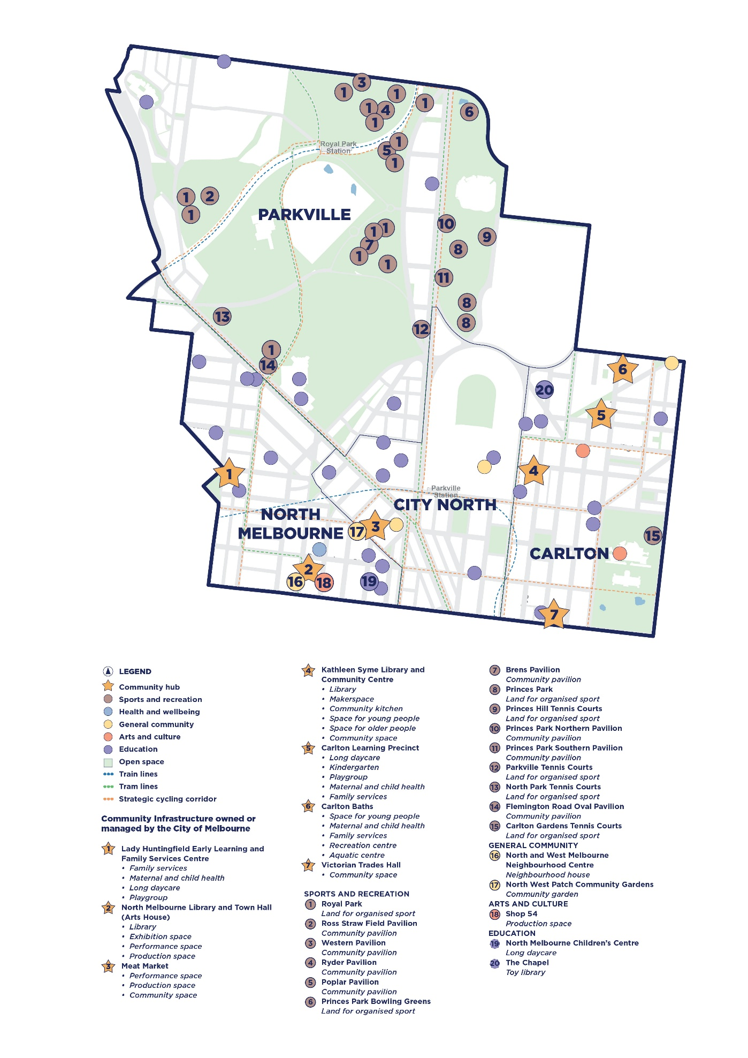
Figure 9: Existing community infrastructure in the north-east
Local area |  | 2023 | 2043 | Change (%)
West Melbourne | Residents | 9521 | 16,554 | +73
West Melbourne | Workers | 4614 | 7630 | +65
Docklands | Residents | 18,199 | 29,586 | +63
Docklands | Workers | 76,700 | 96,600 | +26
Fishermans Bend | Residents | 10 | 3273 | >3000
Fishermans Bend | Workers | 12,510 | 28,799 | +130

South-west
The south-west area includes Docklands, West Melbourne, Fishermans Bend – specifically the Lorimer and Employment and Innovation Area (EIA) precincts – and the potential future renewal area of E-Gate. West Melbourne and Docklands are well connected by major train stations and tram routes. Fishermans Bend currently lacks adequate transport infrastructure, and its future development depends on the delivery of the proposed tram extension and Metro 2 rail line.
The area contains important community infrastructure including The Library at The Dock, Ron Barassi Senior Park and Pavilion, and the Community Hub at The Dock. There are significant gaps in the provision of open space and aquatic and recreation facilities. Existing sports and recreation spaces are not sufficient to meet current or future demand.

Docklands
Docklands renewal began in the 1990s and it is a major residential, employment and visitor destination. Residential growth is expected to continue, with young adults remaining the largest age group and children aged zero to 11 the fastest growing. This is creating increased demand for local community infrastructure. In the short term, there is a need for arts and culture spaces, community gardens, flexible bookable spaces including for older people, and early years services including long day care, kindergarten and playgroups. Docklands Primary School opened in 2021 and is already at capacity, and there is demand for an additional primary school.

E-Gate
E-Gate is an industrial area with long-term potential to accommodate large-scale open spaces and community infrastructure, including recreation and aquatic facilities. Strategic planning and further investigation is required to determine its future role.

West Melbourne
West Melbourne is an inner-city area undergoing change, guided by the West Melbourne Structure Plan. It has a mix of high-density areas near the Hoddle Grid and lower-density residential areas in the north. The area currently lacks indoor community spaces managed by the City of Melbourne and relies on nearby Flagstaff Gardens for open space. It is expected to see the highest worker growth of all non-renewal areas. In the short term, there is demand for early years and family support services, flexible community spaces and community gardens. Demand for arts and cultural spaces is expected to exceed current provision in the medium term.

Fishermans Bend
Fishermans Bend is Australia’s largest urban renewal precinct. Lorimer is planned as a dense urban neighbourhood, while the EIA will focus on advanced manufacturing and business. Although growth will be gradual over the next two decades, the area is expected to accommodate over 12,000 residents and 80,000 workers. Its development depends on investment in transport and community infrastructure. Fishermans Bend should support municipal facilities, including arts, open space and sports and recreation.

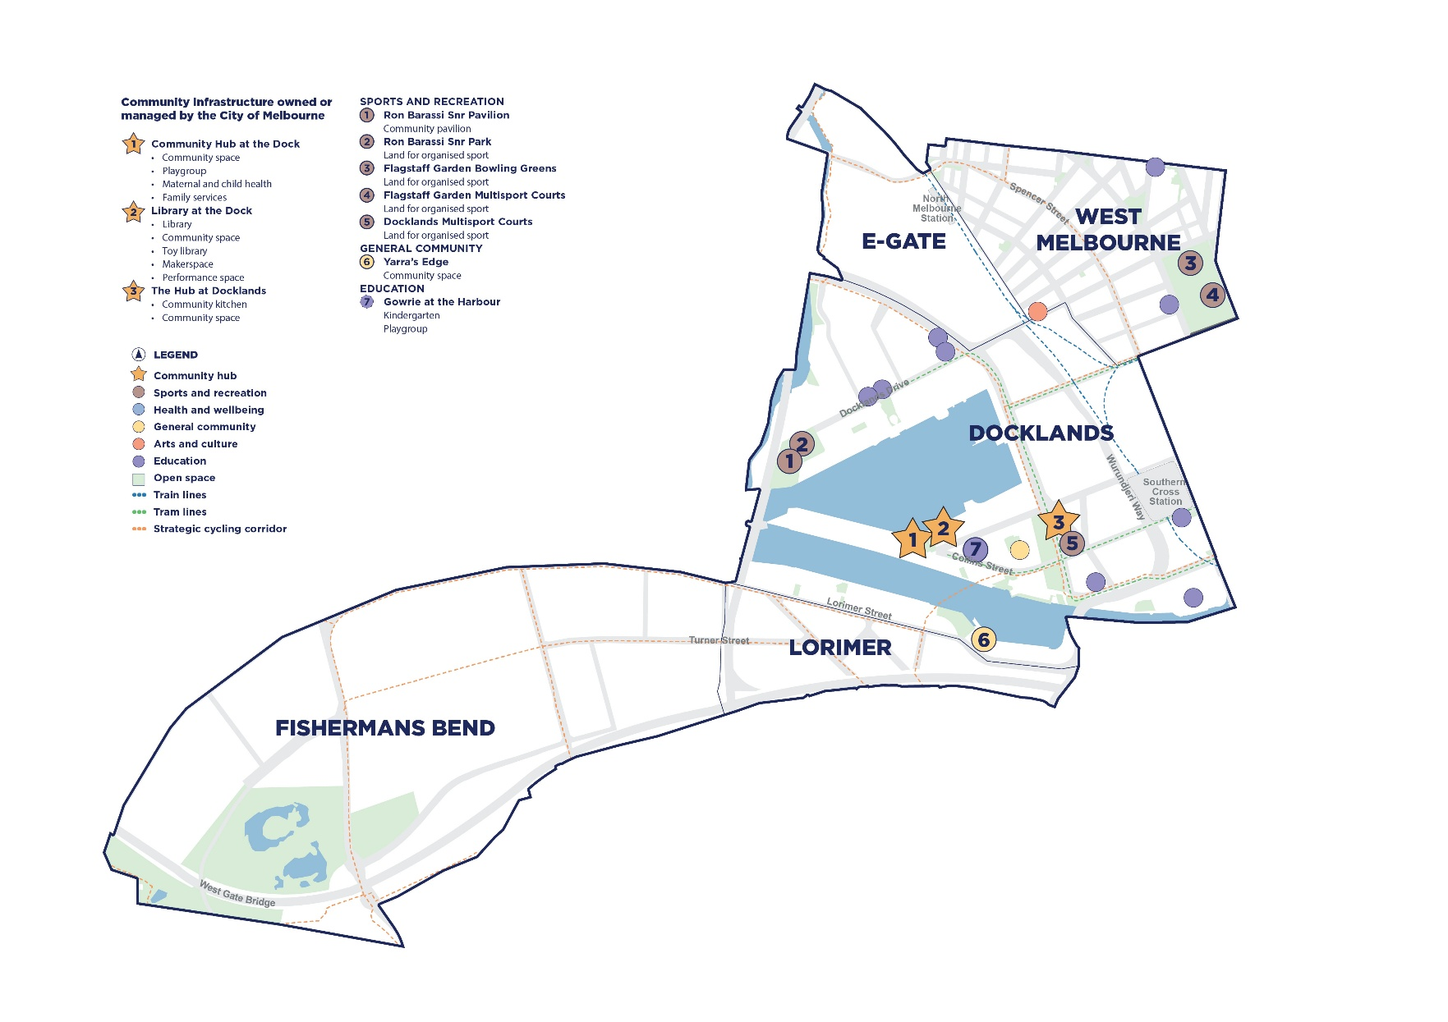
Figure 10: Existing community infrastructure in the south-west

South-east
Local area |  | 2023 | 2043 | Change (%)
Southbank | Residents | 26,528 | 44,503 | +68
Southbank | Workers | 47,117 | 67,218 | +43
East Melbourne and Jolimont | Residents | 5410 | 7498 | +39
East Melbourne and Jolimont | Workers | 16,939 | 20,696 | +22
South Yarra | Residents | 7262 | 10,047 | +38
South Yarra | Workers | 16,477 | 19,505 | +18
The south-east area of the City of Melbourne includes Southbank, East Melbourne, Jolimont, South Yarra, and the Domain Parklands and Sports Precinct. Public transport access is strong, with Southbank and South Yarra primarily served by tram routes, and East Melbourne benefiting from six train lines via Jolimont-MCG and Richmond stations and the future Anzac Station.
Key community infrastructure in the area includes the Boyd Community Hub, East Melbourne Library, and Riverslide Skate Park. Fawkner Park in South Yarra provides a major sports and recreation hub. Southbank faces a significant shortfall in open space and land for both organised and informal recreation.

Southbank and Domain Parklands
Southbank, located along the southern banks of the Birrarung, is Australia’s second most densely populated suburb and continues to grow. It hosts major institutions such as the Arts Centre, the Convention and Exhibition Centre, and the Victorian College of the Arts. Heavy traffic on major roads creates barriers to accessing community spaces. The area has very little open space, and residents and workers rely heavily on the Domain Parklands, which offer over 120 hectares of open space and serve communities across the municipality. There is unmet demand for community infrastructure across all categories with a particular need for flexible, bookable spaces of various sizes. Southbank’s proximity to the City of Port Phillip presents opportunities for collaboration in planning and delivering community infrastructure, including partnerships with the private sector and community organisations.

South Yarra
South Yarra is governed by the City of Melbourne and the City of Stonnington. Due to its location along the Birrarung, residents are more likely to access facilities in neighbouring municipalities. Within the City of Melbourne, the area is largely residential, with large parklands and the Alfred Hospital. Community infrastructure is mostly concentrated in Fawkner Park and consists of single-use facilities that are in good condition but limited in flexibility. There is currently no accessible library and a lack of general community spaces. Short-term needs such as maternal and child health services, long day care, flexible community spaces, and a community garden can largely be met by improving and adapting existing facilities.

East Melbourne and Jolimont
East Melbourne and Jolimont are among the oldest parts of the municipality and are home to key institutions like the Victorian Parliament and Treasury, as well as Fitzroy Gardens. The area has a significantly older population, with nearly a quarter of residents aged over 60. While community infrastructure is limited, it is generally fit-for-purpose. There is demand for additional space to support programs for older people. To meet future needs improving the use and suitability of existing facilities will be important.
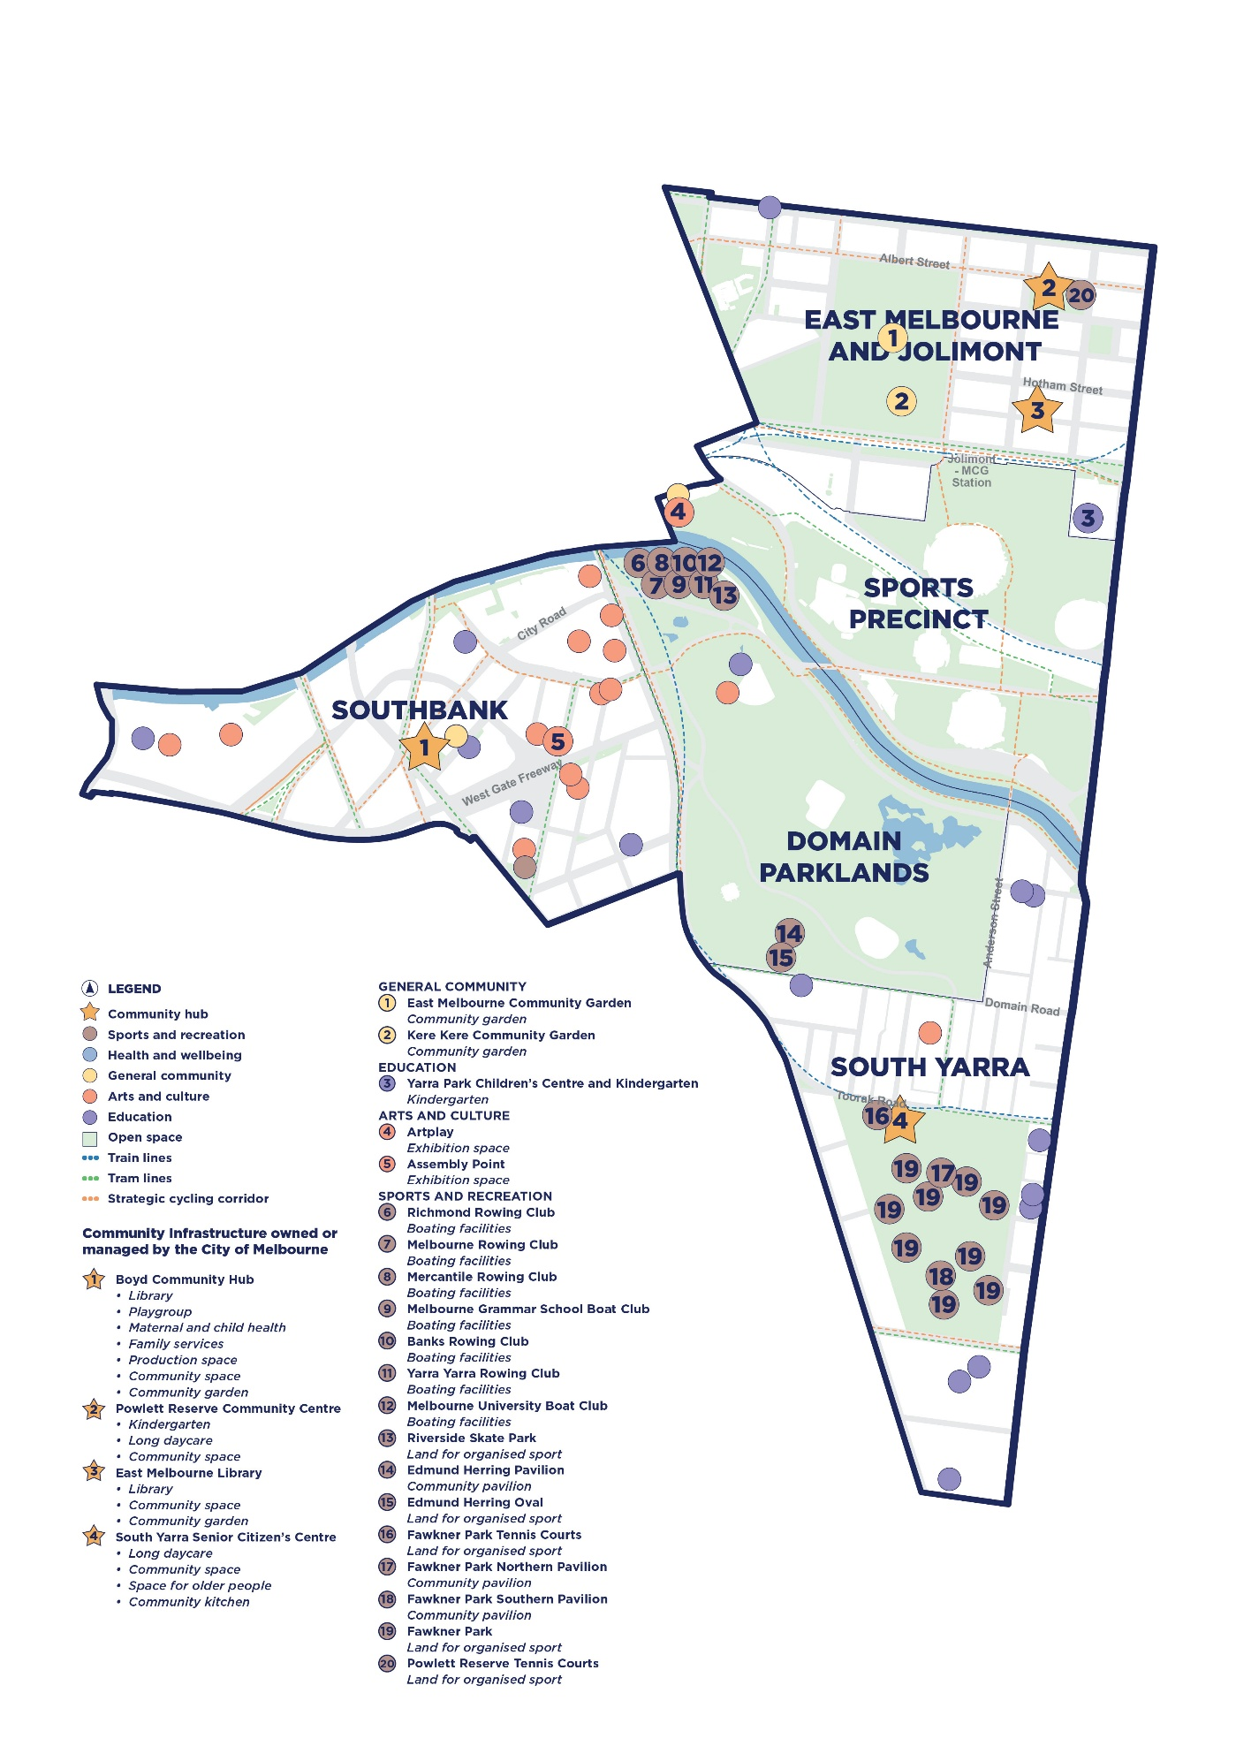
Figure 11: Existing community infrastructure in the south-east
Local area |  | 2023 | 2043 | Change (%)
Hoddle Grid | Residents | 51,804 | 84,532 | +63
Hoddle Grid | Workers | 237,655 | 314,045 | +32

Central city

The central area focuses on the Hoddle Grid, which is Australia’s most densely populated area and serves as the state’s cultural, economic and transport centre. With an estimated daily population of 850,000 people – including workers, students and visitors – community infrastructure in this area plays a broader role than serving local residents. The Hoddle Grid faces the most significant shortfalls in community infrastructure across all categories, both now and into the future.
Delivering new infrastructure in the Hoddle Grid is particularly challenging due to high land costs and limited available development sites. Its central location and role as a meeting place offers unique opportunities, including the potential to establish a major community hub for Aboriginal communities and Aboriginal-focused organisations and businesses. Meeting the needs of this diverse and high-demand area will require strong partnerships, better use of existing assets, and innovative approaches to how infrastructure is planned and delivered.

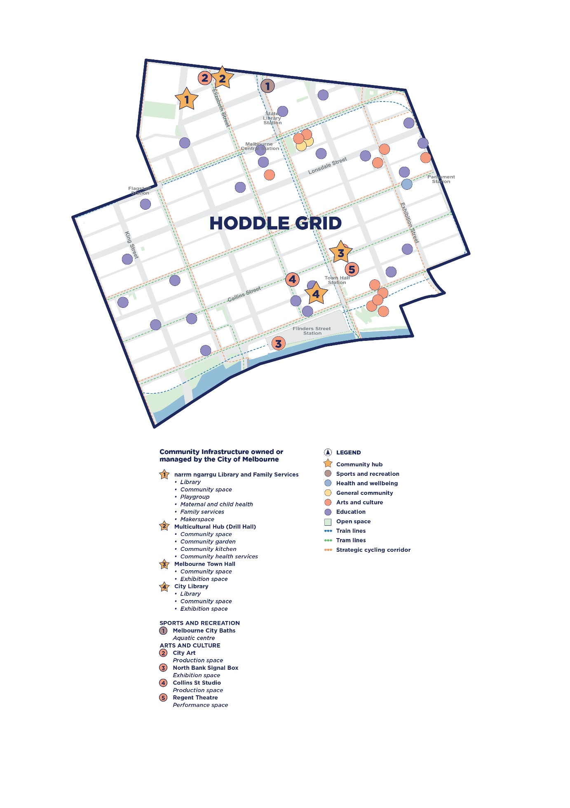
Figure 12: Existing community infrastructure in the central city

Community infrastructure needs
The key findings from the needs assessment (Cred Consulting, 2024) are presented in this section. The analysis included an audit of existing community infrastructure supply. The assessment applied population benchmarks and other demand indicators, tailored to the City of Melbourne’s context. The assessment identifies current and future demand to 2043.
Community infrastructure needs are summarised by category. Each category includes:
- a description of key issues, opportunities and community insights as well as our role
- a description of the type of spaces and what services, programs, and activities they accommodate
- a demand profile for each community infrastructure type including provision standard, current supply, and current and future need
- a snapshot of how spaces are performing as community infrastructure, assessed across five criteria: location and access, functionality, safety, welcoming design, and sustainability and resilience. This complements asset management - which focuses on building condition, capacity and function. Together, these performance insights support integrated asset lifecycle and community infrastructure planning.

How to read the demand profile
Each infrastructure category is accompanied by a demand profile, described in Table 3 below. The spaces included in the assessment for each community infrastructure type depends on the City of Melbourne’s role and data availability.

Table 3: Demand profile example and definitions
Type | Provision standard | Community infrastructure need
The community infrastructure types within the category. | The benchmark for the number of users that create demand (space, place, hectare) for additional community infrastructure. | Current supply within the City of Melbourne. | Demand in addition to existing supply to 2028. | Additional demand to 2043.

Health and wellbeing
Issues, opportunities and community insights | Our role
- People’s vision for Melbourne is a city that considers health and wellbeing in every aspect of our planning.  - Older people tell us that programs, activities and groups to support wellbeing are a top priority for aging well in the city.  - Young people tell us that they would appreciate spaces to gather and socialise and build positive connections to support their mental health.  - Embedding user-centred design processes and universal access into the development of new community infrastructure is fundamental to ensure that spaces reflect user needs, preferences, and aspirations.  - Co-locating unstructured recreation areas with dedicated spaces for young people can help to provide a soft entry into youth-oriented programs and services. | We deliver health and wellbeing services from our community infrastructure with funding and direction from the Victorian Government. We also support other organisations to deliver services by providing spaces and funding, such as community health. Our role in aged care is limited and focused on advocacy.
 | Performance
 | Health and wellbeing infrastructure across eight spaces scored well on safety criteria but low in sustainability and resilience.

Types of health and wellbeing community infrastructure
Type | Description
Maternal and child health | Spaces to deliver universal primary health care services for households with children from birth to school age.
Family services | Spaces to deliver targeted programs for vulnerable children and families where the child’s safety and development are at risk, or where parents are experiencing difficulties which then impact on their parenting abilities and children’s wellbeing.
Space for young people | Supports youth services to deliver a range of crisis, social support, recreation and developmental programs for young people aged 12 to 25 years.
Space for older people | Provides affordable programs and community space for older people to connect and engage.
Space for community health services | Community health services in Victoria offer a wide range of public health programs, focusing on prevention and support for those with the greatest health and social needs. They help improve local wellbeing and reduce pressure on hospitals, working alongside GPs and other health providers as part of the primary health system.
Table 4: Health and wellbeing demand profile
Type | Provision standard | Community infrastructure need
Maternal and child health | 300 children 0 to 4 years
Family services | 7000 residents
Space for young people | 7500 residents 12 to 25 years
Space for older people | 2500 residents 60 and over

 |  |  | Existing supply |  | Demand to 2028 |  | Demand to 2043

Education
Issues, opportunities and community insights | Our role
- The community tells us that it’s important to keep up with all forms of education needs, especially in areas where the city is growing.  - We’ve heard that cost and waitlists for childcare and early years facilities can make it difficult to access these services.  - The Victorian Government Best Start, Best Life reforms will transform the early years sector across the state, impacting the number of facilities needed.  - There has been a trend across Victoria for the delivery of early years hubs, which co-locate services such as maternal child health, family services, playgroup rooms and long day care or kindergarten. This provides a “one stop shop” for young families to access key spaces and services, connect and socialise and also supports cross-referral. These can also be co-located with primary schools. | We own and manage some day care and kindergarten spaces, but most are run by private and not-for-profit providers. We advocate for the right number of schools in the right place and sometimes partner with Victorian Government and other providers to co-locate facilities in schools.
 | Performance
 | Education infrastructure across seven spaces scored well on safety criteria but low in welcoming design.

Types of education community infrastructure
Type | Description
Long day care place | Centre-based childcare service, which provides care and learning for children on an all-day or part-time basis. Long day care services usually operate at least eight hours per day and can include kindergarten programs.
Kindergarten place | Play-based early education program for children aged 3 to 4 years, led by qualified early childhood teachers. Delivered as a sessional program with set hours at stand-alone facilities or integrated into long day care services that offer flexible hours and combine education with extended care.
Playgroup | Welcoming spaces where children, parents, and families come together to learn through play and build social connections. These rooms support casual or facilitated playgroup sessions that can be open to the general community or tailored to specific families, such as those with twins or from culturally diverse backgrounds.
Toy library | Provides access to a range of quality toys that can be borrowed by members of the community. People require a library membership to access the toy library catalogue.
Primary school | Generally covers the first seven years of formal education, from foundation (Prep) to Year 6.
Secondary school | Provides education to students in the middle and upper years of their formal schooling, generally years 7 to 12, which corresponds to students aged approximately 12 to 17 years old.
Table 5: Education demand profile
Type | Provision standard | Community infrastructure need
Long day care place | 2.5 children aged 0 to 4 years, and 2 children aged 5 years
Kindergarten place | 1 child aged 3 to 4 years
Playgroup | 700 children aged 0 to 5 years
Toy library | 2500 children aged 0 to 8 years

 |  |  | Existing supply |  | Demand to 2028 |  | Demand to 2043

General community
Issues, opportunities and community insights | Our role
- The community tells us that shared kitchens and gardens foster connection and provide places to socialise especially in neighbourhoods with lots of small apartments.  - The community thinks we could make it easier to find spaces to book in their neighbourhood.  - There is a growing trend of private sector organisations and institutions leasing their spaces to the community, partly in response to the underused office spaces following COVID-19.  - Opportunities exist to collaborate regionally on redeveloping libraries near municipal boundaries to enhance offerings and address shared population growth and demand. | We own a range of general community facilities. We run programs and activities from these spaces and manage bookings for individuals and community groups. We do not manage community gardens.
 | Performance
 | General community infrastructure across 21 spaces scored well on safety and location criteria but low in welcoming design, and sustainability and resilience.

Types of general community infrastructure
Type | Description
Library | Purpose-built facilities that provide access to a range of learning activities and resources including books, magazines and periodicals, computers and other technology, internet services and meeting rooms. They are often co-located with a broad range of other community and creative spaces such as makerspaces, recording studios and archival and gallery spaces.
Community kitchen | Semi-commercial spaces equipped for large-scale food preparation and cooking, designed to support a range of community activities such as shared meals, cooking classes, and food service training. Featuring industrial-grade appliances and meeting health and safety standards, they offer a versatile environment for both social and educational purposes.
Community garden | Allocated spaces on government-owned and managed land, which operate for the primary purpose of growing fresh food and promoting food security through educational, social, cultural and environmental activities. Community gardens may be provided as spaces with many small individually allocated plots, or as communal garden beds managed collectively.
Bookable community space | Flexible, multi-purpose places that support a wide range of activities, services, and events for people of all ages and backgrounds. They vary in size – from small rooms for quiet reflection or counselling, to large venues for performances, exhibitions, and cultural gatherings – and are used by both community members and service providers.
Makerspace | Creative, hands-on environments equipped for activities like crafting, coding, digital design, music and video production. They support skill development, innovation, and community connection, and can be used for personal projects, learning, or entrepreneurial ventures.
Neighbourhood house | Also known as community houses and neighbourhood centres. They are primarily funded by the Victorian Government and offer activities to support learning, social connection and wellbeing.
Table 6: General community demand profile
Type |  | Provision standard |  | Community infrastructure need
Library |  | 30,000 people
Community kitchen |  | 25,342 people
Community garden |  | 10,000 people
Makerspace |  | 25,000 people
Small bookable space |  | 15,000 people
Medium bookable space |  | 7500 people
Large bookable space |  | 10,000 people
Extra large bookable space |  | 25,000 people
XX large bookable space |  | 50,000 people
 |  |  |  |  |  |  |  |  | Existing supply |  |  |  |  |  |  |  |  |  |  |  |  |  |  |  |  |  |  |  |  |  |  |  |  |  |  | Demand to 2028 |  |  |  |  |  |  |  |  |  |  |  |  |  |  |  |  |  |  |  |  |  |  |  |  |  |  |  | Demand to 2043

Arts and culture
Issues, opportunities and community insights | Our role
- We have heard that affordable space is a significant barrier for artists and community want us to activate underused spaces.  - The community tells us that cultural events bring the community together and help improve connection, belonging and combat social isolation.  - The municipality has a variety of privately owned and operated arts and culture spaces, catering for both community-scale uses and commercial uses. There is particular demand for spaces that can support community groups and artists working in the small to medium arts sector.  - Innovative and emerging forms of art, such as digital and interactive art, may change the functional and operating requirements for arts and culture community infrastructure.  - Clustering arts and culture spaces encourages networking, resource sharing and intellectual property generation. | We own and manage spaces and programs that help creative practitioners engage, grow and connect with the community.  We also support private and state-owned institutions through strategic partnerships and provide financial support to Melbourne’s creative workers and industries.
 | Performance
 | Arts and culture infrastructure across 11 spaces scored well on safety but low in sustainability and resilience.

Types of arts and culture community infrastructure
Type | Description
Performance spaces | Performance or theatre spaces enable performances and spectatorship. They are typically fitted with specialised equipment such as lighting bars and audio equipment.  There are generally two main groups of performing spaces in the municipality – one that caters to commercial activity and another that caters more to independent, small and emerging artists, as well as community groups.
Exhibition space | Exhibition spaces offer opportunities to showcase and experience art and culture. These spaces can range from purpose-built venues designed for large-scale exhibitions to smaller, more intimate settings used for either professional or community shows.
Production space | Production spaces support creative work and innovation by providing dedicated areas for artists and creative organisations. Studio spaces offer secure environments for artists to develop their work, either individually or as part of a collective, while office spaces cater to creative sector businesses and organisations. These spaces may be programmed for specific uses or open for broader community access to support art production.
Table 7: Arts and culture demand profile
Type | Provision standard | Community infrastructure need
Performance space* | 35,000 people
Exhibition space* | 30,000 people
Production space* | 30,000 people

 |  |  | Existing supply |  | Demand to 2028 |  | Demand to 2043
*Refers to government-owned spaces, as the focus of the Community Infrastructure Plan is supporting community outcomes. However, we recognise the role of private arts and culture spaces in supporting the broader arts and culture network in the municipality.

Aboriginal and Traditional Owner
Issues, opportunities and community insights | Our role
- Ongoing engagement with Traditional Owners identifies the need for caring for Country and designing for Country in our open spaces and built environment.  - Priorities identified through Aboriginal Community engagement, for example the First Nations Committee, the M2050 First Nations Roundtable and with Traditional Owners, include affordable housing, cultural safety in service delivery and design, creating First Nations hubs and embedding First Nations knowledge and language in the municipality for the benefit of the whole community.  - Community support celebrating Aboriginal culture including incorporating Traditional Owner art and language and establishing co-designed places in open spaces.  - The community has told us that markers, Aboriginal place names and information about significant places provide incidental engagement with Aboriginal history and heritage.  - A review of community spaces highlighted opportunities to strengthen cultural safety across the community infrastructure network. | We engage Traditional Owners and the Aboriginal Community to understand community infrastructure requirements for ceremonial and other spaces.  We advocate for, design, deliver and manage Aboriginal community infrastructure in municipal spaces.  We own spaces used by Aboriginal peoples, organisations and services.

Types of Aboriginal and Traditional Owner community infrastructure types
Type | Description
Space for Aboriginal (or Aboriginal-focused) organisations and services | Includes a range of dedicated and culturally safe spaces that provide a place for Aboriginal services, organisations or businesses to operate from. This could span, but not be limited to, Aboriginal support services (such as housing, health care, education and employment), social enterprises or organisations. Dedicated space can be provided permanently, on a short or long-term lease or as a pop-up temporary activation.
Ceremonial spaces | A dedicated space designed with Aboriginal people to support gathering, sharing and cultural practices and ceremonies. These spaces provide opportunities for Aboriginal people to continue and share their cultural and spiritual practices with each other and the broader community.
Table 8: Aboriginal and Traditional Owner demand profile
Type | Provision standard | Community infrastructure need
Space for Aboriginal (or Aboriginal-focused) organisations and services | 200,000 people
Ceremonial space | Determined with Traditional Owners | 2 spaces under construction

 |  |  | Existing supply |  | Demand to 2028 |  | Demand to 2043

Sport and recreation
Issues, opportunities and community insights | Our role
- Community pavilions are mostly used by sports clubs. People often don’t know how or feel unsure about using them for other activities. With better management and facility upgrades, these spaces could be used for a wider range of community events.  - Community Hub at The Dock is the only boating facility with dedicated public access – others are leased with limited community use.  - It can be hard to find sites for sport and recreation. However, people are willing to travel further, including to other councils, which means we can work together to provide these facilities.  - As communities become more time-poor and preferences change, demand is growing for spaces that support social and informal recreation without the need to book, leading to a general decline in organised sports participation in favour of unstructured recreation. | We own and manage most sports and recreation facilities. Sometimes, specialist providers manage facilities, such as recreation and aquatic centres. We also lease spaces to sports clubs and other groups.
 | Performance
 | Sports and recreation infrastructure across 37 spaces scored well on safety but low in sustainability and resilience.

Types of sport and recreation community infrastructure
Type | Description
Land for organised sports | Open space where people of all skill levels can take part in organised sport. These spaces often have purpose-built infrastructure like courts, ovals and fields. Different sports competitions usually share the land throughout the year.
Community pavilion | Buildings located at ovals or sports grounds that support organised sport and events. They’re used for changing, coaching, refreshments and socialising, and often serve multiple sports fields. They are important in making sports facilities welcoming and functional for everyone.
Recreation centre | Indoor court facilities that support a wide range of sports. The facilities are used for both training and competitions and usually require bookings. Usually, these centres include multi-purpose rooms and a staffed health club to support broader community activities.
Aquatic centre | Facilities with indoor or outdoor swimming pools, often used for recreation, fitness and learning to swim.
Boating facilities | The buildings and infrastructure that support both community and competitive boating activities.
Land for unstructured sports | Open space designed for informal, spontaneous recreational activities, such as skate areas, table tennis, basketball half-courts, and fitness stations.
Table 9: Sport and recreation demand profile
Type | Provision standard | Community infrastructure need
Community pavilion | 30,000 people
Recreation centre | 75,000 people
Aquatic centre | 75,000 people
Land for unstructured sports | 10,000 people
Boating facilities | n/a | 8 existing sheds
Land for organised sports (ha) | 10,000 people*

 |  |  | Existing supply |  | Demand to 2028 |  | Demand to 2043

Affordable housing and homelessness services
Issues, opportunities and community insights | Our role
- We’ve heard that affordable housing and homelessness support is a top community priority.  - The community tells us that cost of living and increasing rents impact whether they can stay in their neighbourhood.  - In 2021 almost 20 percent of households in the municipality experienced housing stress, defined as spending more than 30 percent of their household income on rent or mortgage payments.  - City of Melbourne has a long history of involvement in social and affordable housing. Over the past 20 years we have been involved in eight property developments, contributing 438 affordable housing units.  - In 2021, 130 people were sleeping rough and 1163 people experienced homelessness in the municipality.  - We support the Housing First approach which focuses on safe and permanent housing as the first priority for people experiencing homelessness. | We manage a limited range of specialist services and spaces for people experiencing homelessness and provide funding to service providers, low-cost community lease arrangements and advocate for programs and services.  We also advocate for affordable housing in private and other government developments through planning reform and partner to deliver housing projects on land we own.

Types of affordable housing community infrastructure
Type | Description
Public housing | A form of social housing that is long-term rental housing owned and managed by the Victorian Government.
Community housing | A form of social housing that is long-term rental housing owned and/or managed by community housing organisations.
Subsidised market housing | Housing that is provided by the private market through several possible subsidy arrangements. Subsidies may support rental or ownership models.
Space for homelessness support services | Homelessness support services include a range of organisations and programs aimed at assisting individuals and families experiencing homelessness or at risk of homelessness. They range from emergency accommodation, supportive housing, outreach programs, case management, and health services.
Transition housing | Transitional housing provides medium-term accommodation provided to individuals or families experiencing homelessness or in immediate need of shelter due to a crisis situation. It often includes support services for residents.
Affordable housing and homelessness services demand profile
The community infrastructure needs assessment did not gather data on the supply of affordable housing and homelessness community infrastructure in the municipality.
The City of Melbourne’s Affordable Housing Strategy 2020–30 identifies the shortfall of 8573 affordable homes in 2021 will increase to approximately 23,200 households by 2036.

Open space
Issues, opportunities and community insights | Our role
- The Open Space Strategy (2012) including the Light Touch Review (2024) guides our planning and delivery of open space.  - Open space is partly funded through the Open Space Contributions Framework, which provides a fair and consistent basis for contributions to deliver or develop open space.  - Even though we have more open spaces than 10 years ago, there is now less open space per person, dropping from 56 sqm for each person in 2012 to 37 sqm in 2021.  - People want green spaces and shade to lessen urban heat island and more laneway greening to create vibrancy in the city. | We plan, deliver and manage public parks and open spaces in the municipality.  We use developer contributions to improve or add new open spaces. Some parks are managed by other levels of government. There are also private spaces the public can use, but that we don’t control.

Types of open space community infrastructure*
Type | Description
Capital city | Iconic open space that is primarily established and managed to stage activities and events of international, national, state and metropolitan importance, catering to a broader public need.
State | Open space that is primarily set aside and managed for the whole of the Victoria and are not integrally linked to the image of Melbourne as is the case with Capital City open space.
Regional | Primary purpose caters to a broader Melbourne-wide catchment of visitors, as well the local community. Generally, these are easily accessible to people from adjoining municipalities and may be of regional recreational importance and use and/or regional environmental value.
Municipal | Open space that is valued and visited primarily by the City of Melbourne population, providing facilities of a broader scale than those of a local or neighbourhood focus.
Neighbourhood | Provides for neighbourhood use within walking distance of home with a diversity of character and facilities that appeal to the local community at a neighbourhood level.
Local | Located within easy safe walking distance of home and large enough to provide for at least two activities. E.g. A playground and open grassed area with seats.
Small local | Located within easy safe walking distance of home and generally able to accommodate a single use such as rest and relaxation, play, socialising, urban heat mitigation, contact with nature and memorial.
Small local link | These areas of open space provide improved connectivity between streets and open space reserves. *Small local links are not considered as part of the Community Infrastructure Plan
Table 10: Open space demand profile
Type | Provision standard | Community infrastructure need
Capital city | Established areas – people to live and work within a 300 metre or 10-minute walk of public open space at least 0.03 to 1.0 ha in size.  Urban renewal areas – people to live and work within 200 metres of public open space at least 0.05 to 0.25 ha in size.
State
Regional
Municipal
Neighbourhood
Local
Small local

 |  | Existing supply |  | Future demand (Open Space Strategy Light Touch Review, 2024)

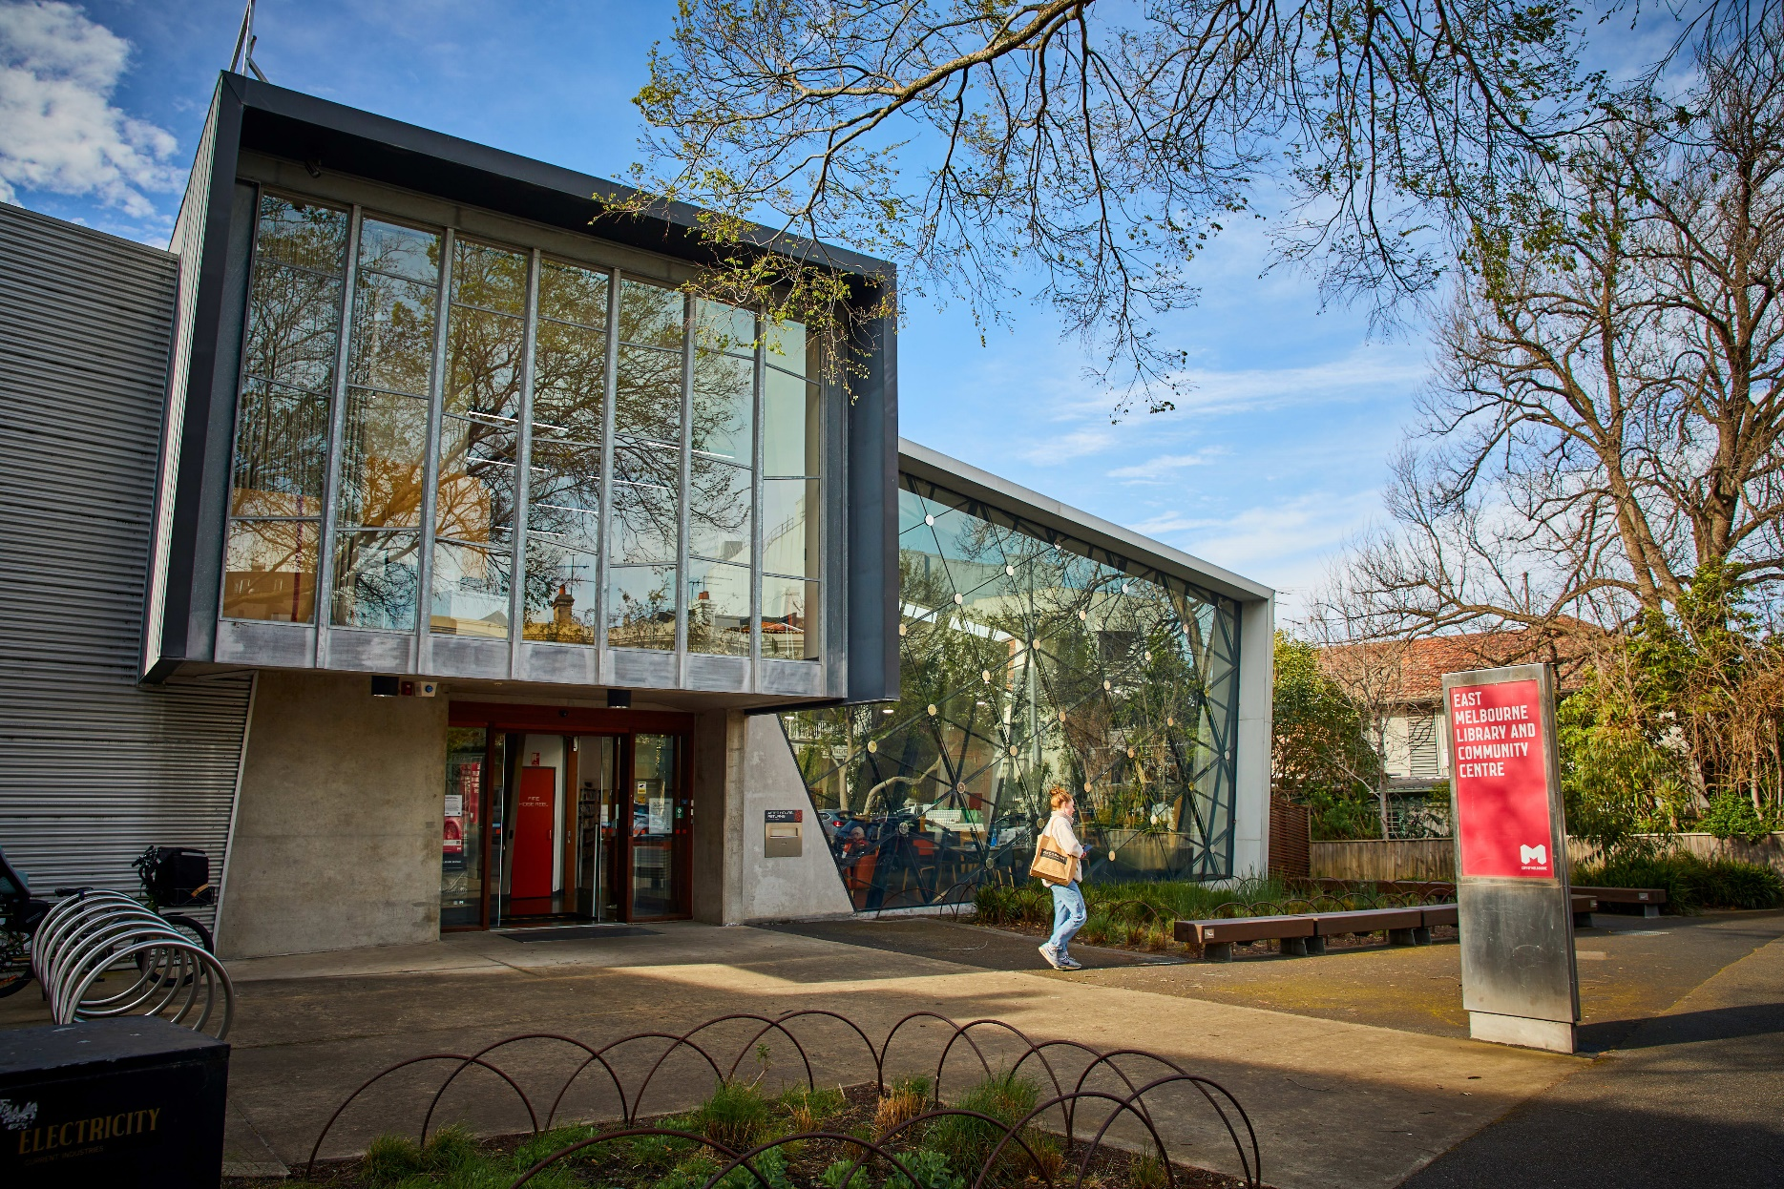
PART B: Meeting community infrastructure needs
Image: East Melbourne Library

Municipal initiatives
Municipal initiatives (Table 11) outline our priorities for the next four years to improve access, equity and quality of community infrastructure for everyone. The initiatives are guided by the six strategic priorities in the Council Plan 2025–29:
- Governing for our future
- Healthy, safe, clean and connected communities
- Building a city for people
- Vibrant and creative Melbourne
- Leveraging our economic strengths
- Living sustainably
Table 11: Municipal initiatives for improving our community infrastructure network
Municipal initiative | Council Plan strategic priority
- We’ll improve how we plan for community infrastructure by using better data, clearer processes, and updated policies to make sure our spaces meet community needs now and into the future. | Healthy, safe, clean and connected communities  Governing for our future
- We’ll make it easier for people to discover and use community spaces by improving signage, naming, and online information. We’ll also explore new ways to use underused spaces and open facilities more often and for longer. | Building a city for people
- We’ll advocate to other levels of government to ensure delivery of community infrastructure and services that are important to our community’s health and wellbeing are delivered. | Healthy, safe, clean and connected communities  Governing for our future
- We’ll partner with the Victorian Government, neighbouring councils, Traditional Owners, institutions and the private sector to share existing spaces and deliver new ones, including a dedicated hub for Aboriginal (or Aboriginal-focused) organisations and activities. | Governing for our future  Vibrant and creative Melbourne
- We’ll review leases and policies, and work with tenants and service providers to open spaces for a wider range of community uses and activities, reduce vacant properties and support continuity of services. | Leveraging our economic strengths
- We’ll improve energy efficiency and transition our buildings to net zero to ensure our community infrastructure is environmentally sustainable. | Living sustainably

Local area planning
This section identifies planned projects and ideas for consideration in future planning to meet community infrastructure needs. The Plan takes a place-based approach, recognising that each local area is unique, with its own character and function, and will experience change in different ways.
As we plan, it’s important to remember that people move between neighbourhoods. Some community infrastructure, like recreation centres, land for organised sports and some open spaces, serve an area wider than the local community. We need to plan for community infrastructure at the neighbourhood level and at the municipal and regional scale, so that everyone in the City of Melbourne can access the spaces that support their health and wellbeing.
How we will pursue future ideas
All ideas for consideration in future planning will be explored to identify those that will have the greatest benefit. We will consider:
- how well the idea aligns with the Community Infrastructure Principles and City of Melbourne strategic objectives
- our role in the opportunity, whether we lead, partner or advocate
- how well the idea responds to community priorities and need, and benefits the greatest number of people
- available funding and budget
- asset management requirements and lifecycle planning
- delivery feasibility and timing.
Future ideas will be subject to review and may be revised to better reflect changing strategic objectives, community priorities, funding opportunities and organisational planning. Future ideas that demonstrate strong strategic fit and alignment with community need will progress through a detailed planning and assessment process to support our long-term financial, resource and asset management.

North-west

Planned projects (next four years)
Project | Our role
- Deliver the new North Melbourne Community Hub on Melrose Street to co-locate existing community services from Jean McKendry Neighbourhood Centre and North Melbourne Community Centre and meet the needs of future populations as identified in precinct planning. | Provide (new)
- Finalise design and delivery of the new 3600 sqm local Chelmsford Street Open Space. | Provide (new)
- Explore redevelopment options for the existing North Melbourne Community Centre and Buncle Street Reserve. This could include upgrading existing facilities to deliver a sports and recreation focused hub, expansion of open space and delivery of additional land for unstructured and organised sports. Any future redevelopment plans should identify suitable sites for relocation and delivery of any uses not proposed as part of the redevelopment. | Plan (upgrade)
- Identify potential interim community uses to temporarily activate land along the rail corridor and Moonee Ponds Creek, working with the Victorian Government and local community. | Partner
- Advocate to the Victorian Government to deliver additional community spaces, an uplift in social housing provision, and no per capita reduction in open space as part of the redevelopment of public housing sites (Kensington, Racecourse Road, Alfred Street). | Advocate
- Advocate to the Victorian Government for provision of a new secondary school. Ensure broader community need is considered and a shared vision established early in planning to support community access and joint use arrangements. | Advocate

Ideas for consideration in future planning
- Responding to current and future demand for early years’ and maternal and child health services in Macaulay, Kensington and Arden, including reviewing existing spaces and timing and delivery of the local community hub identified in the Macaulay Development Contributions Plan.
- Enhancing unstructured recreation through revitalising existing facilities, such as the skate park at JJ Holland Park.
- Maintaining, upgrading and expanding recreation and aquatic spaces, including the Newmarket Reserve precinct and North Melbourne Recreation Centre.
- Increasing and improving open space, as identified in the Open Space Strategy, Macaulay Structure Plan and Arden Structure Plan.
- Exploring the purpose and activation of the Kensington Town Hall precinct, including responding to demand for library, bookable and exhibition space in Kensington.
- Collaborating with neighbouring councils to support shared access to facilities and joint delivery or upgrades of community infrastructure.
- Meeting demand for community infrastructure through the southern portion of the proposed North Melbourne Community Hub site.
- Exploring broader community use of existing spaces, including – but not limited to – the Flemington Racecourse and Showgrounds.
- Coordinating the timing and delivery of community infrastructure identified in the Arden Development Contributions Plan, in collaboration with the Victorian Government.
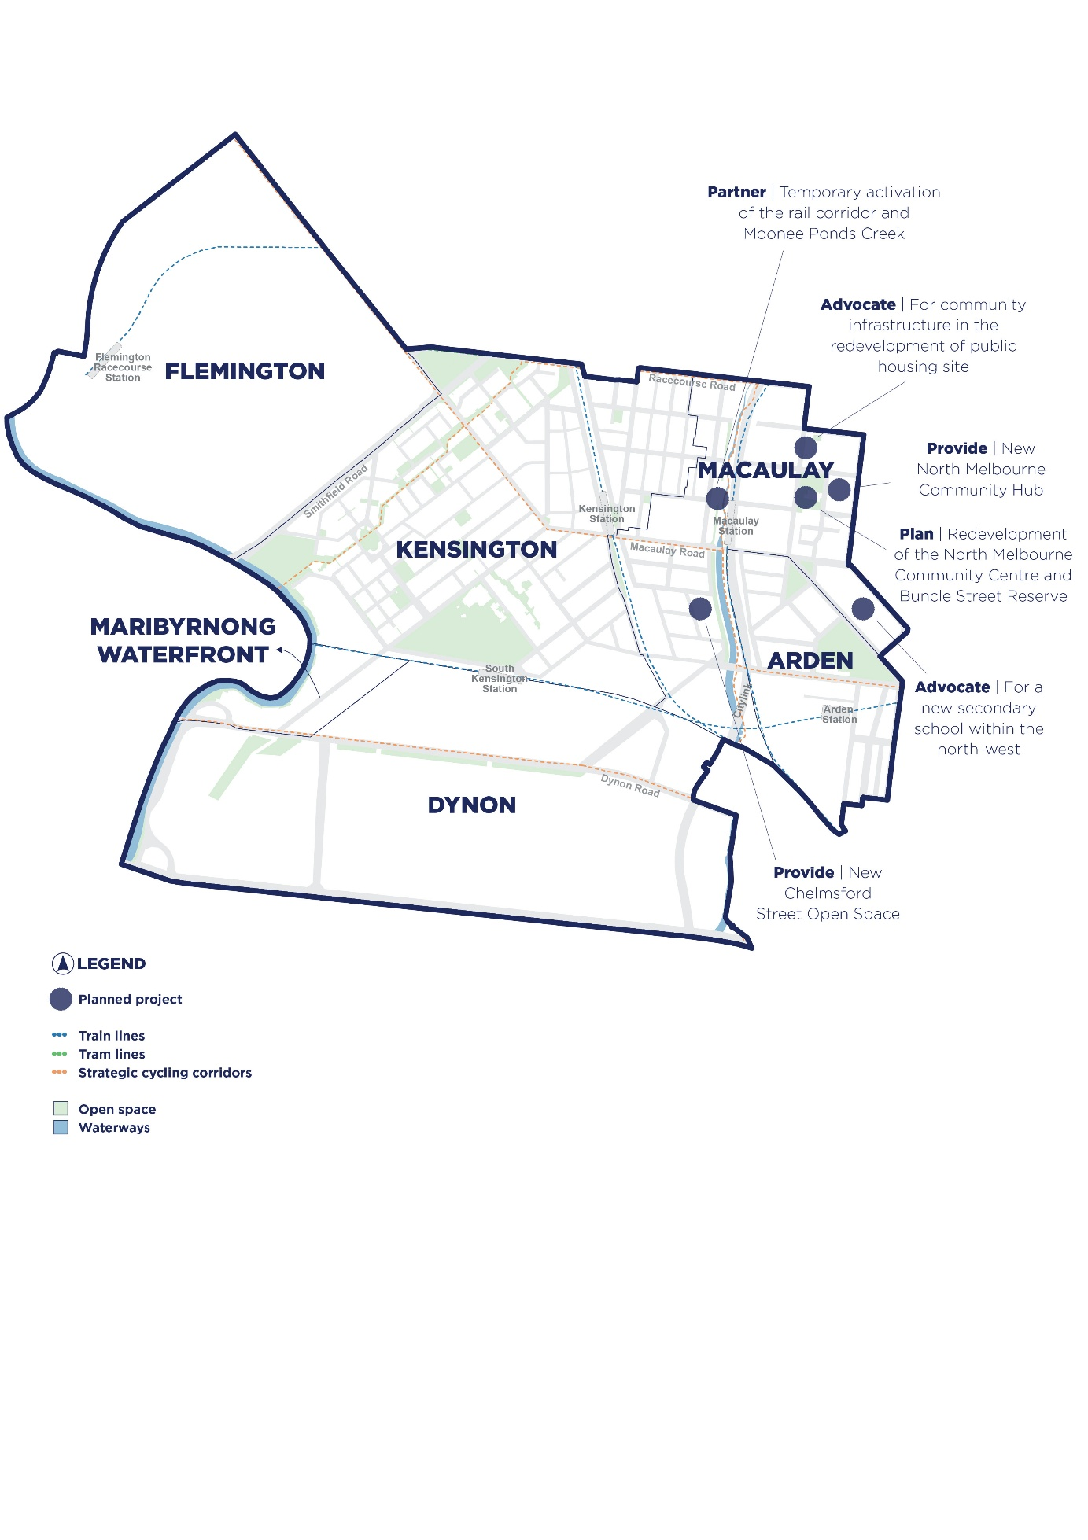
Figure 13: Planned projects in the north-west

North-east

Planned projects (next four years)
Project | Our role
- Finalise the design and delivery of the Chapman Street Reserve upgrade. | Provide (upgrade)
- Finalise the Royal Park Masterplan, to provide direction for its management and development. | Plan (upgrade)
- Implement stage two of the University Square Masterplan incorporating the Parkville Metro Station and new buildings to deliver social spaces and land for unstructured recreation. | Provide (upgrade)
- Implement the Carlton Gardens Masterplan with a focus on meeting broader regional needs within the context of the gardens World Heritage values. | Provide (upgrade)
- Review existing pavilions in Princes and Royal parks and prioritise pavilions to upgrade and expand for greater community access and a diversity of users. | Plan (upgrade)
- Work with universities and other institutions to provide broader community access to existing spaces – particularly for organised and unstructured recreation, learning and bookable space. Develop arrangements that support unstaffed and self-managed bookings and use by the community. | Facilitate
- Prepare an advocacy position for provision of health and wellbeing community infrastructure as part of the Parkville Precinct Redevelopment. | Advocate
- Advocate to the Victorian Government to deliver additional community spaces, an uplift in social housing provision, and no per capita reduction in open space as part of the Lygon Street public housing redevelopment. | Advocate

Ideas for consideration in future planning
- Responding to increasing demand for maternal and child health and family services in Carlton, City North and Parkville and early years education spaces in City North and Parkville.
- Reimagining the purpose and activation of City of Melbourne-owned community facilities in North Melbourne to better meet local needs, improve co-location of services and align with future infrastructure in Arden and Macaulay.
- Supporting future community needs for arts, cultural and bookable community spaces within existing facilities in Carlton.
- Considering the need for a community hub in north-west Parkville to provide access to programs and services, including flexible community, health and wellbeing spaces.
- Increasing and improving open space, as identified in the Open Space Strategy.
- Exploring redevelopment of Carlton Baths in line with asset lifecycle planning, with potential to include flexible community spaces and land for organised and unstructured sport.
- Exploring the need for a community hub in City North to respond to demand for early years, youth and general community spaces including a community kitchen and library.
- Enhancing the function and accessibility of community pavilions to support diverse and inclusive community use.

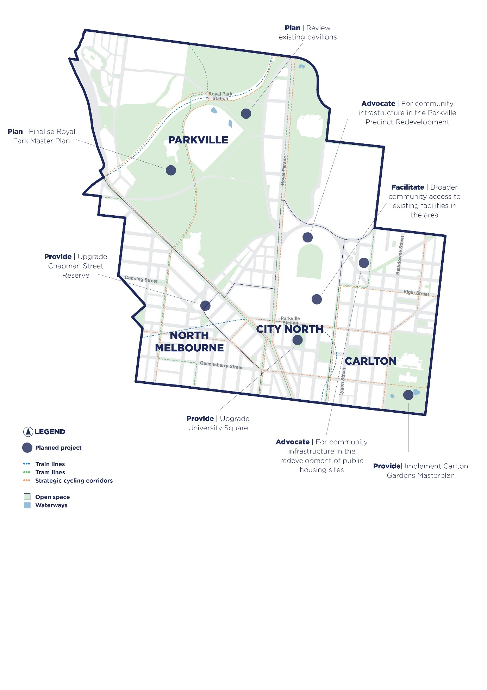
Figure 14: Planned projects in the north-east

South-west

Planned projects (next four years)
Project | Our role
- Plan for upgrades to the Hub@Docklands including new community spaces and improved facilities. Review operating hours and procedures to improve community access and use. Consider long-term opportunities to redevelop the site as a community hub. | Plan (upgrade)
- Complete a master plan for Westgate Park and associated land to provide direction on the management and development of the open space when the City of Melbourne becomes the Committee of Management in 2026. | Plan (upgrade)
- Review Yarra's Edge community spaces to determine an appropriate use, considering partner organisations, to manage and activate the space. | Partner
- Connect cultural and creative organisations to existing and potential development sites, as well as vacant spaces in Docklands and West Melbourne to meet creative needs in the area. | Facilitate
- Advocate for land use outcomes that address community needs and ensure infrastructure identified in endorsed development plans is delivered, including transfer of assets to the City of Melbourne, by working with Victorian Government and private sector in Docklands. | Partner
- Advocate to the Victorian Government for provision of new and/or expanded primary schools in West Melbourne and Docklands. | Advocate
- Advocate to the Victorian Government to expand Ron Barassi Senior Park to improve the diversity and quality of land for organised sports. | Advocate

Ideas for consideration in future planning
- Responding to growing demand for early years, health and wellbeing, and education spaces in Docklands and West Melbourne by reviewing existing facilities to improve operations and expand capacity.
- Exploring partnership and delivery models to meet demand for arts and cultural spaces in Docklands and West Melbourne.
- Supporting access to bookable and flexible community spaces by improving existing spaces and exploring use of non-City of Melbourne-owned spaces in Docklands and West Melbourne.
- Considering the need for additional community hubs to integrate services and address remaining gaps in infrastructure across Docklands and West Melbourne – ideally delivered through a community hub model.
- Enhancing recreation opportunities in the area, including potential upgrades to existing facilities.
- Coordinating the timing and delivery of community infrastructure identified in the Fisherman’s Bend Framework and draft Lorimer Development Contributions Plan, in collaboration with the Victorian Government and City of Port Phillip.
- Increasing and improving open space, as identified in the Open Space Strategy, considering the potential for a municipal open space co-located with recreation and unstructured sports facilities in Fishermans Bend.

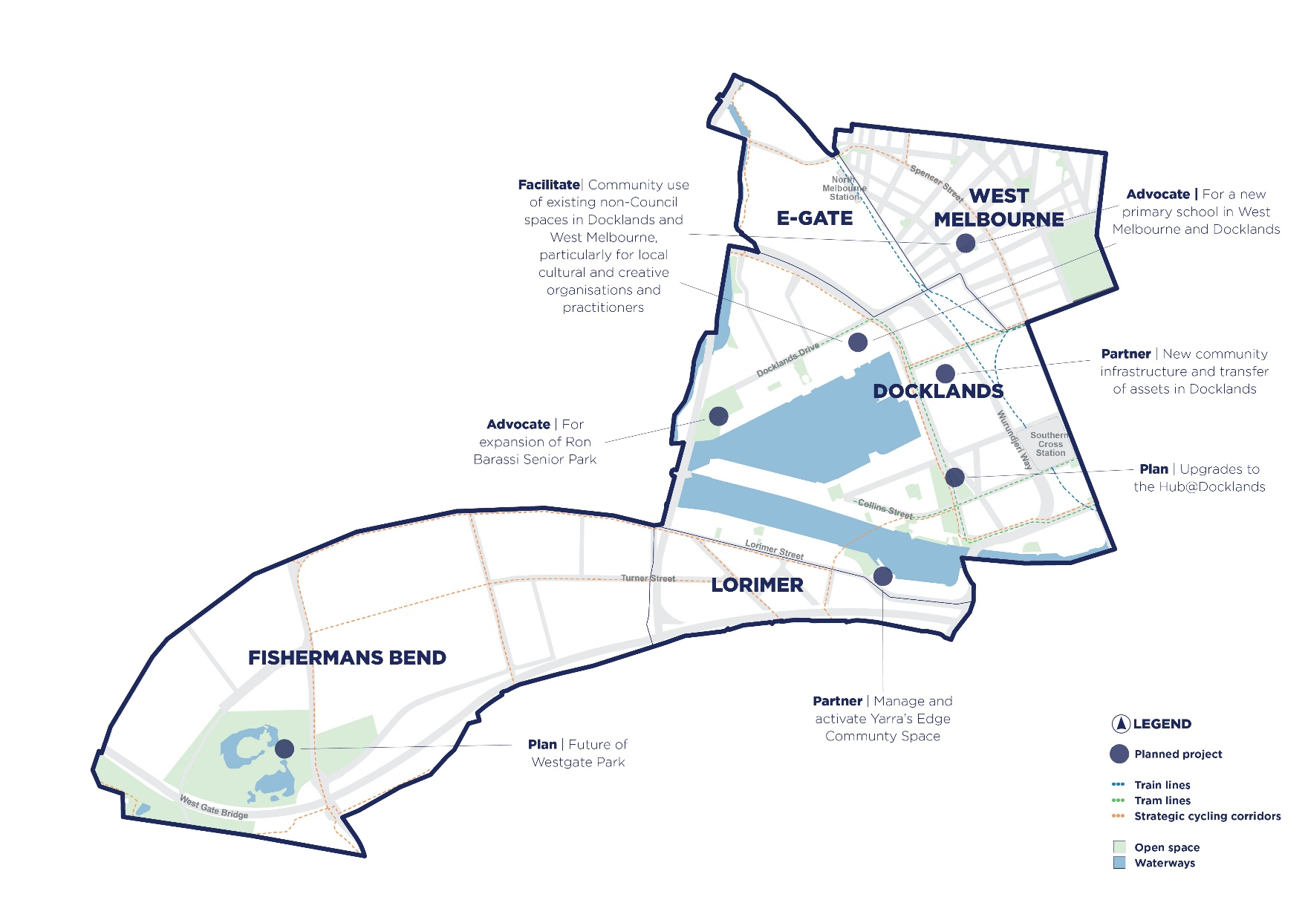
Figure 15: Planned projects in the south-west

South-east

Planned projects (next four years)
Project | Our role
- Deliver the Riverslide Skate Park redevelopment to upgrade facilities and better integrate skate facilities with the surrounding environment. | Provide (upgrade)
- Plan and deliver the Miles and Dodds Street Reserve expansion. | Provide (upgrade)
- Expand and redesign Normanby Road Reserve to provide unstructured recreation facilities and useable open space. | Provide (upgrade)
- Design and deliver an updated and expanded Boyd Community Hub through the fit out of new spaces in the Boyd PDG development. | Plan (new)
- Continue to plan for the Northern Undercroft redevelopment including a skatepark, open space and other recreation and socialising opportunities. | Plan (new)
- Advocate to the Victorian Government for provision of a new secondary school to service the south-east area. Ensure broader community need is considered, and a shared vision established early in planning for the school to support community access and joint use arrangements. | Advocate
- Advocate to the Victorian Government for inclusion of community spaces within Melbourne Arts Precinct. | Advocate
- Seek partnerships and spaces for community access and use in Southbank, including with the Victorian Government, local organisations, private developments and non-government community buildings. | Facilitate

Ideas for consideration in future planning
- Responding to demand for community infrastructure across all categories and types in Southbank, with a short-term focus on early years and flexible community spaces for health and wellbeing and general community use.
- Reviewing the Boyd Library and Community Hub to better meet local and regional needs and provide inclusive spaces for all ages.
- Exploring the potential need for an additional community hub in Southbank.
- Improving access and functionality of existing spaces in East Melbourne to better support flexible community use and early years and family services.
- Reimagining the South Yarra Senior Citizen's Centre as part of a broader review of Fawkner Park, to improve access and diversify users and programs - including early years services – and consider the role of community pavilions.
- Maintaining and expanding arts and culture spaces in Southbank that support community-scale use.
- Exploring the future of the Victoria Barracks and its potential to provide community infrastructure, including open space and unstructured recreation.
- Increasing and improving open space, as identified in the Open Space Strategy.
- Collaborating with neighbouring councils to support shared access to facilities and joint delivery or upgrades of community infrastructure.
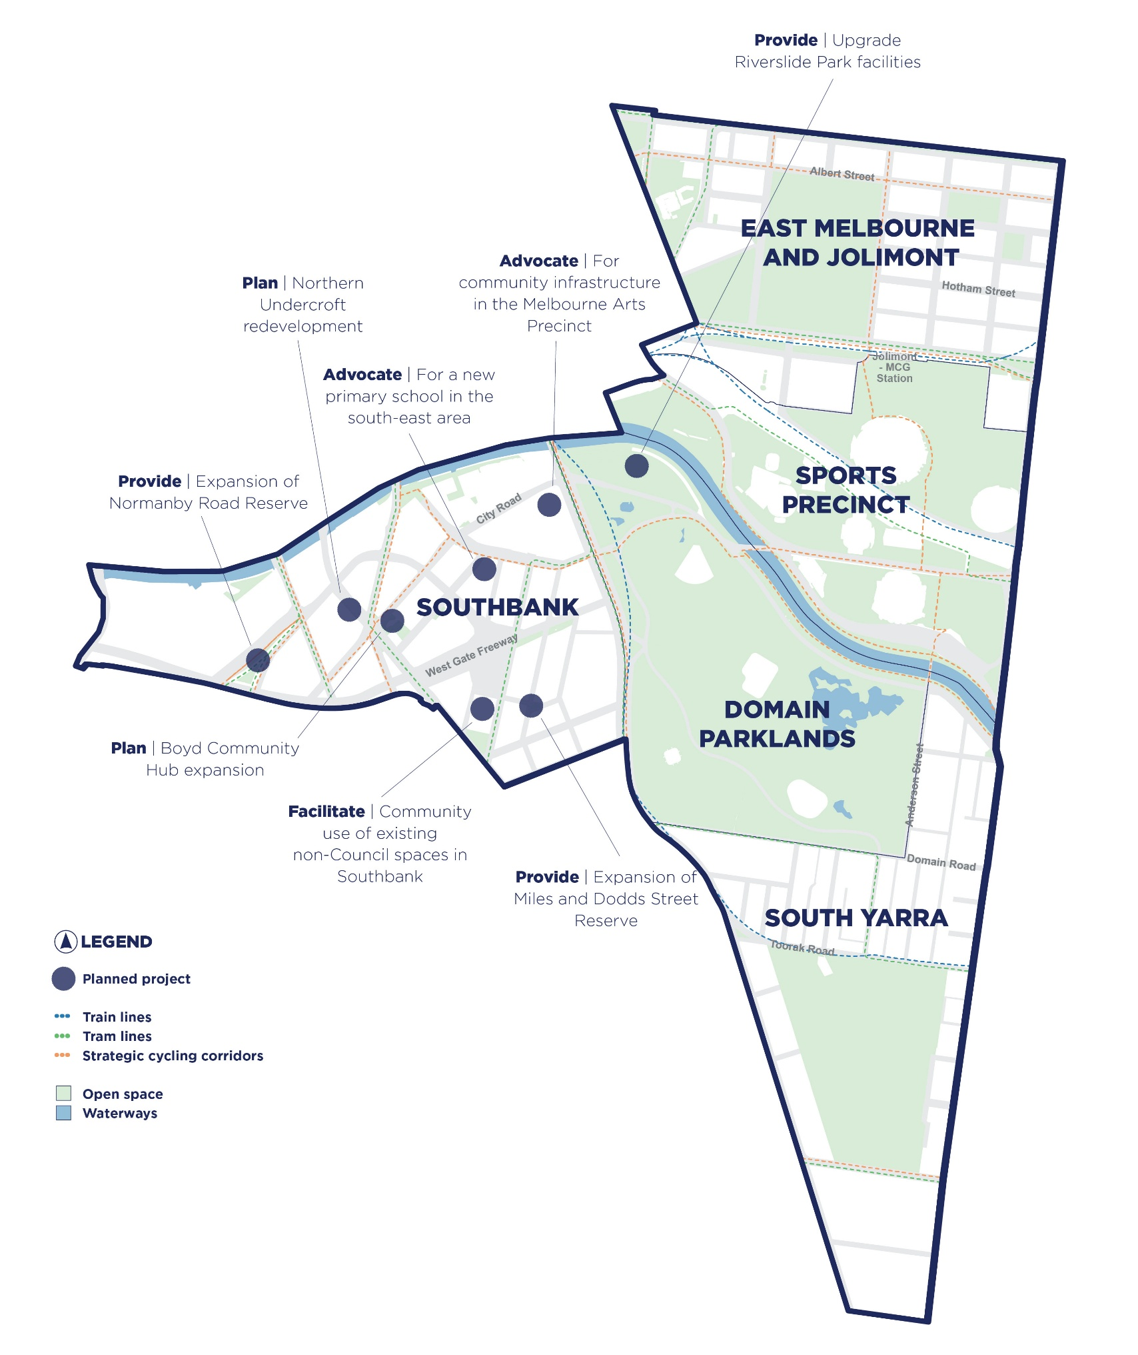
Figure 16: Planned projects in the south-east

Central city

Planned projects (next four years)
Project | Our role
- Review the mix of community infrastructure types and management approach for the Civic Precinct (Council Buildings) and consider how they can be activated and accessed by the community. | Plan (upgrade)
- Design Market Square consistent with the Market Square Charter to provide a range of passive, event and informal open space. Design the Queens Corner Building as a community facility integrated with the broader infrastructure network, including narrm ngarrgu Library and Family Services and the Multicultural Hub. Consider opportunities for arts, culture and flexible programmable or bookable spaces that respond to community needs, as well as the inclusion of new public toilets. | Plan (new)
- Advocate to the Victorian Government for provision of primary schools to service the Hoddle Grid and provision of an early years' hub. Ensure broader community need is considered and a shared vision established early in planning for the school to support community access and joint use arrangements. | Advocate
- Seek partnerships and spaces for community access and use in the Hoddle Grid, including with the Victorian Government, local organisations, private developments and non-government community buildings. | Facilitate

Ideas for consideration in future planning
- Reimagining the role, operations and use of community infrastructure network in the north of the CBD, including Drill Hall and the Multicultural Hub through a precinct plan to better support existing and new services, programs and activities.
- Review opportunities to improve accessibility, convert to electric and provide additional community spaces at Melbourne City Baths and consider potential expansion of the public realm in Franklin Street.
- Exploring the location for a new early years hub – potentially co-located with a school or private development – with maternal and child health and family services, play group and toy library spaces.
- Exploring options to provide space for recreation, organised and unstructured sports as well as a dedicated space for young people and flexible spaces for community gatherings and programs in the CBD through partnerships with major institutions and landowners.
- Investigating community infrastructure opportunities centred along the Birrarung, as identified in future stages of the Greenline program.
- Reviewing potential use of spaces within City Square including more open space.
- Reviewing the management, use and operations of existing City of Melbourne-owned and managed spaces in the CBD to better meet community needs.
- Increasing and improving open space, as identified in the Open Space Strategy.

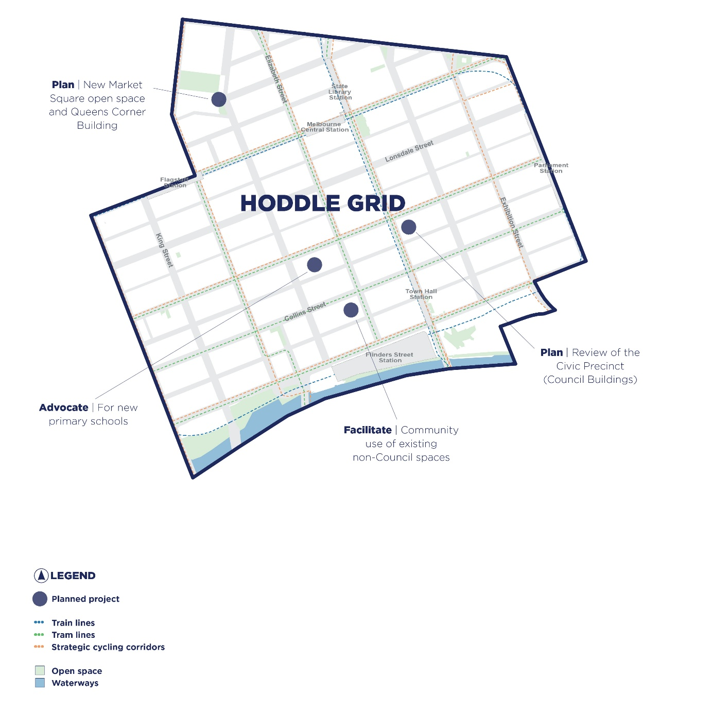
Figure 17: Planned projects in the central city

Appendix A: Policy context
The strategic policy and legislative framework, that has informed the development of the Plan is explained below.
Policies and legislation
The Victorian Local Government Act 2020 requires local governments to provide the best outcomes for the community, while having regard to the long-term cumulative effects of decisions. The overarching policies and legislation considered in developing the Plan include:
- Local Government Act 2020
- Gender Equality Act 2020
- Community Vision 2025–50
- Council Plan 2025–29 (including the Municipal Health and Wellbeing Plan)
- Financial Plan 2025–35
- Asset Plan 2025–29
- Draft Municipal Planning Strategy and draft City Spatial Plan
United Nations Sustainable Development Goals
The United Nations Sustainable Development Goals (SDGs) are 17 globally recognised ambitions to progress sustainable development and track performance, shown in Figure 18.
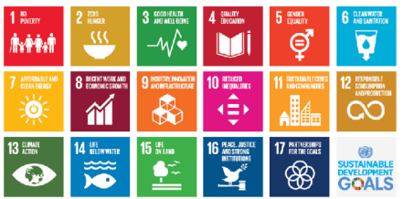
Figure 18: United Nations Sustainable Development Goals

The City of Melbourne is an industry leader, being the first local government in Australia to conduct a SDG Voluntary Local Review on the city’s progress towards the goals. The SDGs are a guiding framework to ensure our initiatives achieve holistic sustainable development, including access to quality community infrastructure.

Strategic plans
Strategic plans that guide community infrastructure planning and delivery are listed below:
- City of Melbourne and Victorian Government, Kindergarten Infrastructure and Services Plan (in draft)
- City Of Melbourne, Affordable Housing Strategy, 2020
- City Of Melbourne, Arts Infrastructure Framework, 2016
- City Of Melbourne, Climate Change Mitigation Strategy to 2050
- City Of Melbourne, Creating Communities Equality Respect, 2021
- City Of Melbourne, Creative Strategy, 2018–28
- City Of Melbourne, Design Excellence Program, 2019–30
- City Of Melbourne, Disability Access Inclusion Plan, 2020
- City Of Melbourne, Economic Development Strategy, 2025–29
- City Of Melbourne, Draft Heritage Strategy, 2024
- City Of Melbourne, Draft Strategic Asset Management Policy, 2025
- City Of Melbourne, Fair Access Sport and Recreation Allocation and Use Policy, 2024–27
- City Of Melbourne, Food City, 2024–34
- City Of Melbourne, Homelessness Strategy, 2024–30
- City Of Melbourne, Inclusive Melbourne Strategy and Action Plan, 2024–26
- City Of Melbourne, Macaulay Structure Plan, 2021
- City Of Melbourne, Open Space Strategy, 2012
- City Of Melbourne, Open Space Strategy Light Touch Review, 2024
- City Of Melbourne, Recreation Facilities Provision Framework, 2024
- City Of Melbourne, Skate Melbourne Plan, 2017–27
- City Of Melbourne, Startup Action Plan, 2017–21
- City Of Melbourne, Stretch Reconciliation Action Plan, 2024–27
- City Of Melbourne, Transport Strategy 2030
- City Of Melbourne, Waste and Resource Recovery Strategy, 2012–32
- City Of Melbourne, West Melbourne Structure Plan, 2018
- Victorian Government, Arden Precinct Structure Plan, 2022
- Victorian Government, Fishermans Bend Framework, 2018

Appendix B: Community engagement findings
The City of Melbourne undertook community engagement between March and September 2025 for the Melbourne 2050 Vision and Council Plan 2025–29. Engagement included the M2050 Summit, Youth Roundtable, First Nations Roundtable, People’s Panel (deliberative engagement), and an online survey.
Nine themes emerged from the first phase of engagement. This section provides a summary of the themes and the opportunities and ideas relevant to community infrastructure that have informed the development of the Plan.

Accessible: with affordable housing, services, food systems, transport and education
Priorities | Opportunities for community infrastructure
Increase access to community facilities | - Evolve how we use community spaces like libraries, childcare centres, and sports facilities, with longer opening hours.  - Introduce Developer Contribution Plans for social contributions and services.  - Deliver cheaper public services.  - Activate/repurpose underused spaces and buildings.  - Gathering spaces that are inclusive, affordable and for all ages.  - Access to study spaces, with extended opening hours.
Prioritise the development of affordable, accessible homes | - Adaptive reuse of buildings for affordable housing.
Improve local food systems and food security | - Integrated food production in all residential dwellings and social infrastructure.

A city that considers ‘people-first’ design, including great transport and walkability
Priorities | Opportunities for community infrastructure
Ensure accessibility and inclusion is embedded in city design | - Deliver and partner for creatively designed dynamic and accessible infrastructure.  - 10-minute walkability.  - Youth-friendly spaces, and city design led by young people.

Connected and intercultural
Priorities | Opportunities for community infrastructure
Well-serviced, integrated and connected neighbourhoods | - Create multipurpose buildings to enable intergenerational uses and services.  - Expand civic education programs.  - Embed inclusivity into all council projects.  - Provide information in multiple languages.

Country-centred: connected to First Nations culture, knowledge and systems
Priorities | Opportunities for community infrastructure
A city that is proudly connected to Country, partnering with Traditional Owners and embedding First Nations culture into the fabric of the city. | - Amplifying Aboriginal visibility through festivals, urban design and public art.  - Multi-purpose, culturally safe community hubs that support health, wellbeing, inter-generational connection and knowledge sharing.  - Gathering spaces for cultural events.  - A future where all children, First Nations and non-First Nations, grow up culturally aware, responsible, and connected.  - Language is everywhere.  - Repurposing vacant buildings into cultural hubs and housing.  - Expanding shared decision-making structures.  - Embedding cultural protocols city-wide.

Exciting and engaging: with arts, entertainment and creativity
Priorities | Opportunities for community infrastructure
Become a globally iconic 24-hour city. | - A 24/7 city – light, bright, activated, with retail, hospitality and community facilities open later at night.
A city with the highest participation in knowledge, creativity and culture in the world. | - ‘Culture Pass’ and access to arts venues and experiences for every child.  - A creative accord prepared by key partners including private and public sectors and the community.

Full of opportunity and choice: fostering business, nurturing new ideas, unlocking creativity, and collaboration
Priorities | Opportunities for community infrastructure
Nurturing a culture of creativity | - Youth startup hubs.

Future-focused: with an emphasis on regeneration principles
Priorities | Opportunities for community infrastructure
Planning for the long-term ensuring resilience and adaptiveness.  Strategically investing public resources for long-term benefit | - All policies prioritise reducing emissions, eliminating waste and regenerating ecosystems.  - All new infrastructure and buildings must generate a positive environmental impact.  - Invest in renewable technology.  - Increase circular economy practices.  - Mitigate and prevent the impacts of climate change.  - We embrace shared commitment and accountability between government, industry and community.  - Country-first decision making.

Green: connections between parks and open spaces, and greenery across buildings and streets, with trees and green walls
Priorities | Opportunities for community infrastructure
Create more connected, accessible green spaces. | - Increase open space creation and acquisition.  - Address spatial inequity in areas with limited green space.  - More green spaces.  - Melbourne is the garden capital.

Health and wellbeing focused
Priorities | Opportunities for community infrastructure
Consider social, physical and environmental dimensions of public health. | - Homelessness support.  - Mental health support (particularly for youth).

Safe and welcoming: with fair leadership, governance and democracy
Priorities | Opportunities for community infrastructure
A unified and connected city that has no boundaries.  Consistent and aligned decisions across local government boundaries.  Cohesion in governance and broader institutions. | - Partner to create an economically just Melbourne with fair opportunities for all.  - Alignment across local government boundaries, government hierarchies and with institutions.
Safety for everyone, at all times of day. | - Implement ‘24-hour by design’ to make Melbourne safe, affordable and accessible.  - Safety in public parks and spaces.

2024 City of Melbourne Health and Wellbeing Report Insights (SGS Economics and Planning) and ABS Census of Population and Housing, 2021. Compiled and presented by .id (housing.id.com.au/melbourne/housing-stress/).

