
Grown–up Guided Walk for Children
PARKVILLE HERITAGE REVIEW
South Parkville
Tour distance: 800 m
Tour time: Approximately 1 hour
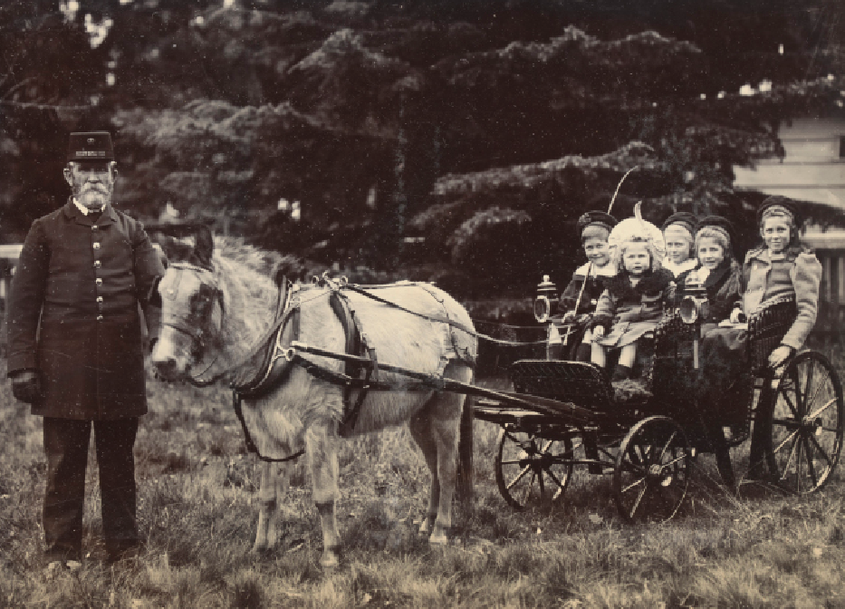
Contents
Acknowledgement of Traditional Owners 3
This Page is for the Grown–Ups! 4
START 5
Corner of Bayles and Fitzgibbon Streets 5
Stop 1 6
Old Parkville Post Office (now a house), 69 Fitzgibbon Street, corner Bayles Street 6
Stop 2 8
Old Royal Park motor garage (now a house), 26 Wimble Street 8
Stop 3 10
Butler Lane, Rear of 46 Morrah Street (second House from Wimble Street) 10
Stop 4 12
Old Shop (Now a cafe), 52 Morrah Street 12
Stop 5 14
House, 44 Morrah Street 14
Stop 6 16
Old Horse Market (now University High Oval), 77 Story Street 16
Stop 7 18
Old Cattle Market (now Bio21), Story Street 18
Stop 8 20
Old Stable (now a house), Behind 34 Gatehouse Street 20
Stop 9 22
Ievers Reserve, 42 Flemington Road 22
Images 24
Front Cover 24
Stop 1 24
Stop 2 24
Stop 3 24
Stop 4 24
Stop 5 25
Stop 6 25
Stop 7 25
Stop 8 25
Stop 9 25
Back Cover 25

Acknowledgement of Traditional Owners
City of Melbourne respectfully acknowledges the Traditional Owners of the land we govern, the Wurundjeri Woi–wurrung and Bunurong / Boon Wurrung peoples of the Kulin and pays respect to their Elders past and present. We acknowledge and honour the unbroken spiritual, cultural and political connection they have maintained to this unique place for more than 2000 generations.
We accept the invitation in the Uluru Statement from the Heart and are committed to walking together to build a better future.

This Page is for the Grown–Ups!
The Parkville Heritage Review is the most comprehensive review of heritage places in the local area since 1979. Reviewing an expansive area centred on Royal Park, City of Melbourne’s independent consultant has identified places of local and state significance.
This walking tour has been designed for adults to bring children to some of the places identified in the Review. It includes an old post office, a coach house, a motor garage, a horse, pig and cattle market and old stables used by a famous artist. The tour ends at Ievers Reserve where there is a playground and toilets.
The recommendations in the Review are being implemented through Planning Scheme Amendment C444, which has been prepared by City of Melbourne.
Find out more and have your say at participate.melbourne.vic.gov.au/parkville-heritage-review.
Unless otherwise stated, text based on the Parkville Heritage Review by GML Heritage, and images by GML or City of Melbourne. Other images used with permission.

START

Corner of Bayles and Fitzgibbon Streets
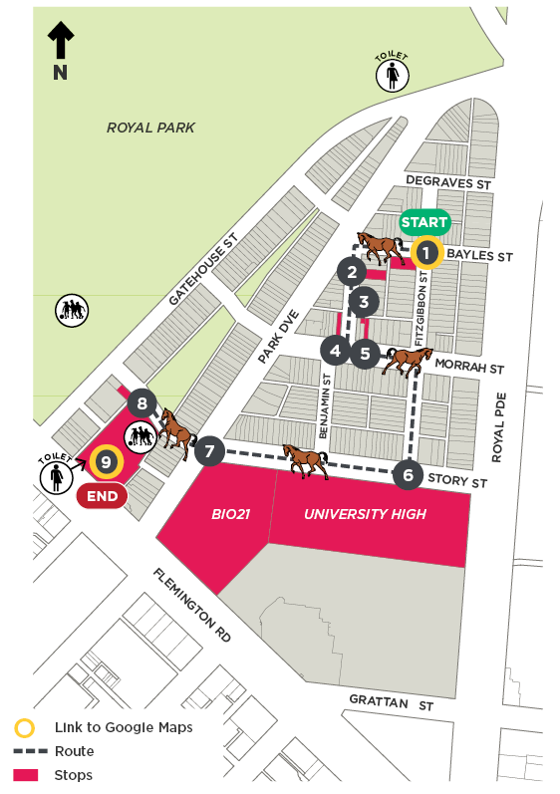

Stop 1

Old Parkville Post Office (now a house), 69 Fitzgibbon Street, corner Bayles Street
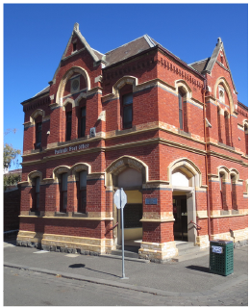
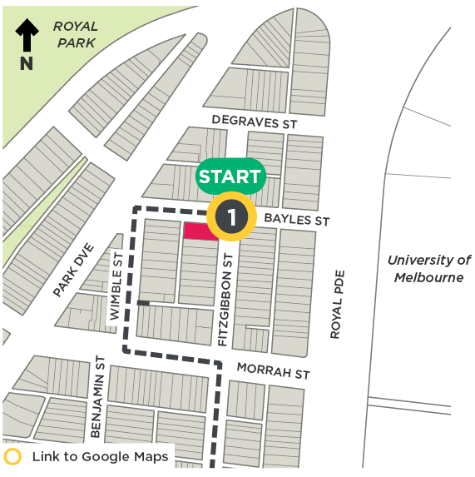
This old post office was built in 1889, which was over 130 years ago. It was probably built when your Great–great–great grandparents were little!
There are stained–glass windows that say ‘Parcel Post’ and ‘Money Orders’. What do those signs mean? Ask your grown–up to explain.
Before social media, emails and even fax machines, people used to write letters to keep in touch with their friends and family. Post offices like this one were once a hive of activity. You can tell this was a busy place from all of the doors on Bayles and Fitzgibbon streets.
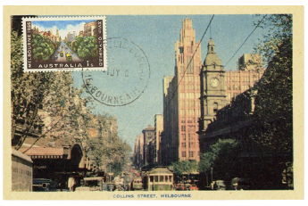
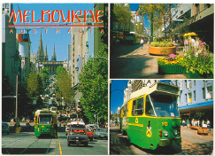
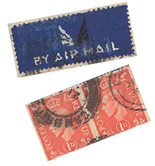
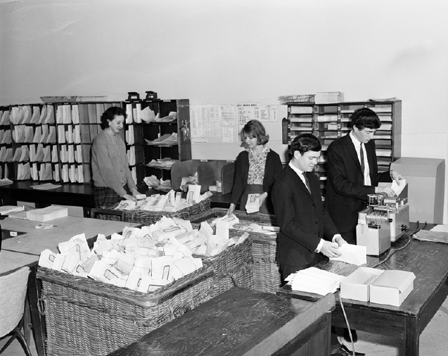
People sorting letters in a mail room

Stop 2

Old Royal Park motor garage (now a house), 26 Wimble Street
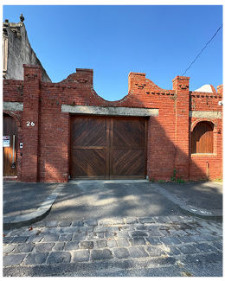
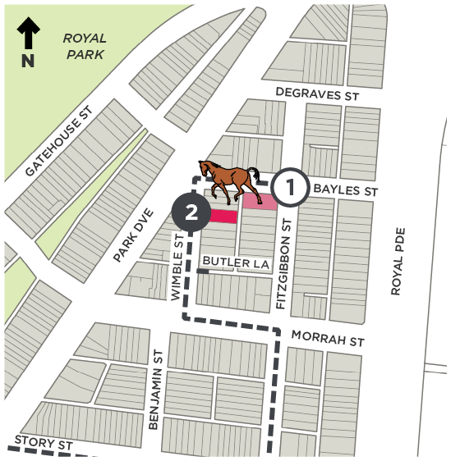
This old brick wall was once part of the Royal Park motor garage, and before that, it is thought to have been a coach house with a large doorway to fit horses and carriages.
Horses and carriages were a common sight in Melbourne until about 100 years ago, when cars and trucks started to appear on our streets. Your great or great–great grandparents may have been the first people in your family to buy a car in the 1920s–1940s.
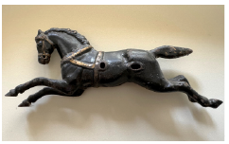
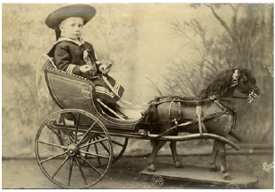
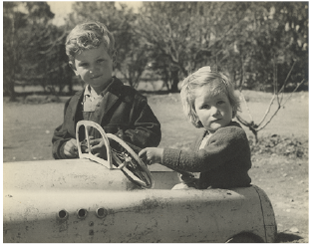
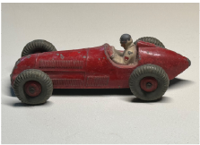
Horses and cars have been popular toys for a long time! Do you have a favourite toy horse or car?

Stop 3

Butler Lane, Rear of 46 Morrah Street (second House from Wimble Street)
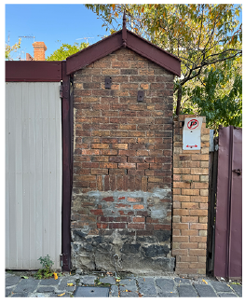
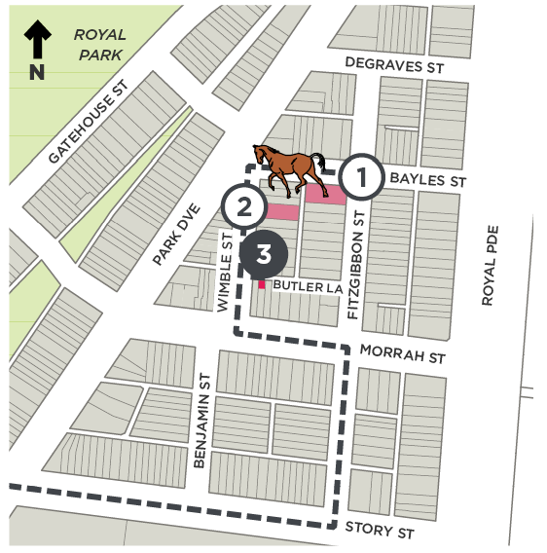
In Butler lane, at the second back yard on your right, you will see an outdoor toilet or ‘dunny’. This wall has the remains of an old hatch door, for the collection of ‘night soil’ (toilet waste) from the toilet by people with a horse and cart. They took it to a compost yard, such as at nearby Royal Park.
Before sewer systems, this is how toilets were emptied and the lanes in Parkville were built for collecting night soil. Thank goodness we now have plumbing!

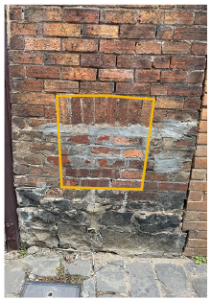
There are many old night soil doors in Jaguers Lane near Bayles Street!
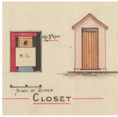
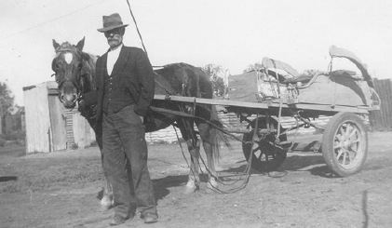
Drawings for a toilet, and a dunny man with his trusty horse and cart

Stop 4

Old Shop (Now a cafe), 52 Morrah Street
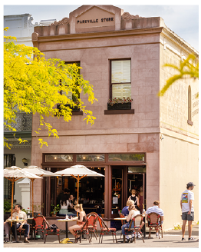
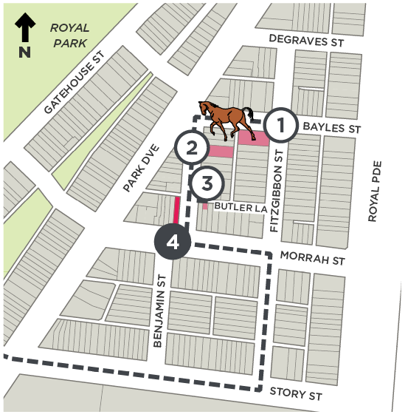
This building dates to 1884. It was originally a corner grocery store and you can see a large ‘ghost’ sign advertising John Bull Oats on the wall in Wimble Street. Can you see any other letters or words?
By the 1980s, this building was a milk bar, still selling groceries along with newspapers and lollies. The grown ups with you may remember buying mixed lollies in paper bags. They can tell you which ones were their favourites!
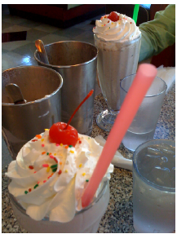
Milkshakes have long been a milkbar favourite
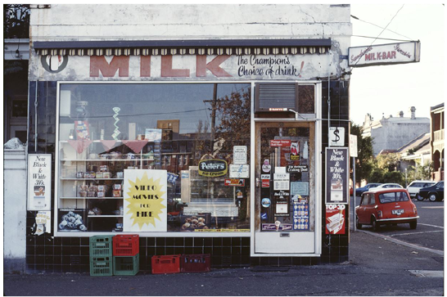
This is the same building in 1983 as a milkbar

Stop 5

House, 44 Morrah Street
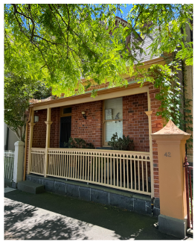
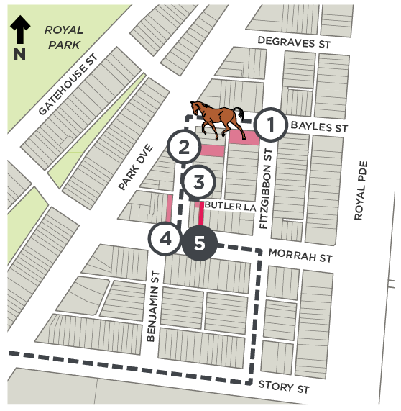
This house was built in 1873, and was one of the first houses in Parkville. It has a very steep roof with a window set into it. This small house may have been home to a family. Because there was little room inside, children would often play in the street or nearby lanes after school. What games do you think they played?
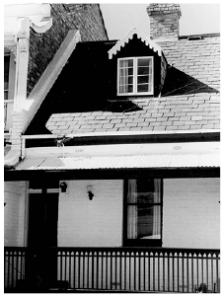
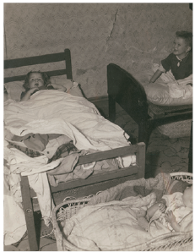
Children often shared a bedroom or even a bed in small houses
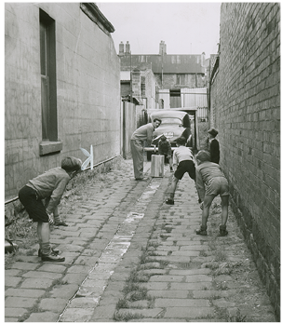
These children were playing cricket in a Melbourne lane, 1950

Stop 6

Old Horse Market (now University High Oval), 77 Story Street
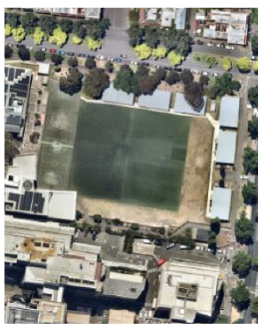
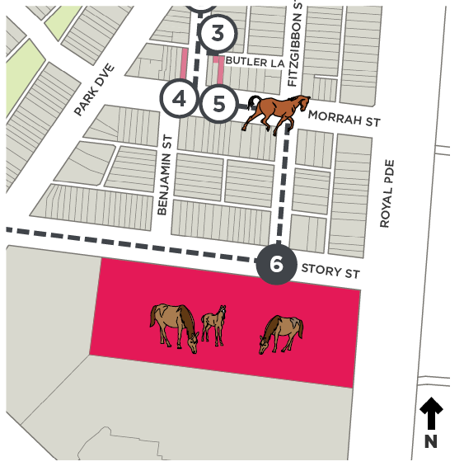
It is hard to imagine that this high school was once the location of a very busy horse market! Here horses would trot around an oval with a building in the centre and would be sold to the highest bidder.
Horses were very important to people at the time this market operated, from about the 1860s to 1910s. Horses were ridden or pulled carts and carriages as transport. They pulled heavy loads like daily milk deliveries and they helped to plough fields for crops.
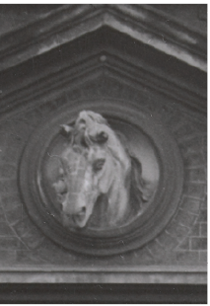
This horse head used to be on the entrance to the horse market
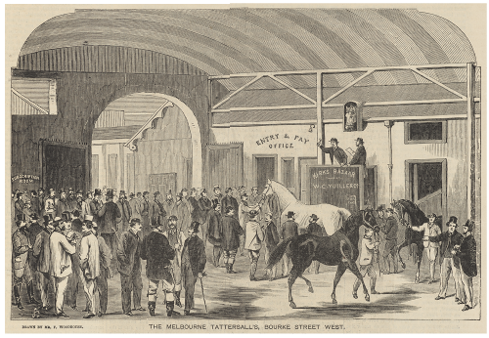
One of Melbourne’s horse markets

Stop 7

Old Cattle Market (now Bio21), Story Street
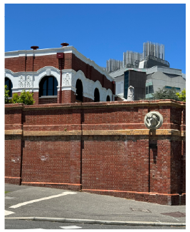
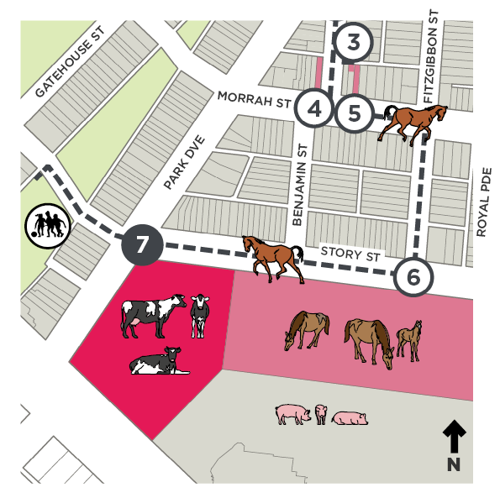
At the last stop you saw where the horse market was. At this stop there was a cattle market where cows were sold, and next door they sold pigs. The brick wall and horse head, built in 1888, are all that remain of the once busy Northern Market.
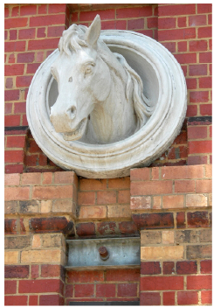
Can you find this horse on the corner?
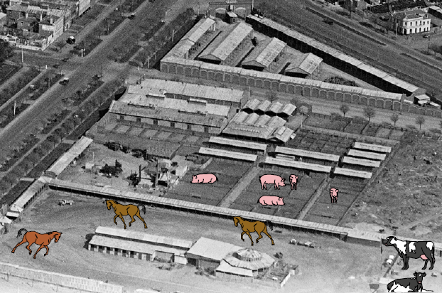
This is an old photo of the markets taken from an aeroplane or hot air balloon. Can you see where the pig pens were?

Stop 8

Old Stable (now a house), Behind 34 Gatehouse Street
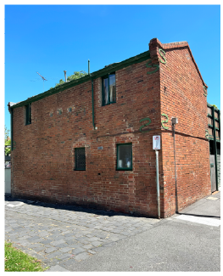
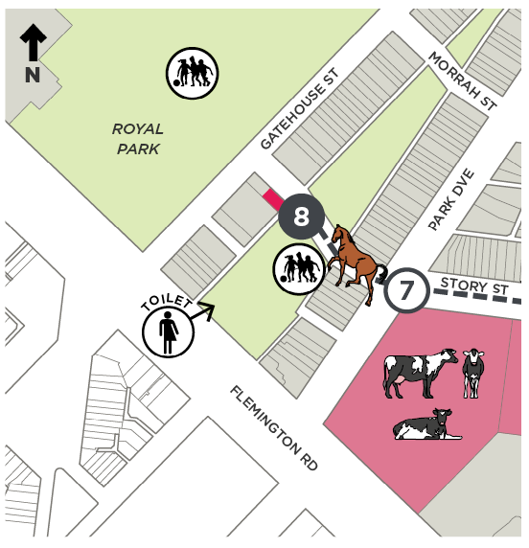
This building is an old stables and once the studio of an artist called Sidney Nolan. Sidney painted here in the 1940s, including local scenes of Parkville and the first of his famous Ned Kelly paintings.
Ned Kelly was a bush ranger in Victoria in the 1870s to 1880s. He wore an armoured bulletproof suit to protect him from the police. You can see his armour at the State Library of Victoria.
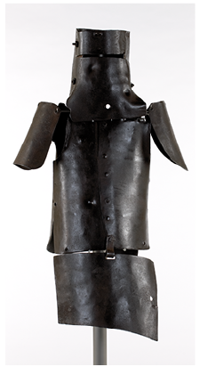
Ned Kelly’s armour
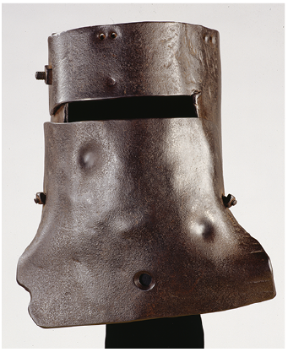
A close–up of Ned Kelly’s helmet

Stop 9

Ievers Reserve, 42 Flemington Road
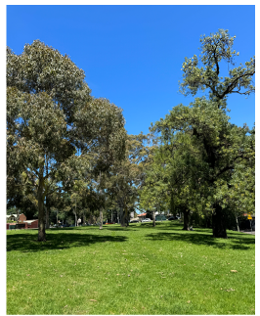
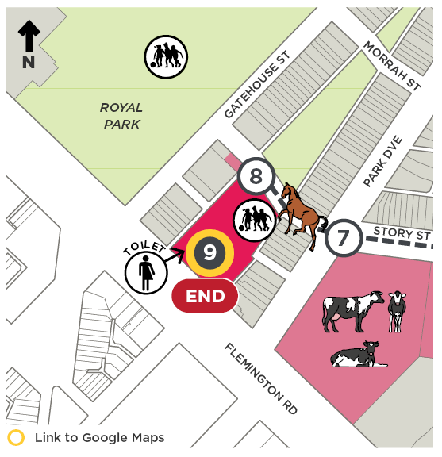
Our last stop is at Ievers Reserve, where there is a playground, a picnic table and toilets.
This reserve used to be a creek running through woodland. There were wattles, eucalypts and she–oak trees.
Kangaroos would have fed on grasses, emus, eastern bettongs, otter–like rakalis, platypus and fat–tailed dunnarts and other animals may have lived here. The air would have been filled with birdsong from kookaburras, magpies, cockatoos and many other types of birds, depending on the time of year. There may have been eels and frogs in the creek. We finish the tour here acknowledging that for tens of thousands of years, this was and still is Wurundjeri Country.
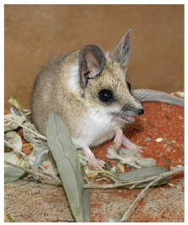
A cute fat–tailed dunnart
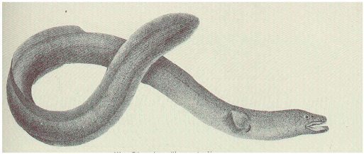
Short finned eels are found in freshwater creeks

Images

Front Cover
Le Souef children with Frank Meaker, March 1900, in or near Melbourne Zoo, Royal Park. Source: State Library of Victoria, Accession No. H91.280/1/89

Stop 1
Melbourne postcard - Rymer collection.
Stamp and Airmail stamp - Stamped envelope addressed to H. J. Cannon (Lofty) from Ronald Searle, 1946. Source: Pictures Library, State Library of Victoria, Accession No. H2003.92/13
Postcard - Melbourne Postcard with a 1956 Olympics Stamp c1956. Source: City of Melbourne Art and Heritage Collection, Record No. 1755477
Image - Mailroom staff sorting letters and using teleprinter, Bourke Street Store No. 200, 1970. Source: Pictures Library, State Library of Victoria, Record No. 9939752434807636

Stop 2
Toy horse - Toy Horse, c1900s; photo by R Rymer, 2024. Source: Rymer collection
Toy racing car - Toy car, c1950s; photo by R Rymer, 2023. Source: Rymer collection
Child in toy horse and cart - Little boy sitting in toy carriage, c1890–1900. Source: Pictures Library, State Library of Victoria, Accession No. H2005.34/54
Children in toy car - Children and toy car, c1950–1959; photo by Hans Bonney. Source: Pictures Library, State Library of Victoria, Record No. 9939664804307636

Stop 3
View in Butler Lane - View of remnant night soil opening, Butler Lane. Source: City of Melbourne, 2023
Drawings of outhouse toilet - Villa residence to be erected for James Allee Esq. Richmond, 48 Berry Street, East Melbourne, 1888; photo by William Pitt. Source: Pictures Collection, State Library of Victoria, Accession No. WD/HOU/46/1
Man and horse - Dunny man Andree Gourlay with his horse and cart in Broken Hill. Source: The Daily Telegraph, 6 November 2014, ‘Australian jobs of yesteryear: The knocker upper, the dunny man and the town husband’, accessed December 2023, dailytelegraph.com.au/news/nsw/australian-jobs-of-yesteryear-theknocker-upper-the-dunny-man-and-the-town-husband/news-story/65aa43d5ece11c89f00e3af4182cdb59

Stop 4
Milkshakes - Milkshakes at Mel’s, 3 July 2010, photo by Lauren Michell Rabaino. Source: Wikipedia, accessed 2 February 2024, en.wikipedia.org/wiki/Milkshake
Milkbar - Exterior view of milkbar in Parkville, Victoria, 1983 or 1984; photo by Christopher van der Craats. Source: Pictures Collection, State Library of Victoria, Accession No. H2019.250/60

Stop 5
Children in bed - Interior, children’s bedroom, c1935; photo by F. Oswald Barnett. Source: Pictures Collection, State Library of Victoria, Accession No. H2001.291/75
Dormer window - 44 Morrah Street, Parkville, December 1974; photo by John Collins. Source: Pictures Collection, State Library of Victoria, Accession No. H98.250/1532
Children playing cricket in the lane - Lane next to the Harvey home where Neil and his brothers learned to play cricket, 1950; photo by The Argus. Source: Pictures Collection, State Library of Victoria, Accession No. H2004.100/1685

Stop 6
Aerial photo - Nearmap, accessed December 2023.
Horse bust on wall - Cropped image of American soldiers standing in the entrance to United States Army Camp at the old Horse Bazaar, Parkville, 1941. Source: Pictures Collection, State Library of Victoria, Accession No. H2000.200/1245
A horse market in Melbourne - Tattersall’s Horse Bazaar, Bourke Street West, August 1863; photo by Samuel Calvert. Source: Pictures Collection, State Library of Victoria, Accession No. IMP22/08/63/5

Stop 7
Horse bust on wall - Photo of the horse bust on the remnant Northern Market Wall. Source: GML Heritage, 2022
Historic aerial photo - Looking from Melbourne University over the city to Albert Park and St. Kilda, c1920s–30s; photo by Charles Pratt. Source: Pictures Collection, State Library of Victoria, Accession No. H91.160/519

Stop 8
Ned Kelly’s armour and helmet - Suit of armour worn by Ned Kelly in 1880. Source: Pictures Collection, State Library of Victoria, Accession No. H20171

Stop 9
Fat–tailed dunnart - The fat–tailed dunnart (Sminthopsis crassicaudata) is a species of mouse–like marsupial. Source: Wikipedia, accessed December 2023, en.wikipedia.org/wiki/Fat–tailed_dunnart
The short–finned eel - The short–finned eel (Anguilla australis). Source: Wikipedia, accessed December 2023, en.wikipedia.org/wiki/Short-finned_eel

Back Cover
We hope you enjoyed the Parkville children’s walk, which was prepared as part of the Parkville Heritage Review.
The Parkville Heritage Review recommends heritage protection for a range of places, some of which you have visited today.
Visit participate.melbourne.vic.gov.au/parkville-heritage-review by 31st October 2025 to find out more and have your say.

