21.13 URBAN RENEWAL AREAS
05/10/2018
GC81
21.13-1 Southbank
Proposed Amendment C323
Housing
- Support medium scale residential development in the Residential Zones of Southbank Village.
Economic Development
- Support Southbank’s development as an extension of the Central City, providing a mix of commercial and residential land uses.
- Support a mix of uses, including residential development, with ground floor retail and small-scale business uses.
- Deliver a good provision of local services and facilities for workers and visitors and within easy walking distance from all residences.
- Support the ongoing operation and establishment of businesses that provide professional and business support services to the Capital City Zone in the Mixed Use Zones of Southbank.
Built Environment and Heritage
- Connect and integrate Southbank with the Central City and the Yarra River.
- Position Southbank as the natural extension of the city establishing the Yarra River at the City’s centre, not its edge. Provide easy and attractive access to and across the river from the central and southern parts of Southbank.
- Maintain low rise development on the northern and southern sides of the Yarra River and Arts Precinct to maintain the low scale river edge to protect key views to the Arts Centre Spire and prevent overshadowing of the south bank of the River.
- Encourage high rise tower development to the north of City Link and west of Moore Street.
- Encourage medium scale development in the Arts Precinct and the areas to the east of Moore Street and to the south of City Link.
- Encourage medium scale development in the Southbank Village.
- Support the physical integration and connection of the Victorian College of the Arts to the surrounding area to enhance its connection with other uses in the precinct.
- Ensure development contributes to the legibility of Melbourne Arts Precinct as an Arts Precinct.
- Encourage the provisions of floor space for arts, cultural and creative industries in the lower levels of buildings located within the Melbourne Arts Precinct.
- Ensure that buildings along St Kilda Road and in Sturt Street maintain the visual dominance of the Arts Centre Spire.
- Maintain the landscape character of St Kilda Road.
- Ensure that development maintains views to the Shrine of Remembrance as an important landmark.
- Ensure that the scale and design of buildings south of Coventry Street preserve the setting and significance of the Shrine of Remembrance as a historic and cultural landmark and place of reverence.
- Promote high rise, high density development, south of the Crown Casino and the Melbourne Exhibition Centre.
- Ensure all new development creates a high quality pedestrian environment and positively enhances the area’s public realm.
- Encourage a mix of public and commercial uses at ground level in new developments to support street life and provide pedestrian interest.
Transport
- Improve the public environment of Southbank by providing public spaces, improving pedestrian facilities and upgrading streetscapes.
- Improve streetscapes as a priority along major pedestrian routes.
- Strengthen pedestrian and cycle connections between Southbank and the Hoddle Grid and South Melbourne.
- Encourage a continuous network of through block links to increase permeability, amenity and safety and to improve access to the Yarra River and Arts Precinct.
- Give greater priority to pedestrian, cyclist and public transport amenity and access ahead of private motor vehicle use.
- Create a connected and permeable neighbourhood.
Infrastructure
- Encourage provision of open space and links between the Port Melbourne foreshore and the Hoddle Grid.
- Support arts and education uses and facilities at Southbank.
- Support arts, entertainment, cultural, educational attractions in Southbank, especially in the Arts Precinct.
Figure 7: Southbank
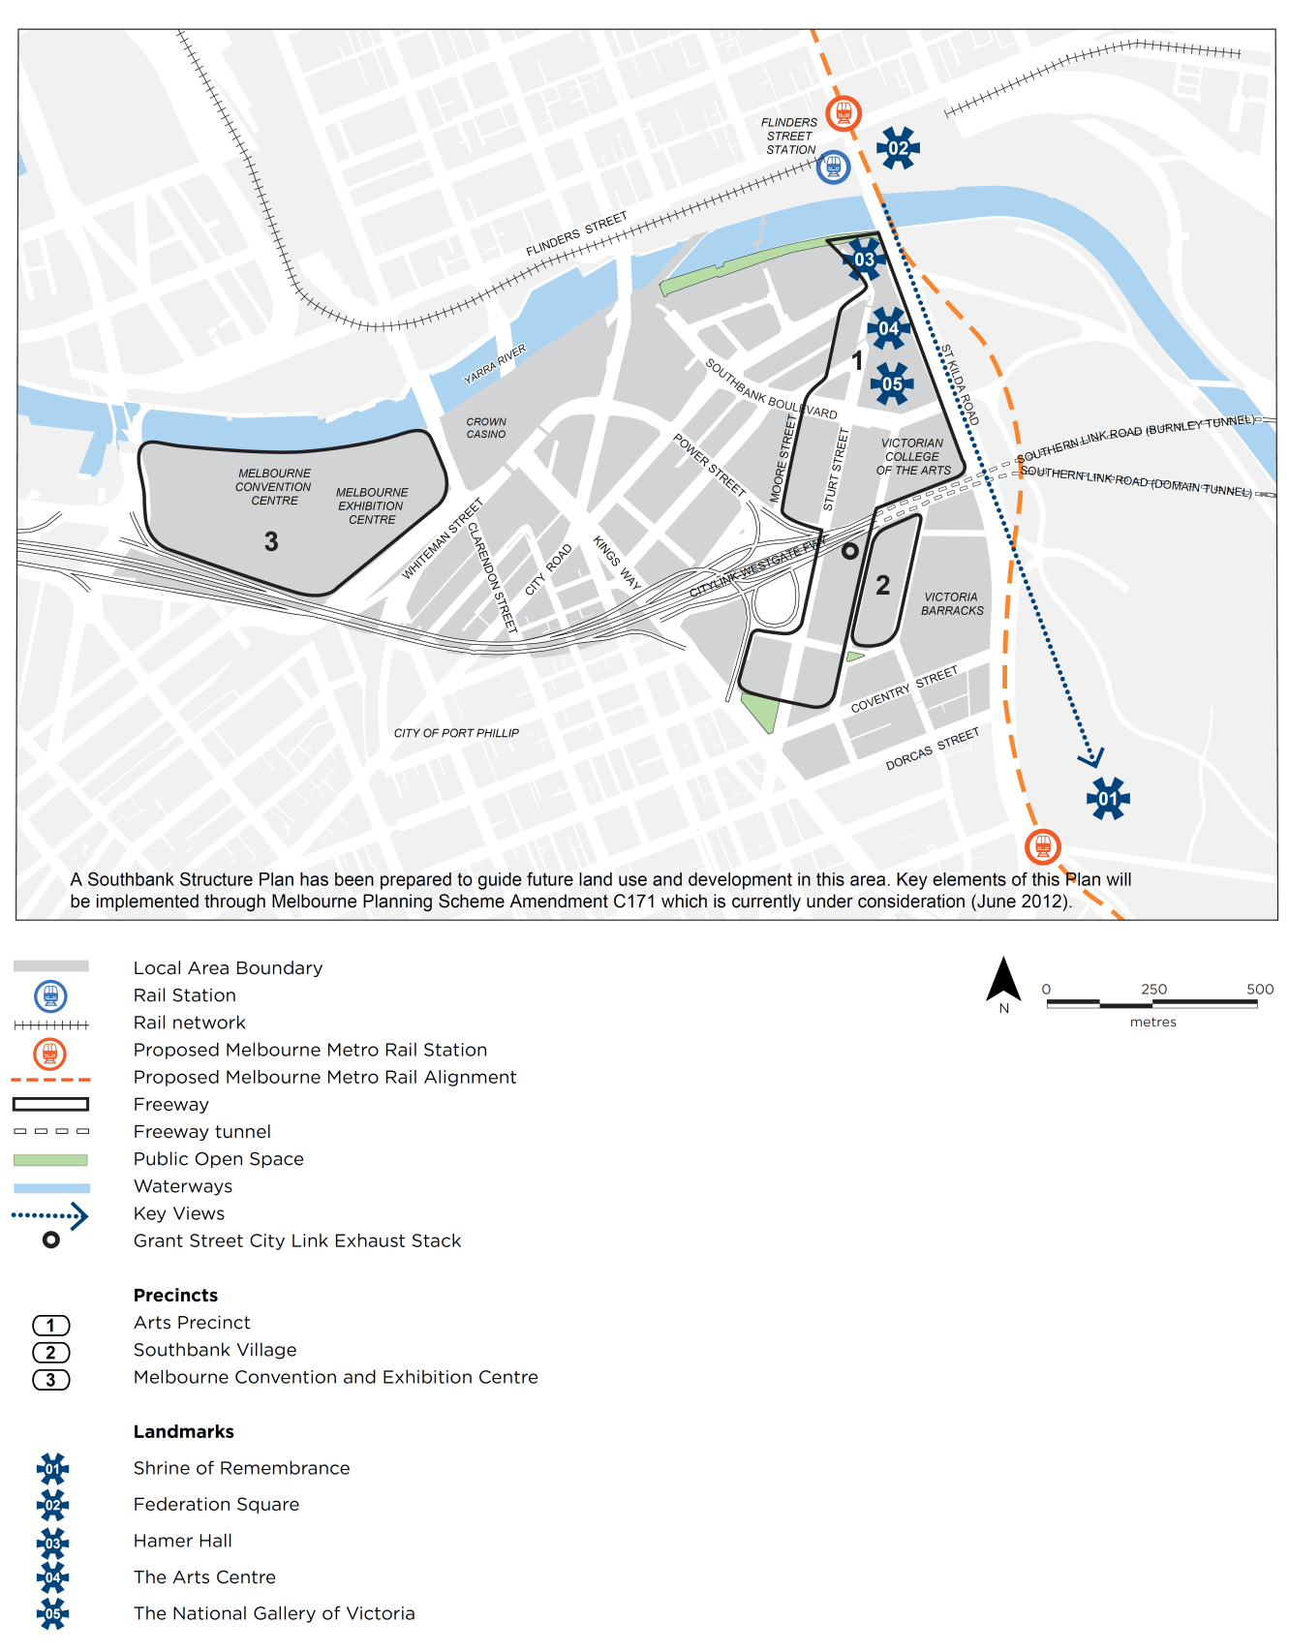
21.13-2 Docklands
12/09/2013
C162
Housing
- Support residential development in Docklands that complements its other functions.
- Encourage medium to high residential density.
Economic Development
- Support mixed use development including office and commercial development in the Digital Harbour, Stadium, New Quay, Victoria Harbour, Yarra’s Edge and Batman’s Hill Precincts.
- Encourage active uses in the areas fronting the waterfront to promote maximum usage and activity at the waterfront.
- Support Victoria Harbour waterfront and Waterfront City as the primary retail precinct for Docklands that complements retailing in the Hoddle Grid.
- Limit the impact of marina development on public access to the waterfront.
- Encourage local industries and uses such as recreational boating, marinas, fish markets, and port services, particularly where access to the waterfront is available.
- Encourage the establishment of leading edge industries through the development and promotion of Digital Harbour and the installation of high technology infrastructure.
- Encourage the installation of high technology infrastructure throughout Docklands.
- Support the consolidation of education and research clusters in Docklands, including the Digital Harbour Precinct and TAFE facilities.
Built Environment and Heritage
- Ensure Docklands is physically and visually linked with the west end of the Hoddle Grid.
- Ensure that buildings provide weather protection and an attractive built form to promote an attractive, vibrant, safe and comfortable street environment.
- Encourage a development pattern that acknowledges Melbourne’s traditional hierarchy of streets, lanes and arcades. The development pattern should be permeable and fine-grained to create a clear pattern of access and movement.
- Ensure that the design of buildings encourages sustainable outcomes.
- Encourage the reuse of heritage buildings.
- Encourage interim land uses, reuse of existing buildings, infrastructure and landscaping which presents an attractive physical environment during the development phase.
- Ensure building heights and setbacks along the waterfront in Docklands allow for optimum climatic conditions on the promenades.
- Encourage a built form profile in the Docklands that forms an extension of the Hoddle Grid building profile.
- Maintain and reinforce views to the water from the Hoddle Grid where possible, particularly along the Collins, Bourke and Latrobe Street corridors.
- Ensure buildings on landmark sites which terminate views or vistas or mark key local focal points are designed to the highest quality.
- Ensure development in Docklands extends and reinforces Council’s public environment initiatives and practices.
- Ensure safe, wide and attractive public promenades are provided along the Docklands waterfront as an integrated part of the development of each precinct.
- Ensure continuous pedestrian and cycle promenades along the waterfront in Docklands.
- Ensure marina development in Docklands allows for public access to the water and the waterfront.
- Strengthen Harbour Esplanade as a civic spine for the Docklands.
- Ensure that new streets and open spaces provide physical and visual linkages to the waterfront.
Transport
- Support pedestrian connections to the Southern Cross Major Transport Hub.
- Strengthen pedestrian connections between Docklands and Port Melbourne and West Melbourne.
- Strengthen pedestrian and cycle connectivity between the Hoddle Grid and Docklands.
- Require the development of Docklands to incorporate a high level and quality of pedestrian and bicycle access.
- Support a wide variety of transport modes to and in Docklands, including public transport, vehicular, pedestrian, cycle and water based transport.
- Support an integrated public transport system in Docklands with a high degree of connectivity between tram, rail and bus services.
- Support the extension of light rail services to Docklands.
- Ensure new developments make provision for on-street car parking and bus and taxi parking adjacent to key public spaces and land uses.
- Encourage the co-location and sharing of car parking facilities where appropriate.
- Develop Footscray Road as a western boulevard entry to the City, through the use of strong urban and landscape design elements.
- Ensure the design of roads in Docklands encourages through-traffic to be diverted away from the harbour waterfront.
- Ensure that the provision of car parking for use and development is consistent with the efficient operation of the Melbourne Docklands area road network and approach roads, and with environmental considerations.
Infrastructure
- Support the development of continual open space links along the Docklands waterfront, Yarra River and Moonee Ponds Creek that provide for recreational and ecological purposes.
- Support the provision of an integrated network of parks and open spaces in Docklands.
- Support the development of Victoria Harbour, Harbour Esplanade and Docklands Park as the recreational focus for the Docklands.
- Ensure adequate and appropriate space is set aside in Docklands for community facilities and that these facilities can be extended and upgraded when required.
Figure 8: Docklands
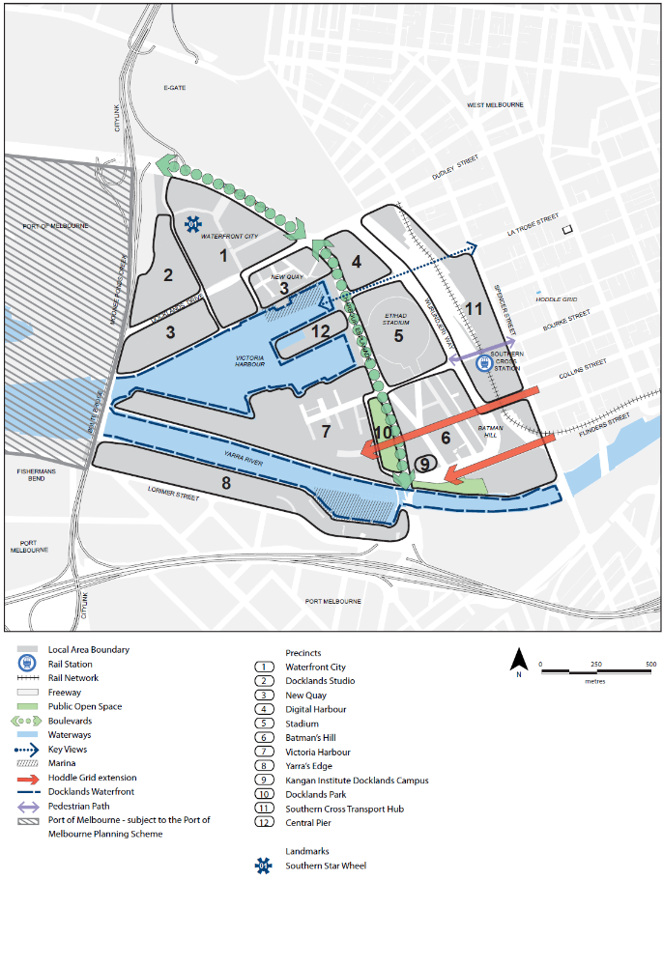
21.13-3 Fishermans Bend Urban Renewal Area
05/10/2018
GC81
Fishermans Bend is a declared project of State significance and is a priority urban renewal area. It is an unparalleled renewal opportunity within Melbourne. It will provide for 80,000 jobs (40,000 within the four mixed use precincts and 40,000 in the Employment Precinct) and a range of well serviced, high density housing options for 80,000 people. The Lorimer precinct is planned to accommodate approximately 12,000 residents and 6,000 jobs.
The Lorimer precinct will provide a mix of residential, retail, commercial, entertainment and employment land uses that complement the functions and built form of the Central City and Docklands. The Lorimer precinct will provide both employment and housing, implementing the sustainable transport objectives of the Fishermans Bend Framework, September 2018 through decreased travel times for residents (refer to figure 9).
The urban renewal of Fishermans Bend is driven by the fundamental principles of economic prosperity, social equity and environmental quality that takes advantage of its close proximity to existing employment, residential and transport links in the Central City/ Southbank/ Docklands areas. Design excellence and environmental sustainability are fundamental to delivering a high quality, high amenity urban environment and realising the vision for a highly liveable urban renewal area.
Development within the Fishermans Bend Urban Renewal Area should seek to achieve an affordable housing target of 6%.
The Lorimer precinct has a distinct role in delivering the Vision for Fishermans Bend. It will have its own distinct character and identity. Figure 10 identifies each of the sub-precincts within Lorimer.
Vision and Strategic Framework Plan
The Fishermans Bend Vision (September 2016) and the Fishermans Bend Framework, September 2018 set out 10 strategic directions and 8 sustainability goals, each of which are to be delivered in the Lorimer precinct.
Housing
- Ensure new residential areas provide for a connected and liveable community and are inclusive and healthy places to live.
- Encourage a vibrant, mixed use precinct close to the Yarra River and connected to Melbourne’s Central City, Docklands and other emerging urban renewal areas.
- Encourage a high density mixed use precinct centred around the Lorimer Parkway, an important recreational and biodiversity green link, promoting a healthy and connected community for people of all ages and backgrounds.
Economic Development
- Ensure Lorimer has excellent access to employment and public transport, being located on the doorstep of the Central City, Docklands and adjacent to the Fishermans Bend Employment Precinct (NEIC), connected by the northern Tram Route.
- Encourage development to deliver opportunities for economic development through a focus on the attraction and retention of key workers, and investment and growth in the knowledge, creative, design, research, education, innovation, engineering, advanced manufacturing and service sectors.
- Encourage mixed use outcomesto create a significant employment opportunities, complementing existing industries in the Employment Precinct (NEIC), and build on strengths in aeronautical and automotive engineering and defence.
- Ensure that new development manages and mitigates potential adverse amenity impacts from existing industry and warehouse uses, or from ongoing port operations.
Built Environment and Heritage
- Encourage a visual and physical connectivity to the Yarra River through a series of new north-south laneways that will stitch the precinct across Lorimer Street through to the Yarra River.
- Encourage a diversity of building typology with exterior finishes, materials and architectural detailing of demonstrably high quality to form an attractive backdrop to the West Gate Freeway and to provide a buffer between the freeway and the remainder of the precinct.
- Encourage perimeter and open block developments with small block sizes divided by laneways, multiple ground floor tenancies and multiple building entries and public access points.
- Ensure heights are reduced in key locations to protect existing and proposed open spaces from being overshadowed.
- Encourage active and fine-grain street frontages including retail uses to activate ground level interfaces with open spaces. Large and smaller format commercial uses are also encouraged within podium or lower levels of development.
- Ensure towers are well spaced to provide for outlook and view through to the river.
- Ensure buildings are designed to protect the amenity of streets and laneways.
- Encourage higher street walls along the freeway interface, providing a buffer from freeway traffic.
Transport
- Support the creation of the northern tram route along Turner Street and Lorimer Street providing direct, high frequency public transport connection to Docklands and the Central City.
- Support the creation of new or upgraded bridges over the Freeway at Ingles Street and Graham Street to provide public transport, bike and pedestrian access to Sandridge.
- Support the continued access to existing industrial uses, including concrete batching plants, during the transition from an industrial precinct to a high density mixed use precinct.
Infrastructure
- Support the creation of the Lorimer Central Open Space located in the heart of the precinct, between Ingles and Boundary Streets.
- Support Turner Street closure and widening to create Lorimer Parkway along the tram route, creating a green link to the new Lorimer West Open Space, and additional green link connecting to new open space at intersection of Hartley and Lorimer Streets.
- Support a network of new streets and laneways to transform the existing industrial scale blocks into a walkable neighbourhood.
- Encourage new facilities to be delivered as part of mixed use development, located in close proximity to the Lorimer Central Open Space or Hartley Street Open Space and northern tram route.
- Support a pop-up community hub created on land adjacent to the Bolte Bridge, evolving into a Health and Well-Being Hub.
- Support an Education and Community Hub (primary) located in the north-eastern part of the precinct and an Art and Cultural Hub located in the south eastern part of the precinct.
- Encourage a Sports and Recreation Hub (or part of cluster) to be delivered as part of mixed use development, located within the ‘investigation area’ at the western part of the precinct.
Flooding, Sea Level Rise and Water Sensitive Design
- Ensure the individual and combined impacts of sea level rise and flooding from storm events is appropriately managed through a combination of precinct wide and property specific physical and management measures.
Figure 9: Fishermans Bend Urban Renewal Area
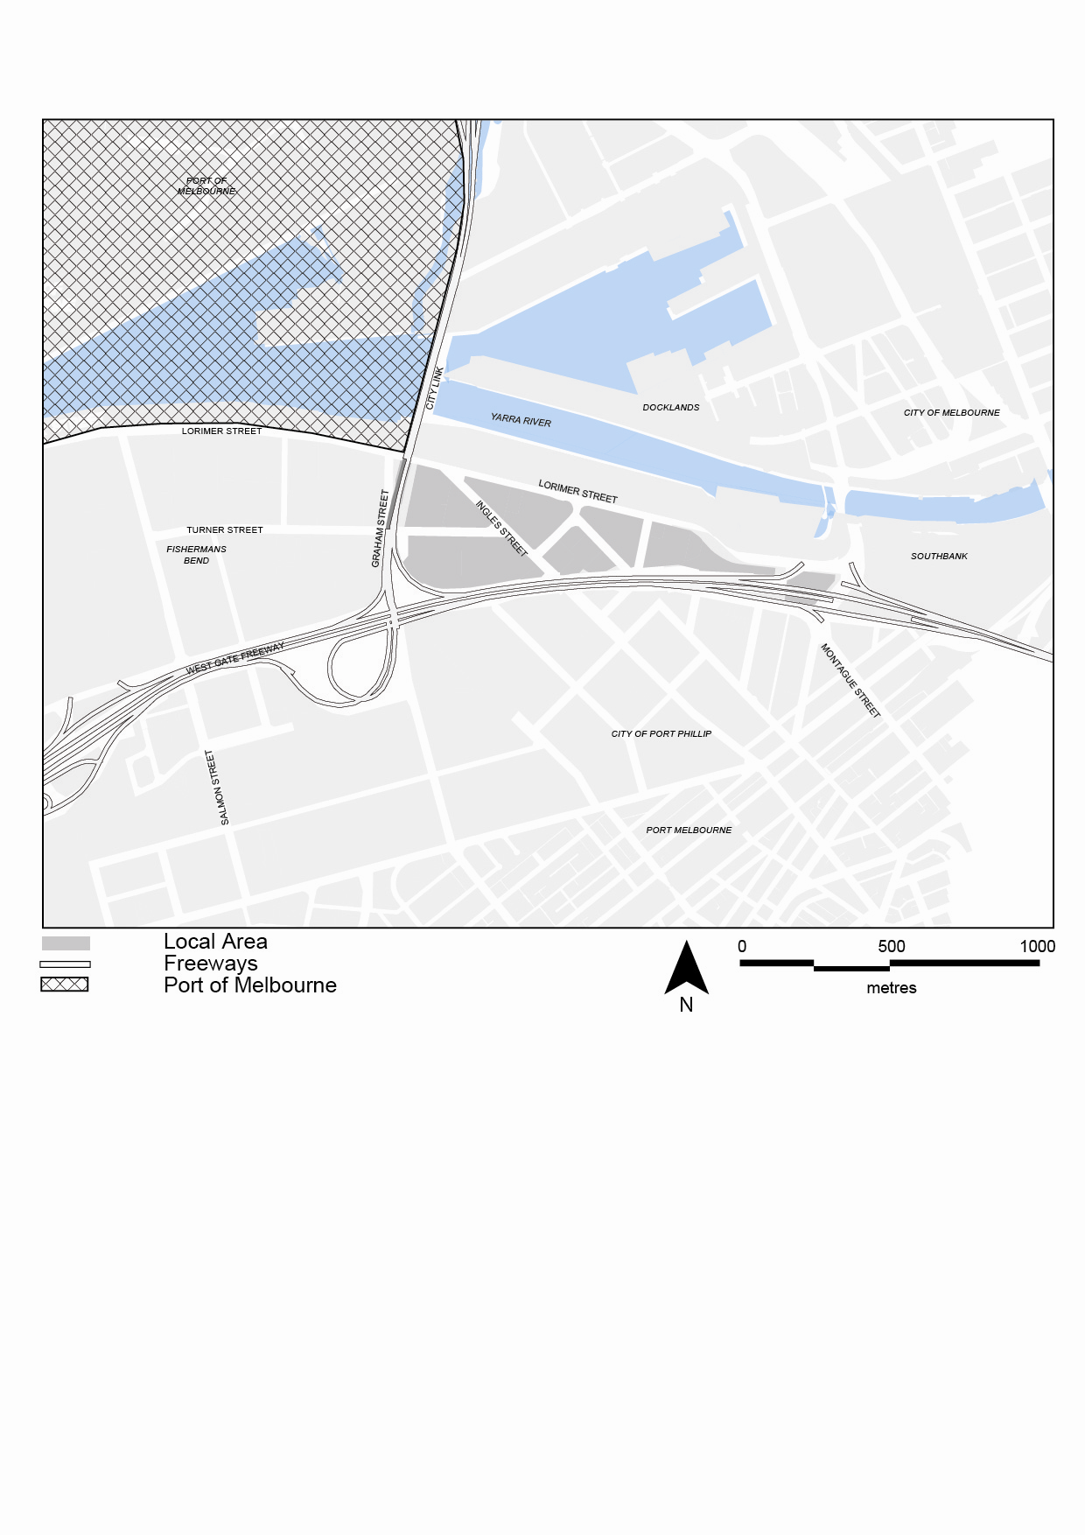Figure 10: Sub-precincts within the Lorimer precinct
