Attachment 2
Agenda item 6.3
Future Melbourne Committee
4 October 2022


Zero carbon buildings for Melbourne - Discussion Paper
October 2022
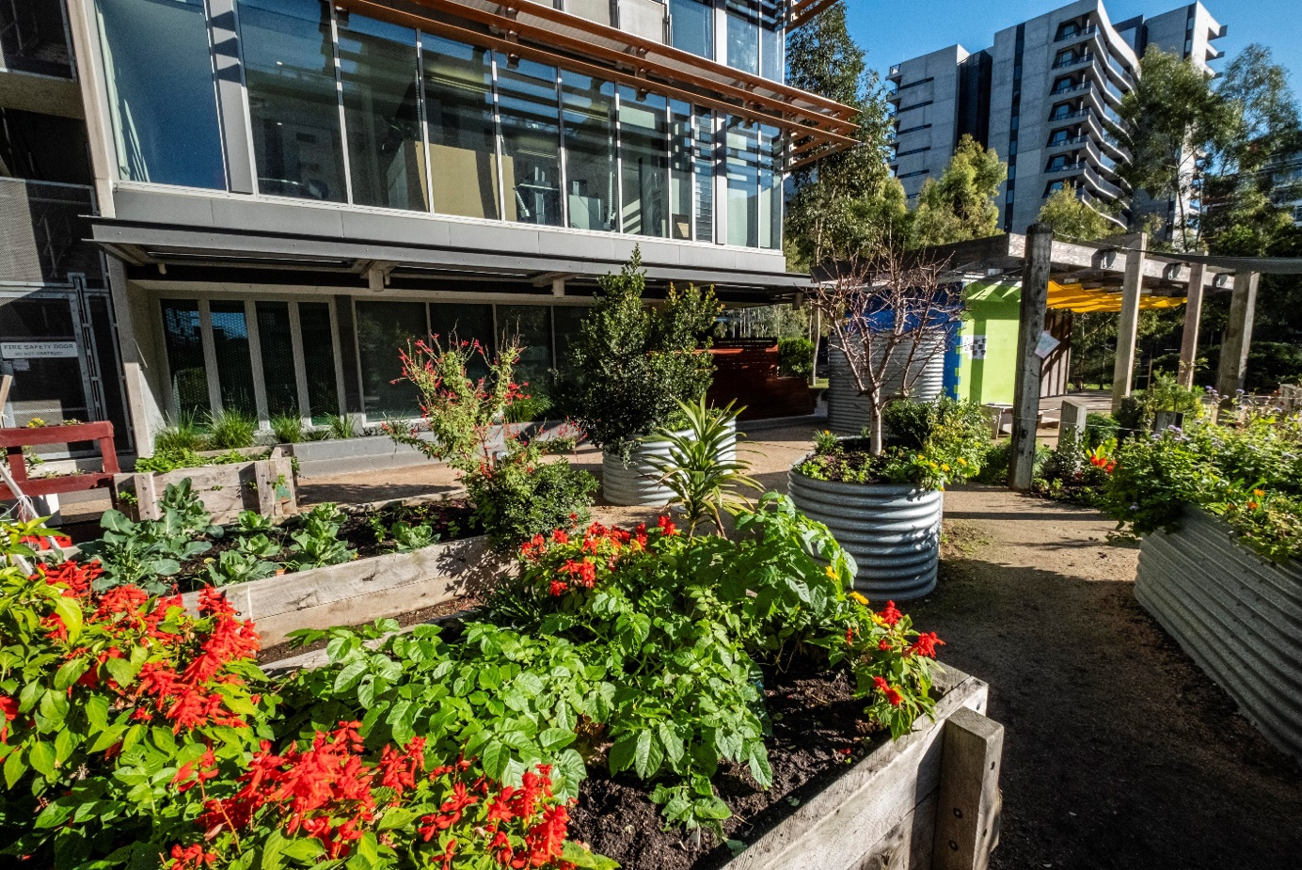

Acknowledgement of Traditional Owners

The City of Melbourne respectfully acknowledges the Traditional Owners of the land, the Wurundjeri Woi Wurrung and Bunurong Boon Wurrung peoples of the Eastern Kulin and pays respect to their Elders past, present and emerging. We are committed to our reconciliation journey, because at its heart, reconciliation is about strengthening relationships between Aboriginal and non-Aboriginal peoples, for the benefit of all Victorians.

Acknowledgment of stakeholder contribution

Thank you to everyone who helped to develop this discussion paper. More than 65 industry, government and academic stakeholders contributed their time and expertise.

Contents
Executive Summary 0
1. Purpose 2
1.1 Background and the state of the market 2
1.2 Context 3
1.2.1 Scope 3
1.2.2 What is a zero carbon building? 4
1.2.3 Residential buildings 5
1.2.4 New buildings 5
1.3 Why we need a Zero Carbon Building Implementation Plan 5
1.4 Summary of previous City of Melbourne initiatives 6
1.5 Existing complementary programs 8
1.6 Advocacy - What other levels of government need to do to support zero carbon ready buildings 9
2. New initiatives to support Zero Carbon Ready buildings by 2040 9
2.1 How do we get there most effectively? 11
2.2 Tools, data and information 12
Initiative 1 – Zero Carbon Building Leases 12
Initiative 2 – Carbon Risk Tool 13
Initiative 3 – Incentivising Periodic Commercial Building Disclosure 14
2.3 Working with Industry 16
Initiative 4 – Aggregation of Buildings for Joint Procurement 16
Initiative 5 – Zero Carbon Building Retrofit Teams 17
2.4 Regulatory reform 18
Initiative 6 – Incentivising performance through rates 18
Initiative 7 – Introduction of an emissions cap through a local law 19
3. Conclusion 21
4. References 22
Appendix A: Existing Complementary Programs 24

List of Figures
Figure 1: Zero Carbon Building Implementation Plan timeline 2
Figure 2: Emissions by sector for the City of Melbourne 3
Figure 3: Office space breakdown in m² for different sectors in the commercial building category 4
Figure 4: Hierarchy of activities for buildings to become Zero Carbon Ready 5

Abbreviations
60L 60 Leicester Street
C376 Sustainable Building Design Amendment C376
CH2 Council House 2
CO2e Carbon Dioxide Equivalent
EPC Energy Performance Contracting
ESCO Energy Services Company
ESD Environmentally Sustainable Development
ESG Environmental Social Governance
EU European Union
EUA Environmental upgrade agreements
EUF Environmental upgrade finance
EWWE Energy Water and Waste Efficiency
HVAC Heating ventilation and air conditioning
MREP Melbourne Renewable Energy Projects
NABERS National Australian Building Energy Rating Scheme
NatHERS Nationwide House Energy Rating Scheme
NCC National Construction Code
NYC New York City
OBF On-bill financing
PCA Property Council of Australia
VEET Victorian Energy Efficiency Target

Executive Summary
The City of Melbourne has committed to guiding the municipality to achieve net zero carbon by 2040. This commitment is part of our efforts to address the community’s concerns about climate change. However, if we are to limit the disruption of the future of climate change, we need to act as fast as possible.
Achieving zero carbon buildings is crucial to our municipal goal of zero net emissions, or zero carbon, by 2040. Buildings make up 66 per cent of the city’s emissions, so everyone who is part of our city’s buildings needs to collaborate to get to zero carbon buildings. Decarbonising the grid, with 100 per cent renewables by 2030 will contribute significantly to reducing emissions from buildings, but will not get us all the way to zero. The initiatives proposed in this paper work in conjunction with other policies and projects aimed squarely at grid decarbonisation.
The City of Melbourne does not have the levers or the resources to address this issue alone. We must work collaboratively with all building stakeholders – building owners, managers, tenants, residents, consultants, architects, cleaners, manufacturers, tradespeople, unions, and educators. As part of this consultation, we want to find out what support you need from the City of Melbourne to be part of the journey to zero carbon buildings.
Further, the COVID-19 pandemic has disrupted the status quo in our property market. Office vacancy rates are the highest they have been in two decades, hitting 12 per cent in June 2022. Additionally, tenants are more attracted to healthier, better performing buildings, moving from mid-tier to A-grade and Premium buildings.
This consultation asks you what you need from the city to support you to be part of this journey. The city has limited resources and limited power, yet the urgency is great; if we are to limit the disruption of the future of climate change, we need to act as fast as possible.
What is a zero carbon building?
The City of Melbourne defines zero carbon buildings as buildings in which no additional carbon is emitted into the environment through the construction, operations and whole of life of the building. We are proposing that all buildings be zero carbon ready by 2040. This means that all buildings will have NABERS energy ratings of 5-star or above, be all-electric and have an ongoing improvement plan to get to absolute zero carbon after 2040, including embodied energy.
Retrofit rate
The City of Melbourne has a long and proud history of influencing building retrofits. For example, our 1200 Buildings Program supported the initial retrofit of 541 buildings, though most of these were not deep retrofits. In addition, to help industry address barriers such as access to finance and knowledge gaps, we supported initiatives such as Environmental Upgrade Agreements, Environmental Performance Contracting and convening communities of practice.
Modelling from Point Advisory (2022) shows that to achieve zero carbon by 2040, we would need to retrofit 77 buildings yearly, to become zero carbon ready. Decarbonising by retrofitting our buildings will contribute $2.7 billion to the Victorian economy over the next 18 years, provide 12,000 job years by 2040 and reduce energy costs by around $184 million per year. In addition to a 100 per cent renewable grid, this will set up Melbourne’s buildings to be healthy, low energy, resilient place to work, live and play.
Consultation process and initiatives
This paper presents seven initiatives to support stakeholders in getting their buildings to zero carbon. The proposals have been informed by research into local and international initiatives and by detailed consultation with industry, academic and Victorian and Australian Government stakeholders. The first three initiatives provide tools, data and information; initiatives four and five cover working with industry and the final two proposals relate to regulatory reform. The consultation process will inform a Zero Carbon Building Implementation Plan co-created with community and industry stakeholders.
Seven proposed initiatives
Tools, data and information
- Developing and promoting zero carbon building leases;
- Developing and promoting carbon risk assessment tool;
- Incentivising periodic commercial building disclosure;
Working with industry
- Facilitation of aggregation of buildings for joint procurement;
- Convening zero carbon building retrofit teams;
Regulatory reform
- Incentivising performance through rates;
- Introduction of an emissions cap through a local law.

Purpose
This zero carbon building discussion paper tests the 2040 zero carbon ready building framing, trajectory (including embodied energy) and seven proposed initiatives that could support stakeholders to achieve zero carbon buildings.
The City of Melbourne has a long history of leadership in climate action, acting as a catalyst for change in Victoria, Australia and beyond through innovative collaboration with industry and community. However, we do not have the levers or the resources to address this issue alone. We must work collaboratively with all building stakeholders, supported by effective regulations and incentives, to achieve zero carbon buildings in our city.
The discussion paper includes questions throughout each section. We want to find out what you need from the City of Melbourne to be part of this journey.
The outcomes of this consultation will inform the development of a Zero Carbon Building Implementation Plan for the City of Melbourne, to be delivered in 2023. Subject to Council endorsement, the Plan will set out actions that the City of Melbourne will take over the next five to ten years to support the transformation of our built environment.
Figure 1: Zero Carbon Building Implementation Plan timeline
Zero Carbon Building Implementation Plan
(Mid 23)
Engagement

Background and the state of the market
In 2019, the City of Melbourne declared a Climate and Biodiversity Emergency. In responding to the climate emergency, the City of Melbourne has committed to achieving net zero emissions by 2040. Reaching net zero emissions by 2040 is a key pillar of the City of Melbourne’s response to the climate emergency and is reflected in our community vision and Council Plan 2021–2025. Our community aspirations reflected in Council Plan include that “buildings are built to the highest environmental standards”.
Achieving zero carbon buildings is crucial to our municipal goal of net zero emissions, or zero carbon, by 2040. Buildings make up 66 per cent of the city’s emissions, so everyone who is part of our city’s buildings needs to collaborate to get to zero carbon buildings. Decarbonising the grid, with 100 per cent renewables by 2030 will only get us part of the way.
The COVID-19 pandemic has disrupted the status quo in our property market. Office vacancy rates are the highest in two decades, hitting 12 per cent in June 2022. Flexible and remote work reduces demand for office space, which flows through to the markets’ value expectations. The ANZ/Property Council of Australia Survey in June 2022 reported property industry expectations that the capital value of commercial office space across Australia will decline 17.4 per cent in the next 12 months. This decline is expected to be particularly pronounced in Melbourne’s mid-tier building stock.
This shift may disrupt business models and highlight the need for low and mid-tier buildings owners to invest to ensure their properties remain attractive to tenants and buyers. With this uncertainty and disruption in mind, we must ensure that this paper's initiatives support and accelerate retrofit investment.
Modelling from Point Advisory (2022) shows that to achieve zero carbon by 2040, we need to retrofit 77 buildings annually to become Zero Carbon Ready. This figure includes deeply retrofitting 77 buildings to NABERS 5-star ratings or above and electrifying an additional seven buildings already operating at NABERS 5-star per year until 2040. We aim to include embodied energy after 2040.
Decarbonising by retrofitting our buildings will contribute $2.7 billion to the Victorian economy over the next 18 years, provide 12,000 jobs by 2040 and reduce energy costs by around $184 million per year.
Case study: Renovate-Europe

Europe has set an annual 2–2.5 per cent renovation rate for all buildings, aiming to retrofit 35 million buildings by 2030 (EU, 2020). Retrofitting these buildings will add 160,000 jobs to the economy and represent an investment of 275 billion euros annually.

Participate Melbourne – as you read through this document, please think about the below questions:
- Will the Zero Carbon Ready building framing help the city and its stakeholders get to zero carbon by 2040?
- Will the seven initiatives support the city and its stakeholders to get to zero carbon by 2040?
- Are the seven initiatives viable for the City of Melbourne to be involved in?
- Are there any other initiatives we haven’t suggested?

Context

Scope
Building emissions form 66 per cent of our municipality’s total emissions, with 60 per cent of total emissions coming from commercial buildings and 6 per cent from residential buildings.

Figure 2: Emissions by sector for the City of Melbourne
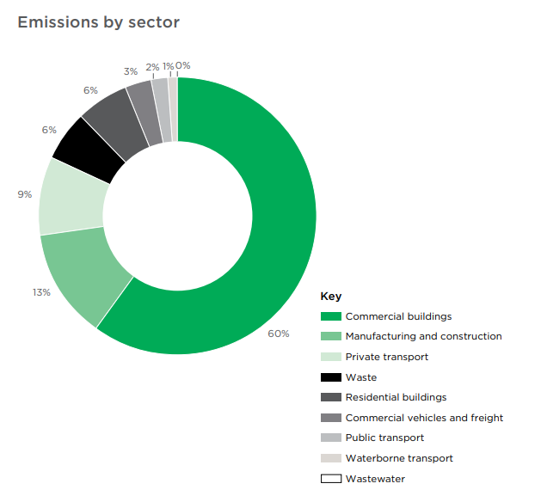
Source: City of Melbourne Climate Change Mitigation Strategy, 2018

The definition of commercial buildings used for this paper is “office buildings or buildings with some office functionality.” This definition includes buildings such as ground-floor office tenancies in an apartment tower, where the building is categorised as belonging to the apartment building sector. Our city currently has around 1517 commercial buildings, with a total floor space of 6.4 million m², as illustrated in Figure 3 below.
Figure 3: Office space breakdown in m² for different sectors in the commercial building category
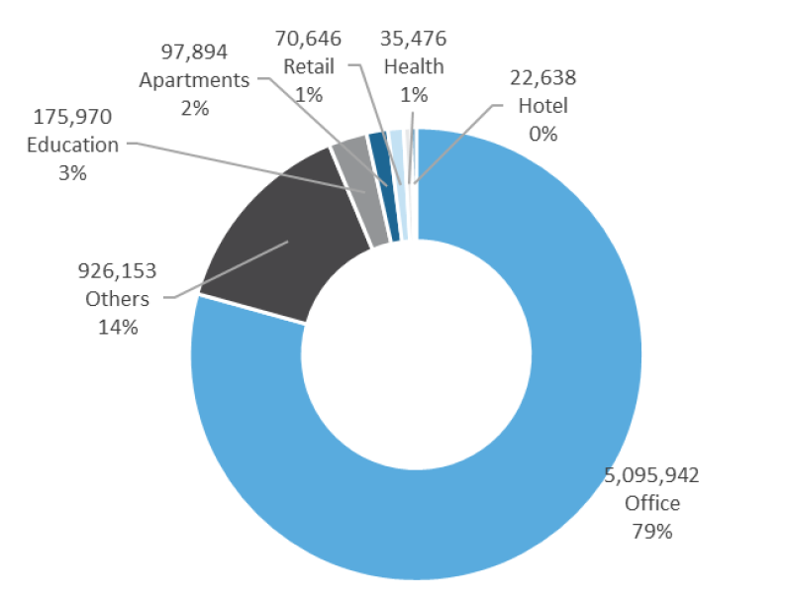
Source: Point Advisory, 2019

What is a zero carbon building?
The City of Melbourne defines zero carbon buildings as those in which no additional carbon is emitted into the environment through the construction, operations and whole life of the building.
To achieve this, we propose that all commercial buildings be Zero Carbon Ready by 2040. This means buildings will be 5-star NABERS or higher energy rated, be all-electric, and have an ongoing improvement plan to get to absolute zero carbon after 2040, including embodied energy.
The 5-star or higher NABERS rating for energy aligns with current industry best practice and is similar to what the EU and other developed countries aim for in their building upgrade programs.
The World Resource Institute (Becque et al., 2019) identified a hierarchy of activities that can be used to define a zero carbon ready building. In this hierarchy of activities, energy is sourced from renewable energy, ideally onsite, and any non-renewable energy is offset. Then, after 2040, zero carbon includes minimised embodied carbon emissions with the remainder offset.
Figure 4: Hierarchy of activities for buildings to become Zero Carbon Ready
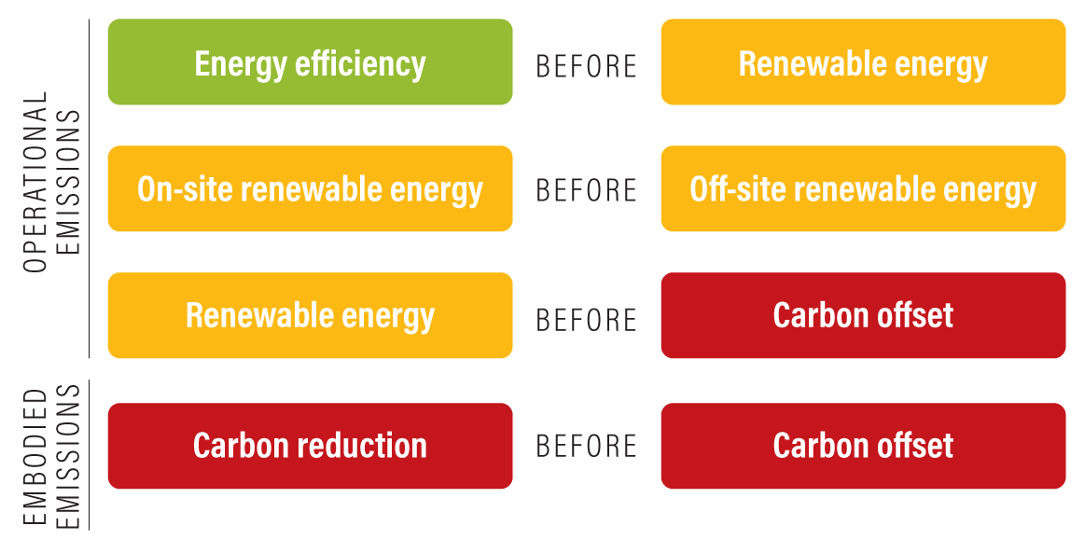
Source: World Resource Institute, 2019

Residential buildings
Houses and apartments are an integral part of the City of Melbourne, comprising 6 per cent of our total emissions and playing an active role in the city's future as a zero carbon, thriving, ecological and socially vibrant place. The consultation process has a separate pathway for residential stakeholders, including initiatives for residents to provide feedback.

New buildings
While new buildings are an important part of Melbourne’s evolving landscape, they will only contribute a small impact, as 90 to 95 per cent of the buildings operating in 2040 have already been built today. For this reason, our consultation focuses on supporting existing commercial buildings to get to zero carbon.
The City of Melbourne is also pursuing planning reform through Amendment C376 and advocating for greater ambition in the National Construction Code to ensure new buildings and significant renovations align with our zero emissions objectives.

Why we need a Zero Carbon Building Implementation Plan
The market is beginning to shift, due to a mix of both shareholder pressure and commitment by companies that see that a viable climate is central to having a strong, thriving economy. However current regulatory and market mechanisms are not enabling change at the scale and pace required to get to zero carbon and adequately respond to climate change.
This consultation explores how the City of Melbourne can address this momentum lag and meet its 2040 zero carbon commitment. We aim to work with industry stakeholders to address some of the barriers and known issues with retrofitting at scale, especially for low and medium-tier buildings. The challenges result from how the building industry works, its fragmentation, and its relationship with the market and regulations.
Unfortunately, these challenges lead to inertia. An Ernst & Young (EY) report (GBCA, 2015) identified many of the problems below and existing solutions covered in the background section of this report. We have not yet achieved the momentum needed.
We need to co-create bolder, practical, capacity-building initiatives with industry and the local community to reach the retrofit rate required.
Barriers and issues with retrofitting at scale:
- Discontinuity of interventions – things get started by one government and then dropped.
- Duplication of effort – people are doing the same thing at different levels of government and industry.
- Absence of effective incentives – if incentives exist, they might target only one aspect or be challenging for the building owner to access.
- Absence of trustworthy technical support – it is difficult for a mid-tier building owner to know which of the many solutions available will be effective.
- Different priorities and pressures – builders, building owners and renters have different agendas, with owners having greater power.
- Land banking office space – some owners hold onto old buildings to gain capital growth without investing in upgrades and maintenance.
- Initial investment without maintenance – owners often invest in smart technologies and new systems without the capacity to maintain them over time.
- Split incentives become a disincentive to investment – building owners pay for upgrades, but the tenants get the savings from the energy use reduction and improvement in air quality.
- Capital constraints – building owners have competing financial priorities and have not prioritised energy issues.

For mid-tier building owners, additional issues include:
- These owners do not typically network amongst themselves (unlike premium or A-grade building owners) and are under-represented in industry bodies like the Property Council of Australia.
- Low tenant demand for better quality buildings and tenancies could be caused by a lack of awareness or by corporate policies driving environmental requirements.

Participate Melbourne – questions for your input
- Please provide some background about you and or the organisation you support (standard demographic and industry questions)
- Do you have plans to invest in a significant retrofit? (options in the next 0-5, 6-10 or 11-15 years)
- Is the Zero Carbon Ready Building framing useful? (yes, no and free text)
- If not, what will help communicate the issue to you? (free text)

Summary of previous City of Melbourne initiatives
The City of Melbourne has a long, proud and successful history in affecting and improving building performance. In the 1990s, the Postcode 3000 initiative began bringing life beyond 9 to 5 into the city. This initiative included using existing buildings beyond working hours and bringing people into the city to live.
In the early 2000s, we undertook strategic work to improve energy efficiency and support green buildings. This work resulted in developing Green Star, the construction of Council House 2 (CH2), and initiatives such as the Melbourne Forum and the 1200 Buildings Program. There was also a process of developing funding mechanisms to support building retrofit costs, with the development of Environmental Upgrade Agreements (EUAs) and Energy Performance Contracting (EPCs).
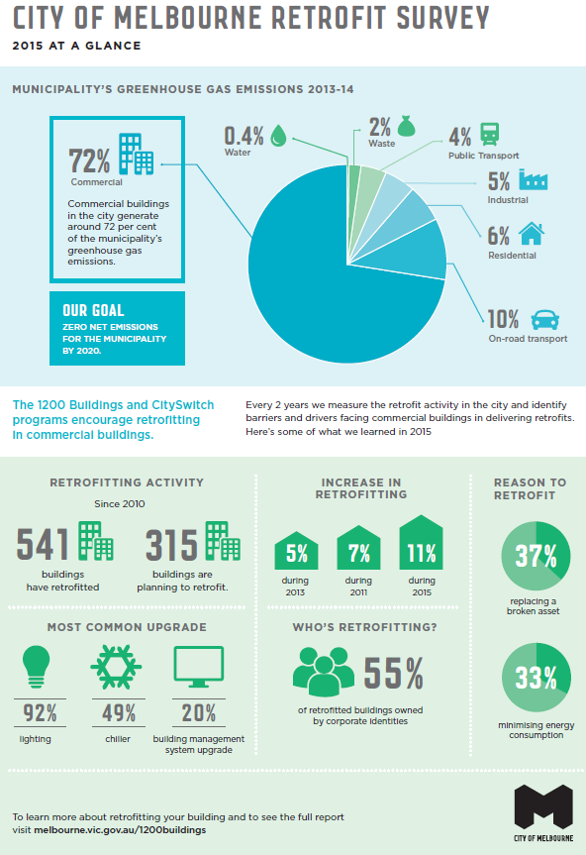
Impact of City of Melbourne initiatives
1200 Buildings Program outcomes:
In the 1200 Buildings Program, commercial office building owners in Melbourne CBD retrofitted 541 buildings, enabling building owners reduce their energy use and save money. The program started in 2010 when the market for energy efficiency was immature, and the industry needed more direct support and information. By the time of the review in 2019, the market had matured significantly, increasing its capacity to provide low-hanging fruit retrofit advice and finance without the need for this program.
Demonstration projects outcomes:
Buildings such as CH2 and Library at the Dock and tools such as EPCs demonstrated what was possible. The ability to test an idea and enable others to learn from it is a powerful tool that supports the market's capacity to take up new ways of working. For example, CH2 played a significant role in enabling comfort in the market to achieve/aspire to six-star Green Star.

Over the last 25 years, the City of Melbourne has used several levers to support buildings to reduce their energy and carbon footprints, as outlined in the table below.
Levers | City of Melbourne initiatives to support buildings to reduce their environmental and energy-based impacts
Demonstration | CH2, Library at Dock, Boyd Centre, Kensington Recreation Centre, Environmental Performance Contracting (EPC), Grey to Green, City as a catchment
Convener | Two Melbourne Renewable Energy Projects (MREPs)
Policy/Legislation | Proposed sustainable buildings amendment C376, Environmental Upgrade Agreements, Energy Water and Waste Efficiency (EWWE) local policy
Knowledge and support | 1200 Buildings Program, solar grants for small buildings, City Switch, Melbourne Forum, Growing Green Guide, Urban Forest Strategy, Environmental Upgrade Agreements
Advocacy | Input into working groups, consultations and requests for information from Victorian and Australian Government programs, precinct plan developments and other opportunities. Other advocacy opportunities include input into the National Construction Code, Building disclosure national legislation, State ESD roadmap, Fisherman’s bend and Arden and Macaulay precinct development plans.

Unfortunately, none of these approaches alone or combined have created the required momentum to get all buildings to zero carbon effectively and at pace. The City of Melbourne does not have the levers or the resources to solve it alone; it can only be achieved with the collaboration of all building stakeholders, supported by effective regulations and incentives.

Existing complementary programs
The following programs are currently in the market and can support the City of Melbourne’s zero carbon building journey. More detail on each program is available in Appendix A.
Existing complementary programs – limitations and potential
Program | Explanation | Limitations | Potential
Environmental Upgrade Agreements / Finance (EUA/F) | A fixed-rate loan for energy-efficient upgrades, which uses energy savings to pay for the loan to maintain a positive cash flow. | Rate of uptake – only 13 EUAs since 2011 in Melbourne. There are less demanding sources of cheap money available. | Supports initiatives presented here and reduce administrative burden of EUAs.
On-bill Finance | A loan for improving the energy efficiency of a building is paid back over time through additional charges on the building’s utility bill. | It needs ongoing collaboration with utilities and evaluation of why this has not reached its potential. | Link to initiatives presented here and review issues identified in the market limiting its potential impact.
Energy Performance Contracting | The EPC vendor assesses the building, develops strategy and installs the necessary equipment to improve energy efficiency at no charge to the client. In return, the EPC vendor receives a significant proportion of the savings made. | Uptake rate low and has not led to acceleration of deep retrofits needed to get to Zero Carbon Ready buildings. Some issues around trust, implementation and process. | Link to initiatives presented here and review issues identified in the market limiting its potential impact.
Equipment/Service Leasing (also known as Energy as a Service) | Like leasing a printer and paying per page, this would be hiring the plant and paying for levels of comfort provided. | Some companies have tried this without resulting in good market uptake. It is a complex option, as measures of comfort are often subjective. | Service leasing could enable plant to be designed for the long term, upgrade and management. It can also support the ability to access data and continually improve.
White Certificate schemes | Energy saving initiatives result in a white certificate that can be traded on the market. They are an additional financial incentive to do retrofits and save energy. | Introduced in the UK in 2002 and in Victoria in 2014, but has not created the needed momentum in either jurisdiction. | Link to initiatives presented here.
Financial incentives/tax breaks | An example is the current instant asset write-off for energy-using equipment. | A temporary measure, which has not driven the take-up needed to meet net zero trajectories. | Link to initiatives presented here.
Individual metering, sub-metering and direct feedback | Installing meters on all energy-using aspects of the building | Cost is a barrier for mid and low tier buildings, as is limited ability to collect and analyse the data usefully. | Understanding usage is useful per se.

Advocacy - What other levels of government need to do to support zero carbon ready buildings
The City of Melbourne only has limited powers within its regulatory context. State and Federal governments are critical partners in supporting the potential for buildings to become zero carbon ready.
State Government:
- Approve Amendment C376: Sustainable Building Design and to allow it to progress to the public exhibition stage. This amendment will ensure new buildings and major redevelopments improve their environmental performance. The City of Melbourne is seeking to work closely with the Victorian Government to raise the bar for new buildings in the City of Melbourne in a way that complements and supports the Victorian Government’s ESD Roadmap, recognising Melbourne’s unique context.
- Implement land tax reform to structure the tax paid by commercial building owners to be based on building energy performance. Linking land tax rates to NABERS energy performance uplift could be revenue neutral to the Victorian Government whilst sending a meaningful price signal to building owners.
Federal Government:
- To help all levels of government to better track the environmental performance of their buildings, it is recommended that Federal Government alter the Commercial Building Disclosure Act to:
  - Reduce the floor area for disclosure to 500m²
  - Change from disclosure only at point of sale or lease to regular, periodic reporting
The Commercial Building Disclosure Act is a critical enabler of many of the initiatives outlined in this paper and is a proven enabler of better building performance. Under the Commercial Building Disclosure Act, owners of large office buildings need to disclose their buildings’ energy performance at point of sale or lease.
- The National Construction Code is reviewed every three years. We welcome the recent announcement of a minimum NatHERS rating of 7 stars for all new residential builds. The City of Melbourne wants to see a similar level of achievement mandated for all new commercial builds (for example Green Star 5 star or above for large commercial offices). This will deliver policy certainty for developers and builders. Moreover, it will ensure new buildings are comfortable, healthy and affordable over their lifetime.
- Work with states and territories to roll out a training and skills package and ensure a smooth and productive transformation of the sector, skills and capacity within the construction sector.
- Establish a national commercial building retrofit incentive fund to stimulate private investment, in the absence of regulation on building performance, as has been implemented in other jurisdictions (EU).

New initiatives to support Zero Carbon Ready buildings by 2040

How do we get there most effectively?
Getting to zero carbon is critical to addressing worsening contributions to climate change. In addition, our proposed approach supports the city to stay vibrant and the building sector to remain viable. For this reason, this consultation would like to hear from you about what would help the municipality and its buildings, offices, shops, and hotels most effectively to get to zero carbon.
We are proposing seven initiatives in three different categories. The first category is tools, data and information. The second covers working with industry, and the third relates to regulatory reform.
Our seven proposed initiatives:
Tools, data and information
- Developing and promoting zero carbon building leases;
- Developing and promoting carbon risk assessment tool;
- Incentivising periodic commercial building disclosure;
Working with industry
- Facilitation of aggregation of buildings for joint procurement;
- Convening zero carbon building retrofit teams;
Regulatory reform
- Incentivising performance through rates;
- Introduction of an emissions cap through a local law.

Participate Melbourne
We are proposing seven initiatives in three different categories. Please provide your opinion on the effectiveness and practicality of each. In addition, feel free to contribute other initiatives you think could be a practical part of the zero carbon building enabling ecosystem. Each idea has a series of questions that include a slider, from ‘will help’ to ‘will not help’. Use the slider to let us know what you think will be most effective and practical.
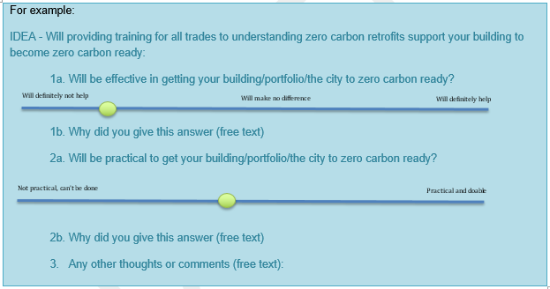

Tools, data and information

Initiative 1 – Zero Carbon Building Leases
Green Leases were a concept first developed and implemented at the 60L green building in the mid-2000s. A Green Lease is a lease between the landlord and tenant that aims to ensure that the ongoing use and operation of the building minimises environmental impacts – e.g. use of water, waste, energy, etc. In the premium office market, 94 per cent of building property owners now use Green Leases.
This level of market buy-in could be harnessed to create a new, more straightforward, clearer product – a Zero Carbon Building Lease. This lease will provide a mechanism for tenant demand of zero carbon buildings and ways for building owners to ensure tenants do what is needed to produce whole of building zero carbon outcomes.
The Zero Carbon Building Lease could build on the accumulated knowledge/experience of implementing Green Leases for the past 18 years. Detailed requirements, expectations and aspects covered in a zero carbon lease would need to be developed. Still, they could provide a demand-side mechanism to support the zero carbon building retrofit rollout.
Case study – 60L Green Building Melbourne
The Green Lease was a mechanism developed for the 60L green building project in the mid-2000s. It was seen as a mechanism to enable tenants to be accountable to building owners for their behaviour in the building, but also as a way for tenants to hold building owners responsible for the environmental sustainability of their tenancies. “The 60L Green Building, almost 20 years on, still performs as well as it did when it was first opened.” Alan Pears AM

Zero Carbon Lease – potential to solve barriers to mid and low-tier retrofits
City of Melbourne's capacity to influence | - The concept could be developed by the City of Melbourne together with partners. For example, we could pilot in new office accommodation or support a pilot with an industry partner and promote it to the market.
City of Melbourne regulatory or legislative levers | - The City of Melbourne could require for Councils’ future accommodation.  - Similar to a NABERS Commitment Agreement, it could become a condition on planning.
Considerations | - Zero Carbon Leases encompass more than just energy. Although this introduces a new specific product, which will need to interact with other lease requirements, it is more straightforward than the Green Lease.  - Green Leases have not been taken up in the mid/low-tier buildings.
Opportunities | - The Green Lease has a 20-year market penetration and could be linked to building teams (tenant voice), disclosure and rate mechanisms.
Solutions it provides | - Provides a way for tenants and owners to be aligned on a zero carbon pathway.  - It gives a market-understood way to offer and ask for a well-understood product.  - Provides an assurance and documentation approach for ESG reporting for accommodation.

Initiative 2 – Carbon Risk Tool
A Carbon Risk Tool is an approach to understanding the future risk of carbon for mid and low-tier buildings. It can inform retrofit strategies if developed into an effective tool for all building owners, not just the top end of town.
The idea behind this metric is to enable investment decisions around the impact of a building’s carbon performance on its value. It can include looking at aspects of regulation, ESG requirements and carbon pricing. The initiative would work with industry to create a simple, agreed-on way for building owners to understand, manage and potentially report on this carbon risk – a ten-minute tool, for example.
For example, a free online tool in the EU allows property owners to assess stranding risk for individual assets (www.crrem.eu). This tool helps building owners understand the market's expectations on the carbon performance of a property and make decisions on retrofit options and purchase priorities.
The COIMA property group case study below shows how an eight billion Euro company uses the ability to measure the carbon intensity of its buildings to actively manage its portfolio.
Case study – COIMA property group Milan
COIMA property group uses an approach to actively measure, benchmark and make decisions based on the carbon intensity of its portfolio. COIA measures CO2 intensity compared to EU requirements. It then either retrofits or retires the asset depending on decarbonising cost.
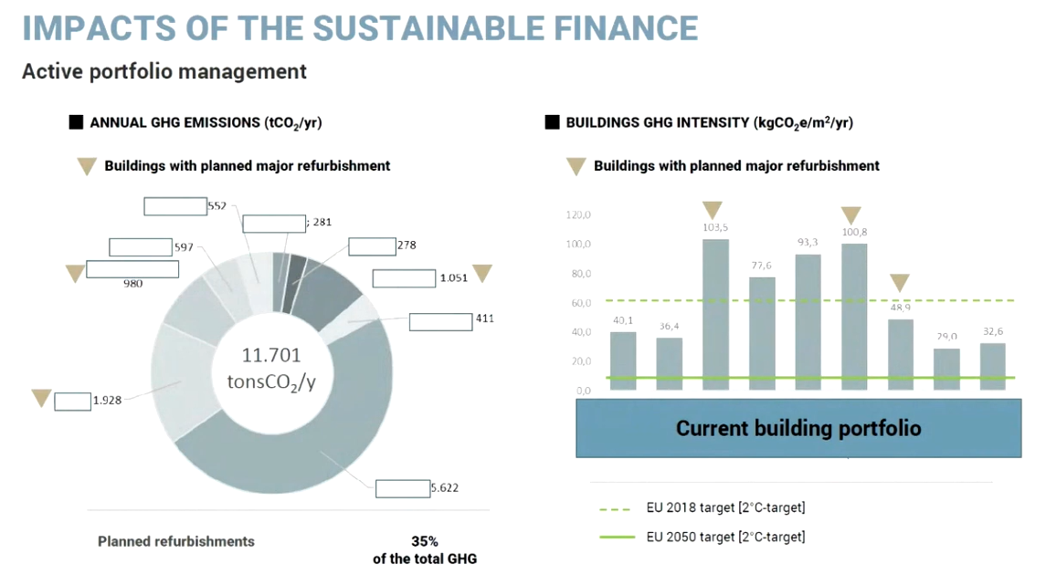
Source: ARUP webinar 27th October 2021 on net zero carbon.

Carbon Risk Tool – abilities to solve barriers to mid and low-tier retrofits
City of Melbourne's capacity to influence | - Bring together industry stakeholders to discuss and develop a process – pilot
City of Melbourne regulatory or legislative levers | - Building owners could be asked to report on or use this tool, in order to receive other incentives
Considerations | - Is this initiative more about communication than enabling?  - Will it happen anyway without need for the Council’s involvement?  - Relevance to mid/low tier buildings
Opportunities | - City of Melbourne helping the industry understand their risks  - Supports/enables other initiatives
Solutions it provides | - Provides a way to have a market – investor other pressures – driven approach for building owners to work with their assets and their energy consumption

Initiative 3 – Incentivising Periodic Commercial Building Disclosure
Commercial Building Disclosure (CBD) is a national regulatory program that requires both sellers and lessees of commercial office spaces over 1000 m² to provide energy efficiency information to buyers and tenants using NABERS for its rating system.
This program is set to expand beyond commercial office buildings (hotels, data centres and retail) and to include a periodic disclosure requirement. Unfortunately, due to COVID-19, the expansion was put on hold. However, it is expected it will soon be back on the agenda as it is a central part of the Trajectory for Low Energy Buildings (Commonwealth of Australia, 2018).
The City of Melbourne will continue advocating for releasing these requirements as a critical enabler for buildings to get to zero carbon.
This initiative proposes a program to incentivise periodic reporting of a building’s NABERS rating. Experience on the uptake of NABERS shows that a voluntary program will need incentives and support, as the cost of assessors is a hurdle for new starters. For example, City Switch already has a discount for NABERS ratings but this has not driven a significant uptake by mid and low-tier building owners.
Case study – NSW government New Starters Offer
The NSW program New Starters Offer (NSW Government Offer: Energy & Water Starters and New Buildings | NABERS) provides a financial contribution of up to $3,000 ex GST towards energy ratings and an action plan. Buildings need to be NABERS rated, produce an action plan and commit to a second rating. The program aims to reach 600 buildings.

Incentivising Periodic Commercial Building Disclosure to solve barriers to mid and low-tier retrofits
City of Melbourne's capacity to influence | - Support early implementation of the national scheme – may need negotiation with the Federal government or NABERS to establish a partnership.
City of Melbourne regulatory or legislative levers | - Require improved performance link to disclosure, rates, cap, or other mechanisms
Considerations | - Funding will support updates – for example, NSW at $3,000 per building to get the initial rating, an action plan and a subsequent rating. This initiative would need Victorian government support.  - The program would need management to attract and engage building owners and manage the participants.
Opportunities | - Provide data and potential to develop a targeted strategy and mechanism for continuous improvement.  - A voluntary program could be linked to rates or other incentive mechanisms  - Benefits to property owners are a higher return and lower vacancy rates (Lee et al. 2017).  - Link data to ways to celebrate buildings to help them get new tenants.  - Potential to de-risk property purchases
Solutions it provides | - Enable retrofit planning  - Ability to improve learning rate  - Underpin regulatory, rates, capping and finance mechanisms

How ongoing disclosure can help the industry
Case study – Buildings renovation passport example in Australia – Building Fitness Program Cundall
The Building Fitness Program is a process that maps out a program of staged upgrades and improvements to a building. The aim is to reduce emissions but also enhance occupants' experience, comfort and wellbeing, add measurable market value and ensure the structure can remain viable and valuable. Cundall’s Building Performance Services team developed the Building Fitness program.
It aims to help building owners and tenants understand how to make a start. It explains the simple steps in making any property future-fit, trimming waste energy use and improving operational performance. It also gives an overview of the tools, techniques and strategies involved, starting with the first step of understanding and benchmarking current performance and long-term asset management goals. Unlike the passport above, this is a strategic assessment and business review to enable long-term asset improvement planning: understanding how the building currently performs, reviewing sustainability strategy, developing a pathway of goals, understanding the building’s climate and resilience risks and then aligning with ESG strategy. From this, the relevant building stakeholders are in a solid position to develop the 10-15 year building retrofit plan (Cundall, 2021).
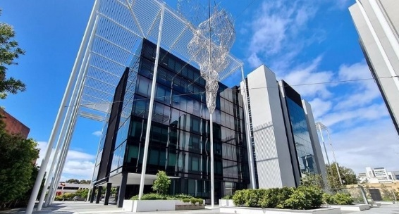
Case study – Workzone East – Perth
Knight Frank and RF CorVal engaged with Cundall to produce a five-year sustainability roadmap. This roadmap reduced greenhouse gases from 535,355 kg CO2 in 2017 to 349,960kg CO2 in 2021, taking the NABERS Energy rating from 4.5 Stars to 5.5 Stars. In addition, they used NABERS to guide the reduction of their consumption. The Australian Government’s Climate Active Carbon Neutral Standard for Buildings was used to achieve carbon neutrality. As a result, Workzone East was rated as Perth's first zero carbon commercial building.
Image: The Workzone East building at 1 Nash Street in the Perth CBD, supplied by Knight Frank.

Working with Industry

Initiative 4 – Aggregation of Buildings for Joint Procurement
The City of Melbourne has led Australia in bringing together business and government to decarbonise through joint procurement of renewable energy through the Melbourne Renewable Energy Project (MREP). This concept could also be applied to supporting lower grade and ungraded buildings to build capacity to carry out deep retrofits jointly.
This initiative would address the problem of smaller buildings' capacity to access professional services, advice and capital to retrofit their buildings. Aggregating buildings into similar categories – hotels, storage, parking, and unrated office buildings – could help them solve issues together. In addition, a group of buildings undergoing lighting, HVAC, insulation and electrification works jointly will lead to economies of scale for investment and purchasing.
Case study – Melbourne Renewable Energy Project
The City of Melbourne has facilitated a power purchase agreement for businesses across the city as part of the second wave of the Melbourne Renewable Energy Project (MREP 2). This project is the second purchasing group we have brought together. It includes seven large energy users: RMIT University, Deakin University, CBUS Property, ISPT, Fulton Hogan, Citywide Asphalt, and Mondelez International.
MREP 1 established a new wind farm and saw many local councils and cultural institutions become powered by renewable energy. In facilitating MREP 2, the City of Melbourne helped educate and empower large energy users to understand their role in achieving our ultimate goal: for all of Melbourne to be powered by 100 per cent renewable energy. The challenges for these MREPs were the initial negotiations and partnership development. Ultimately, we reduced the innovation cost for the private sector and proved a model where transaction costs could be shared amongst a group, thereby lowering costs for participating organisations.

Aggregation of Buildings – ability to solve barriers to mid and low-tier retrofits
City of Melbourne's capacity to influence | - Capacity to broker relationships that aggregate needs has been demonstrated through MREP.
City of Melbourne regulatory or legislative levers | - The initiative is voluntary but could link to disclosure, rates or emissions cap requirements.
Considerations | - Will small property owners be interested in being involved?  - How will it be funded? Facilitation, retrofit design and engineering, plant, equipment and materials.  - MREP worked with prominent organisations to aggregate smaller property owners who could take more resources.
Opportunities | - Lower cost retrofits through economies of scale.  - Cash positive retrofits.  - Building the capacity to get high-level professional advice that smaller properties might not have access to otherwise.  - Links to tactical demonstration projects like City of Melbourne’s BREATH demonstration.
Solutions it provides | - Supports the increase of energy efficiency and health of buildings stock that might not otherwise have the capacity to do so.

Initiative 5 – Zero Carbon Building Retrofit Teams
Many of the identified market failures and challenges of rapid decarbonisation stem from the building industry's current adversarial and transactional nature. An emerging body of literature, grown from the integrated design movement, suggests that a critical approach to addressing this is to shift to a more collaborative, relational way of working.
A way of starting down this path is to develop a ‘decarbonisation of assets’ trajectory based on the building fitness program mentioned above and extend this into a scope of work, timelines and capital required. It could be developed by a building team of experts from different parts of the industry, including a dedicated planner from the City of Melbourne, plus researchers, data experts and potentially connecting in graduates.
The concept of building teams is that a building owner sets up a team tasked with looking after the building over a defined period. Together the building team determine a trajectory over that time to achieve zero carbon, and beyond. This trajectory maps asset replacement plans, ensuring a steady rate of investment into the building. In addition, the team builds a relationship with the building and its stakeholders. As such, a well-functioning team will be more agile and responsive to change, monitor and learn from initiatives, and respond more quickly and effectively to adaptation needs. Building teams across sectors is a meta-capacity development process.

Case study – Town Teams in placemaking
The Town Teams concept came out of Western Australia. It involves a community working with a council and local industry to plan revitalisation. Having all the decision-makers in the room reduces barriers, increases opportunities and supports effective innovation. (Image: Town Teams Movement - The Ignite Us Ravenswood (Town Team 2022))

Collaborative Building Retrofit Teams – ability to solve barriers to mid and low-tier retrofits
City of Melbourne's capacity to influence | - Initial ability to broker, pilot, create guides and fact sheets and host an initial community of practice.
City of Melbourne regulatory or legislative levers | - The voluntary initiative could require improved performance linked to disclosure, rates, cap, or other mechanisms.
Considerations | - Is changing the industry works something the City of Melbourne can do?  - Cost of the pilot and brokering and maintaining momentum.
Opportunities | - This initiative will address many current market failures and create future capacity.  - It can shift the industry to be more relational, which Aboriginal communities have been trying to teach us.  - Enables the ability to be more agile and resilient.
Solutions it provides | - Overcome knowledge gaps and enable development of zero carbon building trajectory plans.  - Build and sustain momentum for improved building performance.  - Capacity building of multi-disciplinary teams.  - Access to capital and other incentives.

Regulatory reform

Initiative 6 – Incentivising performance through rates
The City of Melbourne could use its rate charging ability to encourage emissions reduction, leveraging anticipated future expanded Commercial Buildings Disclosure requirements (see Initiative 3 above), as demonstrated by improvements in NABERS energy ratings. An emissions analysis shows that differential rates could reduce emissions from the mid-tier office sector.
This initiative would mean targeted rate-in-the-dollar reductions (over 10 years) for buildings undertaking upgrades to increase their NABERS ratings. It would be funded by maintaining – or in some scenarios increasing – the rate-in-the-dollar applied to buildings that do not participate, rather than reducing this rate as property and rental values rise.
Rates Incentive – ability to solve barriers to mid-tier retrofits
City of Melbourne's capacity to influence | - Excellent. This is well within the City of Melbourne's capacity to implement, although limited by the need for disclosure.
City of Melbourne regulatory or legislative levers | - Good potential to integrate as part of the rate mechanisms.
Considerations | - There is a need for a mandatory, regular disclosure mechanism to enable it.  - The various options considered in the economic and emissions analysis showed a relatively small impact on total emissions. The benefit would be how this supports momentum and enables other aspects of the Zero Carbon Building Implementation Plan to be taken up.  - The cost of administering the incentive should be reviewed over time to ensure transaction costs are commensurate with economic and emissions dividends.
Opportunities | - Being part of the rate mechanism can support connecting this with other opportunities, for example, aggregation or building teams. In addition, it is cost neutral for the City of Melbourne.
Solutions it provides | - Effective and links in well with other initiatives and ideas.

Initiative 7 – Introduction of an emissions cap through a local law
One way for the City of Melbourne to encourage building owners to reduce the emission intensities of their buildings is to set an emission ceiling for buildings. The ceiling would come into force by a specific date. Buildings would then be charged penalties per tonne of emissions over the ceiling. An emissions cap could provide both the incentive and the revenue to support building owners to manage, measure and improve building performance.
In 2021, the EU introduced minimum energy performance standards for worst-performing buildings. Similarly, New York City has introduced minimum performance targets and penalties per tonne of carbon emissions over the limits.
Case study – New York City emissions cap
New York City Council (2019) brought in Local Law 97, setting emissions intensity limits for various building typologies. The first emission limits apply from 2024 until 2029, with tighter limits from 2030 to 2034, when the financial penalties also increase. This timeframe gives property owners time to evaluate their stock and identify strategies to meet requirements. It also allows the industry to build the capacity to support these strategies.
The law has brought in a penalty of $US268 (around $A358) for every metric ton (tonne) of CO2e above the limit. The value was determined as the “social cost” of carbon. The strategy will reduce greenhouse gases by 80 per cent by 2050 of all of NYC’s building stock. It is part of NYC’s Climate Mobilisation Act of 2019. The Act aims to reduce six million metric tons of CO2e, create 26,700+ jobs, avoid 150 hospitalisations and prevent 50 to 130 deaths annually by 2030 (Petrass, 2022).
The table below lists building NYC Emission Limits for 2024-2029 & 2030-2034 (Sajip, 2019)
OCCUPANCY CLASSIFICATION | 2024-2029 LIMIT  (kg CO2 eq/SF/year) | 2030-2034 LIMIT  (kg CO2 eq/SF/year)
B - Business | 8.46 | 4.53
B - Ambulatory health, emergency response, and other critical applications listed in LL97  H - High Hazard  I 2 & I 3 - Institutional | 23.81 | 11.93
M - Mercantile | 11.81 | 4.03
A - Assembly | 10.74 | 4.20
R 1 - Residential (Hotels) | 9.87 | 5.26
E - Educational  I 4 - Institutional | 7.58 | 3.44
R 2 - Residential (Multifamily) | 6.75 | 4.07
F - Factory | 5.74 | 1.67
S - Storage  U - Utility & Miscellaneous | 4.26 | 1.10
I 1 - Institutional | 11.38 | 5.98

Emissions Cap – ability to solve barriers to mid and low-tier retrofits
City of Melbourne’s capacity to influence | - The City of Melbourne has limited power to set emission caps and penalties. We are not sure if the penalties are significant enough to drive change.
City of Melbourne regulatory or legislative levers | - We have the power to enact emissions caps through local law.
Considerations | - Time required to develop and get approval for the relevant policies, documents and systems to put this into place.  - Whether we can implement, monitor and administer such a system.  - The metrics and reporting frameworks could be linked to NABERS and periodic disclosure (see Initiative 3 above).  - Does the cap apply to the whole building or just the tenancy space? (Net Lettable Area)
Opportunities | - A certain pathway to getting to zero carbon.
Solutions it provides | - Encourages building owners to start to understand their energy use.  - Provides a clear path for retrofit strategies with a clear understanding for building owners of the expected increase of stringency of the cap.

Conclusion
Our ability to meet our climate targets and achieve Zero Carbon Buildings depends on collaboration with everyone involved in the city’s buildings. Thank you for being part of this consultation/discussion and for providing feedback. The input we receive from this consultation will inform our Zero Carbon Building Implementation Plan – and the actions that the City of Melbourne will take over the next five to ten years to support the transformation of our built environment.
Lastly, do you have other ideas or thoughts that could support the City of Melbourne in implementing systems that will help in this?

References
ARUP (2021) Webinar Net Zero Carbon Delivery, 27 October 2021. Retrieved from https://www.arup.com/news-and-events/net-zero-for-property-local-and-global-insights-series-webinar-2 (accessed 18 July 2022).
BPIE (Buildings Performance Institute Europe) (2021). Deep Renovation: Shifting from exception to standard practice in EU Policy. Retrieved from: https://www.bpie.eu/publication/deep-renovation-shifting-from-exception-to-standard-practice-in-eu-policy/ (accessed 18 July 2022).
Becqué, R., Weyl, D., Stewart, E., Mackres, E., Jin, L. and Shen, X., (2019). Accelerating building decarbonisation: Eight attainable policy pathways to net zero carbon buildings for all. World Resources Institute, Washington, DC. Retried at: https://www.wri.org/publication/accelerating-buildingdecarbonization (accessed 03 August 2022).
City of Melbourne (n.d.) Melbourne Renewable Energy Project: A new generation of energy. The City of Melbourne. Retrieved from: https://www.melbourne.vic.gov.au/business/sustainable-business/mrep/Pages/melbourne-renewable-energy-project.aspx (accessed 03 August 2022).
Commonwealth of Australia (2018). The trajectory for Low Energy Buildings, Commonwealth of Australia. Retrieved from: https://www.energy.gov.au/government-priorities/buildings/trajectory-low-energy-buildings#:~:text=The%20Trajectory%20for%20Low%20Energy,and%20residential%20buildings%20in%20Australia (accessed 03 August 2022).
EU (2020). A Renovation Wave for Europe - greening our buildings, creating jobs, improving lives. Retrieved from: https://eur-lex.europa.eu/legal-content/EN/TXT/?qid=1603122220757&uri=CELEX:52020DC0662 (accessed 18 July 2022).
EU (2021). Questions and Answers on the revision of the Energy Performance of Buildings Directive. Retrieved at: https://ec.europa.eu/commission/presscorner/detail/en/qanda_21_6686 (accessed 03 August 2022).
GBCA (2015). Mid-tier commercial office buildings in Australia a national pathway to improving energy productivity, Green Building Council of Australia. Retrieved from: https://www.gbca.org.au/uploads/97/36449/Mid-Tier%20Commercial%20Office%20Buildings%20Pathway%20report.pdf (accessed 18 July 2022).
IEA (2020), Sustainable Recovery, IEA, Paris. Retrieved from: https://www.iea.org/reports/sustainable-recovery (accessed 18 July 2022).
Lee, D., Dixon, I., Dunn, T., & Donovan, C. (2017). Life cycle cost comparison of a high NABERS performing commercial building. Procedia Engineering, 180, 311-319.
Marianayagam, M. (2022). How to make any building future-fit. Cundall. Retrieved at: https://www.cundall.com/ideas/publications/how-to-make-any-building-future-fit (accessed 03 August 2022).
New York City Council (2019). Local Law 97. Retrieved at: https://www1.nyc.gov/site/sustainablebuildings/ll97/local-law-97.page (accessed 03 August 2022).
Sajip, J. (2019). Local Law 97 of 2019: Understanding the NYC Building Emission Limits. New York Engineers. Retrieved at https://www.ny-engineers.com/blog/local-law-97-of-2019 (accessed 03 August 2022).
New York City Council (2021). Climate Mobilization Act, NYC Buildings and Climate Change. New York City Councils. Retrieved at: https://council.nyc.gov/data/green/ (accessed 03 August 2022).
Petrass, R.M. (2022) What Australian cities can learn from New York City’s building emissions laws. Retrieved at: https://thefifthestate.com.au/urbanism/planning/what-australian-cities-can-learn-from-new-york-citys-building-emissions-laws/ (accessed 03 August 2022).
Point Advisory (2022) Commissioned model for the City of Melbourne on retrofit rate, investment, jobs and economic contribution. Unpublished.
Town Teams (2022) About. Retrieved from: https://www.townteammovement.com/ (accessed 18 July 2022).

Appendix A: Existing Complementary Programs
This section briefly describes some of the existing programs that, to date, have not managed to gain traction in the mid-tier commercial building sector. It outlines the capacity for the City of Melbourne to influence uptake, the limitations and considerations for each program, and the opportunities they provide to support the new initiatives outlined in this consultation.
Environmental Upgrade Agreements / Finance (EUA/F)
Environmental Upgrade Agreements are innovative loan agreements for environmental upgrades on commercial buildings, with a financial institution and the City of Melbourne (via the Sustainable Melbourne Fund – Independent Trust by Melbourne City Council since 2002).
The contract allows building owners to access fixed rate loans for energy-efficient upgrades that use the energy savings to pay for the load to maintain a positive cash flow. Repayments are made to the local council (i.e. City of Melbourne) through the rate mechanism as per the diagram below:
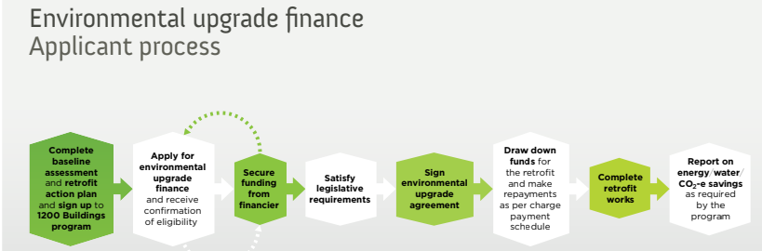

City of Melbourne's capacity to influence | This financial tool could be used in supporting retrofit planning, especially if the below limitations are addressed.
Considerations | There have only been 13 EUAs since 2011, with the last one taken up in 2018. Many building owners now have access to commercial debt facilities with a lower admin burden than EUF. Access to capital (mainly through debt finance) has not proven to be a significant barrier to commercial building upgrades.
Opportunities | Link to other opportunities (disclosure, building teams, rates or cap) to enable money to be used to facilitate a zero carbon trajectory.
Energy Performance Contracting
Energy Performance Contracting (EPC) is a form of ‘creative financing’ to fund energy efficiency improvements for organisations. The EPC vendor, termed an ESCO or Energy Services Company, assesses the building, develops the strategy and installs the necessary equipment to improve energy efficiency at no charge to the client. In return, the EPC vendor will take a significant proportion of the savings made.
City of Melbourne's capacity to influence | Good
Considerations | Uptake has not seen the momentum needed, so we would need to work on weaving this into whatever strategy is developed out of the consultation.
Opportunities | Link to other opportunities (disclosure, building teams, rates or cap) to enable zero carbon trajectory
On-bill Finance
On-bill financing (OBF) is a type of loan that can be used to invest in improving the energy efficiency of a building. The loan is paid back over time through additional charges on the building’s utility bill. This mechanism encourages building occupants and owners to invest in energy efficiency measures, decreasing energy consumption and utility bills.
City of Melbourne's capacity to influence | Needs collaboration with utilities
Considerations | Uptake hasn’t seen the momentum needed, so it would need to do some work at weaving this into whatever strategy is developed out of the consultation with the utilities
Opportunities | Link to other opportunities (disclosure, building teams, rates or cap) to enable zero carbon trajectory
Equipment/service Leasing (Energy as a service)
A well-known example of equipment leasing is the office printer. Instead of paying for a printer, you pay for the service of printing, and the printer company is incentivised to put in efficient, upgradable, long-life equipment. Equipment or service leasing could support more efficient building operations and embodied energy as products are designed for long life and do not need to be replaced often. Having the service of comfort instead of paper would mean that asset managers and HVAC suppliers would need to consider how this could work as a business model for them. Especially how to have the comfort metrics, measurement and response to equipment designed.
City of Melbourne's capacity to influence | Explore through information sessions, fact sheets
Considerations | It isn’t something that has seen mainstream application to buildings and other aspects than printers. So it would need to be developed and communicated.
Opportunities | It is a great way to address incremental improvement, embodied carbon, data collection and research.

White Certificate schemes
White Certificate Schemes are a tool for adding financial incentives to retrofitting. They are government schemes that create additional financial rewards for energy savings on top of the reductions in bills.
Once an energy efficiency project is implemented, a certificate is issued to represent the savings made, usually equivalent to one tonne of CO2e emissions. Energy retailers or other liable entities require the credentials to meet legislated efficiency targets. The retailers pay the certificate creator for their generated certificates based on a variable market rate.
The income generated by certificates can improve the business case for upgrades, reducing payback times and increasing the internal rate of return. However certificate creation is highly regulated, and eligible projects should establish the correct processes and record-keeping requirements before implementation. Accredited service providers can project manage a building owner’s submission and bear compliance risk on their behalf. In Victoria, we have the Victorian Energy Upgrades program underpinned by the Victorian Energy Efficiency Target (VEET) Act 2007.

City of Melbourne's capacity to influence | Advocacy of the scheme to building owners could be a key role the city could play.
Considerations | This program began in the UK in 2002, introduced in Victoria in 2014. Both initiatives have supported upgrades but neither have cut through and built the momentum needed.
Opportunities | This program could be an enabler of the initiatives proposed by overcoming some financial barriers.
Financial incentives/tax breaks
Fiscal policy, imposing taxes, tax rebates, and tax exemptions can influence and promote retrofits. In addition, these incentives are used in other areas of the economy.
City of Melbourne's capacity to influence | Not high – advocacy is the key instrument.
Considerations | Tax reform is complex and time-consuming and requires policy change at other levels of government.
Opportunities | It would be a good enabler as part of an ecosystem of opportunities to support retrofits.
Individual metering, sub-metering and direct feedback
Data is critical to enabling the improvement of building performance. The NABERS mandatory disclosure regulations have demonstrated this, with Australia leading the world in commercial building energy efficiency improvement with the larger buildings that have been required to disclose a NABERS rating. Integrating a data, measurement, review and feedback process as part of building retrofit processes would embed the potential to respond quickly, to continually improve and create a learning rate that will help retrofit momentum.
City of Melbourne's capacity to influence | Implementing metering and feedback capacity could be part of retrofit programs also, and the benefits and technologies could be explored through information sessions, fact sheets
Considerations | Data integration into building management is good in theory but is difficult in practice, needs incentives and sound data collection and integration into decision making
Opportunities | It is a great way to address many issues holding back energy efficiency potential, by providing a quick response, understanding of what is happening, and ability to learn and improve.

