Northern Undercroft and City Road Park project 
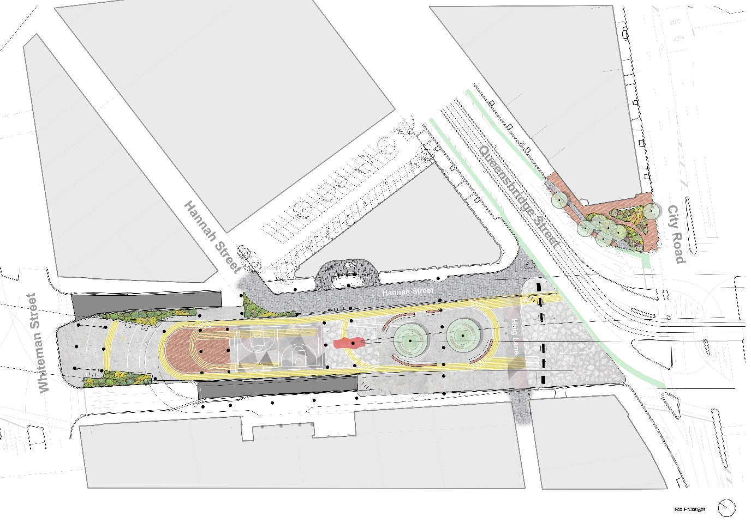
This plan presents a concept for the Northern Undercroft and City Road Park in Southbank between Queensbridge Street and Whiteman Street. The plan is oriented north west.
The Northern Undercroft
This is the larger of the two open spaces in the drawing. It is a long space with Whiteman Street to the north, Hannah Street to the east, Queensbridge Street to the south east and City Road to the south. The Northern Undercroft in situated under the Kings Way overpass.
The northern end of the space is dedicated to a flexible open space. To the south of this is more space for multipurpose recreation needs with two half-court basketball courts. In the centre of the space is a bouldering wall and the section to the south of this shows flexible skate and plaza elements. Planting is used sparingly in the space, as light is limited due to it being underneath the Kings Way overpass.
City Road Park
This is the smaller of the two open spaces shown in the plan. It is a park on the corner of Queensbridge Street in the north and City Road in the south. The park shows a new off road bike path which connects into an existing on road bike path on Queensbury Street.
It shows small garden beds and seating for pedestrians to navigate through. Trees are placed on the edge of park. It uses recycled red brick as the surfaces to celebrate the heritage of Southbank.

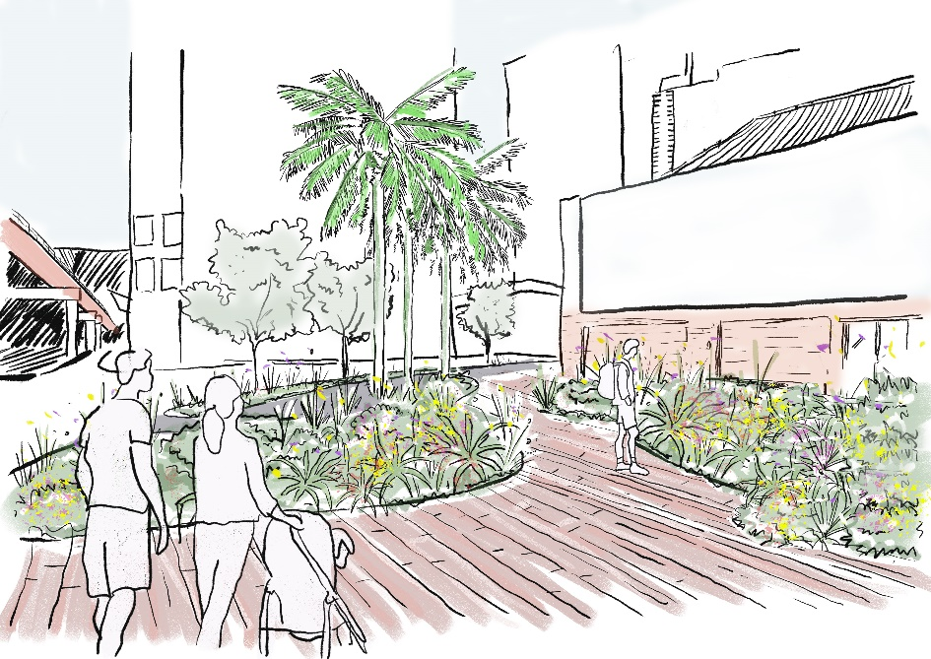
Artist’s impression of City Road park looking North. It shows people using the space to walk through, looking at the planting and pushing a pram. There are garden beds and trees shown on the edges of the park with a red brick pedestrian path through the centre.
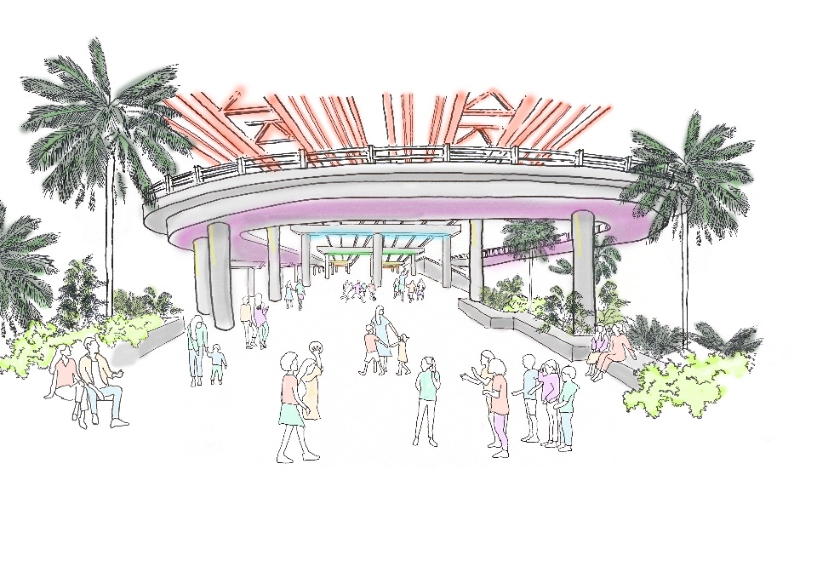
Artist’s impression of the Northern Undercroft looking south from the northern end. It shows the heritage bridge structure and slip lanes of Kings Way above. There are many people shown using the space informally, some people are sitting on the edges. There is a layer of urban greening on the edges of the drawing.

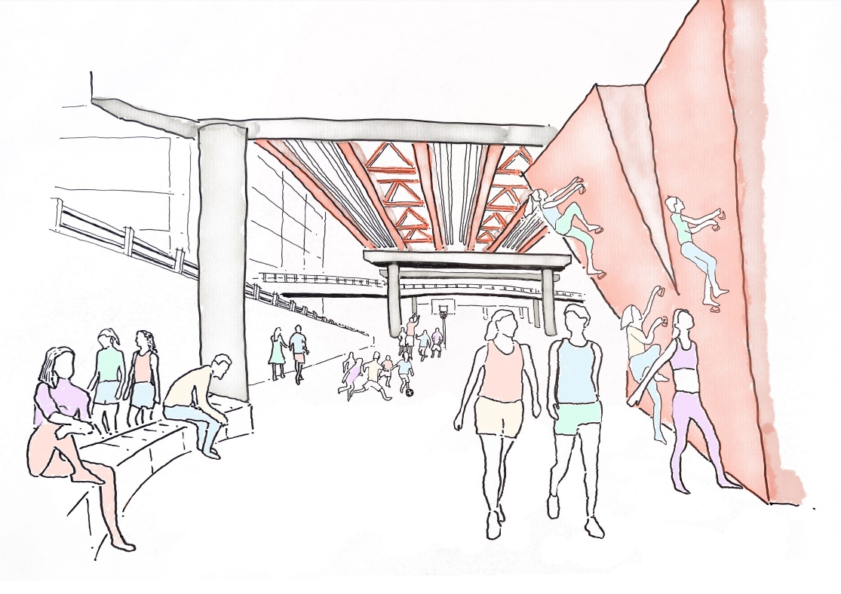
Artist’s impression of a bouldering wall with people climbing on it. The drawing also shows the heritage bridge above and support pylons. There is a seat wall drawn on the side with people sitting and enjoying the space.

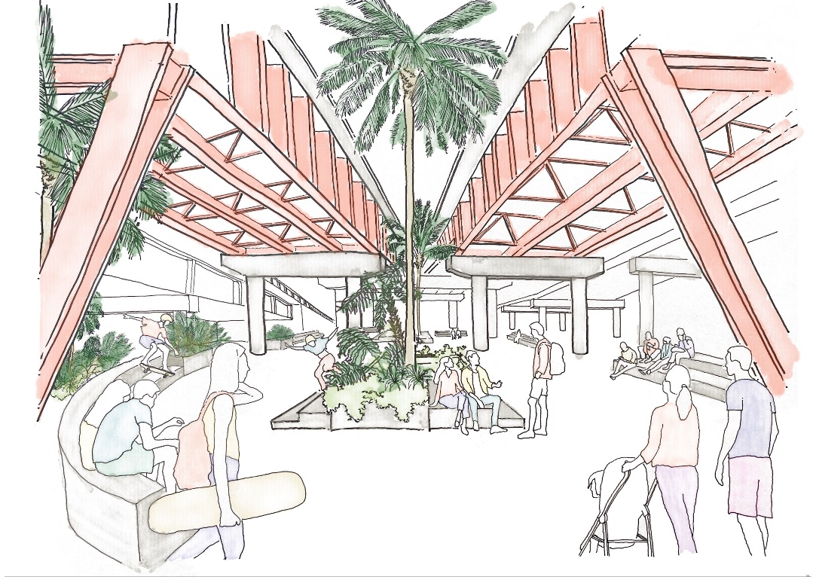
Artist’s impression of a skate-able urban plaza showing people using the space to skate, sit and talk, and push a pram. There is urban greening in the centre and edges of the plaza space.

