Acknowledgement of Traditional Owners
The City of Melbourne respectfully acknowledges the Traditional Owners of the land we govern, the Wurundjeri Woi-wurrung and Bunurong / Boon Wurrung peoples of the Kulin and pays respect to their Elders past and present. We acknowledge and honour the unbroken spiritual, cultural and political connection they have maintained to this unique place for more than 2000 generations.
We accept the invitation in the Uluru Statement from the Heart and are committed to walking together to build a better future.

Draft Community Engagement Policy (2026–30)

Introduction 4

Policy scope 4

Our approach to community engagement 5

Who we engage 6

When we engage 7

How we engage 7

Community engagement principles 9

Roles and responsibilities 10

Revision 11

Definitions 12

Our legislative requirements 13

Melbourne’s Integrated Planning and Performance Framework 14

Introduction
The City of Melbourne values the knowledge, experience and diversity of our communities and is committed to ensuring community voices are central to our work.
Meaningful community engagement strengthens trust, transparency and accountability by enabling meaningful participation in Council decisions.
Council is focused on engagement that reflects our city’s diversity, strengthening connections with multicultural communities and providing opportunities for participation in multiple languages.
Through effective engagement, Council seeks to build a city that is resilient, inclusive and connected.
This policy underpins Council’s commitment to empower all communities, including our young people, to participate in city democracy.

Policy scope

Our community and stakeholders interact with Council and provide feedback in many ways.

Where a planned process is required – to inform specific Council decisions – we describe this as community engagement. A community engagement process is designed to encourage people to get involved in a project, where the decision is of interest or impacts them.
The purpose of this policy is to:
- clearly define community engagement – including how, when and why we conduct community engagement
- share our commitment to community and the principles that guide our approach to community engagement
- describe the role of community engagement in Council decision-making
- describe when community engagement is not recommended.

This policy was developed in consultation with a range of external and internal stakeholders. We conducted an initial phase of community engagement from August to September 2025 to understand community preferences, barriers and motivations for participating in community engagement. This included discussions and workshops with neighbourhood houses, resident associations, precinct associations and community organisations.

To help us implement this policy, we have developed community engagement practice guidelines to provide City of Melbourne staff with best practice guidance, templates and resources.

Our approach to community engagement
We hear from community in many ways. This includes through customer service, market research and direct contact with City of Melbourne staff or a Councillor. For the purposes of this policy, community engagement is a planned process to support Council decision making on a specific matter – for example, development of a new policy or to inform design for a new community facility. It encourages people to get involved in Council decisions that interest or impact them.
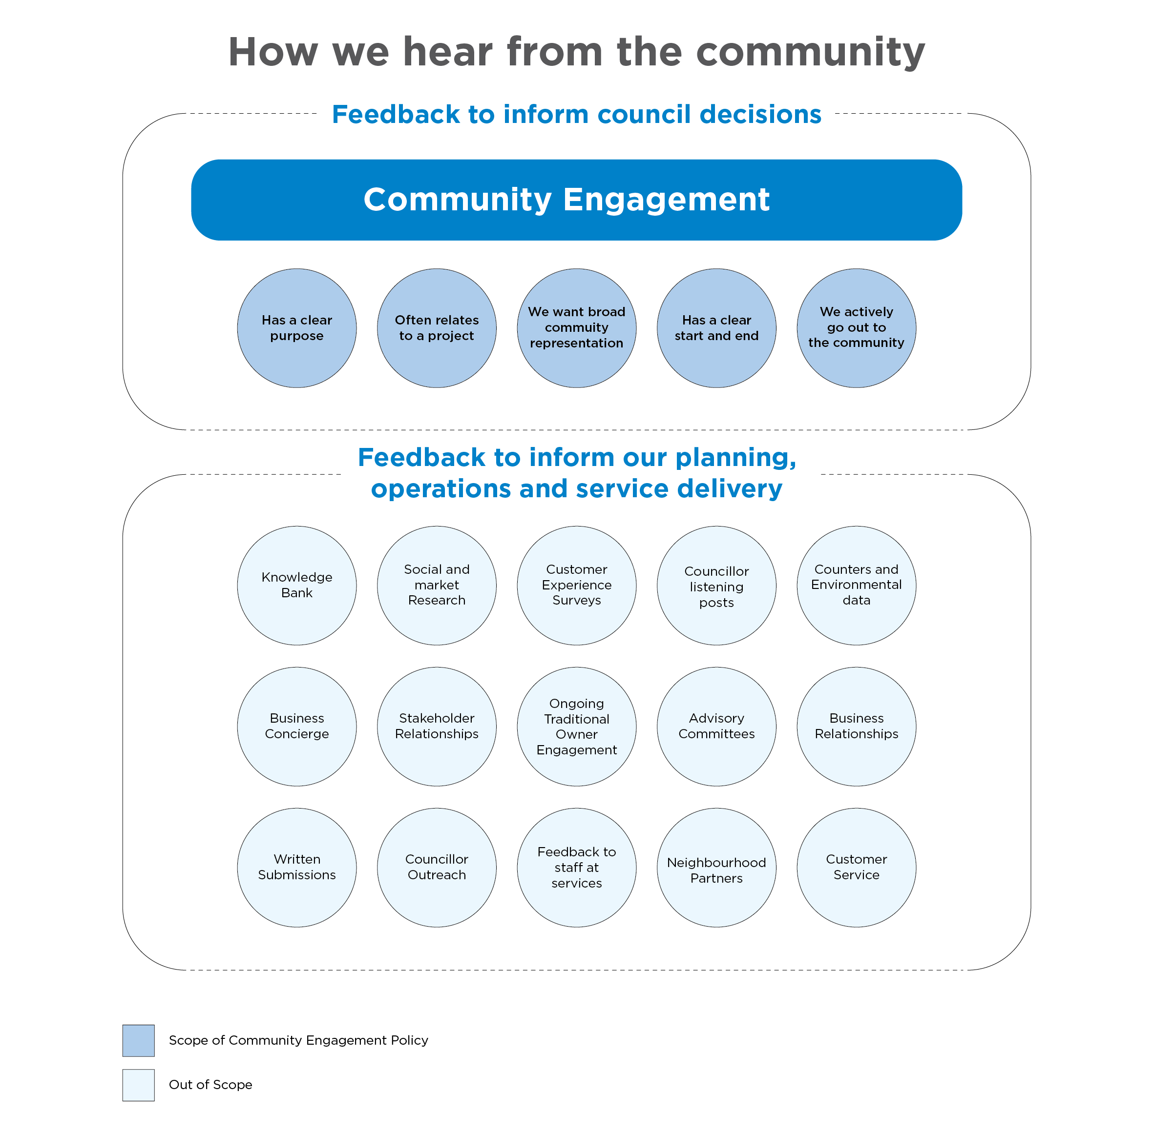

Inputs into community engagement
Before planning engagement, we consider what we already know about the community who is likely to be interested in and/or impacted by the matter. To do this, we consider what the community has shared in previous engagements as well as relevant feedback we have heard through other channels, such as customer service or our place-based teams. This initial information is used to guide how we engage and how we support and encourage participation.

Using community engagement results
Feedback gathered through community engagement is one important input into Council decisions. When community engagement results are presented to Council, they are considered alongside several other inputs, such as technical advice, budget constraints, and previous commitments. This means Council may at times need to make decisions that some parts of the community do not agree with, because of other factors.

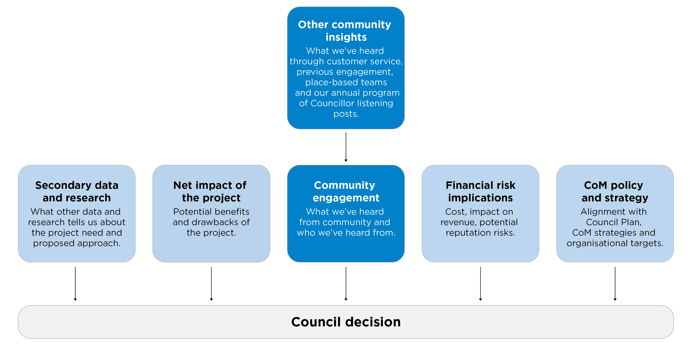

Who we engage
The City of Melbourne community is unique and diverse. As a capital city, our community includes people who live, visit, study, work or own a business in the municipality and Traditional Owners. Community engagement supports Council with the complex task of collecting and considering the diverse experiences and perspectives of those across our community.
When we plan engagement, we consider who is most impacted and/or interested in the matter. Communities may be impacted by a matter because of factors such as their proximity to a place, their use of an impacted program or service and/or their identity. Communities may be interested in a matter because of factors such as their values, skills, expertise or profession. Council may consider the level of impact or interest in a matter when weighing up the responses collected through community engagement activities.
To support equitable participation, we recognise some groups – including businesses, young people, and people who speak a language other than English at home – can face additional barriers to engagement. We are committed to continuous improvement in engaging our multicultural and multilingual communities.
We are committed to looking beyond our regular methods and approaches to enable and encourage equitable participation.

When we engage
Engagement is recommended when the community is expected to be interested in, impacted by and able to influence a matter. Council will prioritise legislatively required engagement, and engagement opportunities which offer the community higher levels of influence in the decision or outcome. Where there is very limited opportunity to influence outcomes because of other factors, we may focus on informing community about the matter.
Engagement is required | Engagement is recommended | Engagement is determined by assessment | Informing the community is recommended
- Legislatively required engagement  e.g. deliberative engagement on the Council Plan  (see Appendix for more details)  - Statutory engagement processes e.g. planning scheme amendments, sale of Council assets  - Community can make submissions to Council meetings on any engagement or other matter | - Municipality wide plans and strategies  - Major infrastructure projects  - New and reviewed policies  - Early-stage pre-draft engagement with clear negotiables the community can influence | - Projects from already engaged on strategies and plans  - Local infrastructure projects with a limited catchment area  - Projects where there are limited or unclear negotiables the community can influence | - Projects where Council has limited ability to influence outcomes based on community feedback  (for example, where funding agreements in place)  - Projects which cannot clearly address the community engagement principles  (for example, a works notice being sent out ahead of works commencing)

Factors that influence when we engage the community
Factors that influence timing of community engagement include:
- Community engagement activities should be reconsidered, where possible and practical, where the matter is considered likely to affect voting in the election and during times or emergency.
- Community engagement associated with activities and decisions which are the subject of statutory processes (for example, applications under the Planning and Environment Act 1987), can be expected to continue through the election period to ensure Council does not breach its statutory obligations.
- Community engagement should anticipate the impact of holiday periods and major events on participation.

How we engage
Community engagement seeks to purposefully include individuals in the Council decision making process. The City of Melbourne uses a variety of methods and activities to support participation from our diverse community.

Wherever possible, engagement will begin early in the planning stage. Community engagement in the early stages of a project can help identify and develop initial ideas, principles, opportunities and solutions. When we seek feedback as part of an engagement program, we will provide information to help community understand the matter and support meaningful participation.

The City of Melbourne aligns our engagement activities with the International Association of Public Participation (IAP2) Spectrum of Public Participation. Each engagement matter will be assessed to determine how to engage. Most planned engagement activities sit within the levels of consult, involve and collaborate. We will meet or exceed legislative and statutory requirements to engage.

 |   Inform |   Consult |   Involve |   Collaborate |   Empower
 | Inform | Consult | Involve | Collaborate | Empower
 | Consultative engagement  The community provide feedback on alternatives, draft documents or decisions. |  | Deliberative engagement  The community are provided with sufficient time and information to consider the matter in depth before providing a response.
Community participation goal | To provide the community with balanced and objective information to assist them in understanding the problem, alternatives, opportunities and/or solutions. | To obtain community feedback on analysis, alternatives and/or decisions. | To work directly with the community throughout the process to ensure that community concerns and aspirations are consistently understood and considered. | To partner with the community in each aspect of the decision including the development of alternatives and the identification of preferred solutions. | To place final decision making in the hands of the community.
Commitment to the community | Council will keep you informed. | Council will keep you informed, listen to and acknowledge concerns and aspirations, and provide feedback on how community input influenced the decision. | Council will work with you to ensure that your concerns and aspirations are directly reflected in the alternatives developed and provide feedback on how community input influenced the decision. | Council will look to you for advice and innovation in formulating solutions and incorporate your advice and recommendations into the decisions to the maximum extent possible. | Council will implement what you decide.
Recommended timing | A Council decision is imminent or has recently been made. | There is a proposal, concept, set of options, or draft to share. | A proposal, concept or draft is being developed. | Scoping of issues and opportunities at the start of a project. | When Council has delegated decision making to the community.
Example activities | - Information sessions  - Community engagement reports  - Future Melbourne Committee agendas  - Council meeting minutes  - Online and traditional media | - Online surveys  - Intercept surveys  - Listening posts  - Mapping activities  - Prioritising activities  - Ideas boards | - Community meetings  - Pop-up engagement  - Webinars  - Interactive online tools, such as question-and-answer forums | - Citizens panels  - Participatory budgeting  - Workshops  - Reference groups  - Advisory committees | - Polls  - Referendums
Types of projects | - Final draft policies, plans and strategies  - Imminent or recently made Council decisions.  - Selling of land | - Local law reviews  - Revenue and ratings plan  - Leasing of land  - Draft policies, plans and strategies | - Municipal plans and strategies with timeframes of four years or more | - Community Vision  - Council Plan  - Annual Budget  - 10-Year Asset Plan  - 10-Year Financial Plan | - Delegated decision making
Community engagement principles
Each matter for engagement will be assessed to determine how to address the community engagement principles with respect to the strategic priority, level of resourcing and project negotiables.
Value | Principle | What this looks like
Meaningful | A community engagement process must have a clearly defined objective and scope | - We clearly communicate the purpose of the engagement.  - We inform the community of how their feedback will be used.
Transparent | Participants in community engagement must have access to objective, relevant and timely information to inform their participation | - We design engagement activities to be objective and welcome all views on a matter.  - We provide engagement information that is accessible to intended audiences.
Representative | Participants in community engagement must be representative of the persons and groups affected by the matter that is the subject of the community engagement. | - We ask participants how the matter being engaged on interests or impacts them.  - We plan engagement activities intended to reach the communities most impacted by the matter.
Inclusive | Participants in community engagement are entitled to reasonable support to enable meaningful and informed engagement. | - We anticipate and accommodate the needs of intended participants when designing engagement activities.
Impactful | Participants in community engagement are informed of the ways in which the community engagement process will influence Council decision making. | - We communicate engagement negotiables and non-negotiables.  - We share community engagement results as soon as practical following the end of the engagement period.  - We support decision makers to understand the strengths and limitations of engagement results.
Accountable | Evaluation of community engagement impact guides our practice | - We report on the outcome or decision of the community engagement matter.  - We measure how community engagement has impacted decision making outcomes.  - We regularly evaluate our processes and practices to inform continuous improvements.

Roles and responsibilities
Role | Responsibilities
Everyone | - Participate in community engagement processes in a fair and respectful manner.
Lord Mayor | - In addition to the responsibilities of all Councillors, the Lord Mayor has a special role to lead engagement with the municipal community on the development of the Council Plan (as per the Local Government Act 2020 (VIC), s. 18(1c)) .
Councillors | - Endorse the Community Engagement Policy.  - Uphold and champion the City of Melbourne's community engagement principles.  - Lead Councillor listening posts to hear directly from the community.  - Objectively review and consider insights gathered through community engagement when making decisions
CEO and Executive Leadership Team | - Approve community engagement plans for major projects and legislatively required deliberative engagement.  - Ensure reputational and other risks of community engagement are managed.
Directors | - Approve community engagement plans.  - Ensure community engagement will be resourced and carried out at the appropriate level given the likely impact to the community, the level of risk, and the extent to which the community is able to influence the final outcome or decision.
Managers | - Ensure community engagement practices are carried out in accordance with community engagement plans, this policy and the Community Engagement Practice Guidelines.
Council officers | - Ensure quality and timely community engagement and reporting is delivered in accordance with this policy and the Community Engagement Practice Guidelines.

Revision

This policy will be reviewed in 2030 after the adoption of the Community Vision and Council Plan by 31 October 2029, or whenever Council determines a need has arisen.
Project | Approach
Policy adoption date | TBC April 2026
Next review date | December 2030
Related procedures | Community Engagement Practice Guidelines
Other references | IAP2 Public Participation Spectrum  IAP2 Core Values for the Practice of Public Participation  Public Engagement Framework

Appendix

Definitions
Terminology | Definition
Community | Individuals united by at least one common characteristic such as geography, shared interests, values, experiences, or tradition.  As a capital city, our community includes people who live, visit, study, work or own a business in the municipality and Traditional Owners.
Community engagement | Community engagement is a planned process to support Council decision making. It encourages people to get involved in Council decisions that interest or impact them.
Community Engagement Practice Guidelines | Guidelines to assist staff to determine when and how to engage with the community.
Community engagement principles | Principles that guide our community engagement approach, including the five principles from section 56 of the Local Government Act 2020.
Consultation | Consultation is the practice of seeking feedback on a draft, concept, proposal or options, with a view to address feedback before presenting the work to Council.
Deliberative engagement | Deliberative engagement is a specific process used to involve, collaborate or empower a representative group to reach a collective outcome or decision for complex matters, and where Council commits to use the outcome to the greatest degree possible.
Informing | Informing is the practice of sharing information with the community where the purpose is to educate or raise awareness of a matter.
Municipal community | Under the Local Government Act 2020: the municipal community includes -  (a) people who live in the municipal district of the Council; and  (b) people and bodies who are ratepayers of the Council; and  (c) traditional owners of land in the municipal district of the Council; and  (d) people and bodies who conduct activities in the municipal district of the Council;
Participatory budgeting | A democratic process that empowers citizens to directly influence decisions on how some of a public budget is spent.
Community Stakeholders | Individuals who have a higher level of influence in the engagement process than the wider community because of their expertise in the matter, or because the matter is likely to impact them in a more direct way.
Stakeholder group | A group of people with a higher level of interest or impact, that are organised into a club, association, organisation or entities and have governance mechanisms in place to provide a representative response on behalf of all members.

Our legislative requirements
Elements of our community engagement work are guided by Victorian Government legislation which sets specific engagement requirements for some Council activities. These statutory requirements usually relate to long term strategic council planning and budgeting, amendments to the planning scheme, development of public health and wellbeing plans, local law making, land acquisition and sales, electoral reviews and some road changes.
The Local Government Act 2020 outlines a set of overarching principles and requirements to guide the engagement approach of councils. Other relevant legislation includes:

- Charter of Human Rights and Responsibilities Act 2006
- Child Wellbeing and Safety Act 2005
- Disability Act 2006
- Equal Opportunity Act 2010
- Gender Equality Act 2020
- Local Government Act 1989
- Multicultural Victoria Act 2011
- Planning and Environment Act 1987
- Privacy and Data Protection Act 2014
- Public Administration Act 2004
- Public Health and Wellbeing Act 2008
- Road Management Act 2004
- Subordinate Legislation Act 1994
- Traditional Owner Settlement Act 2010

Community engagement at City of Melbourne is also informed by our policies and strategic plans, including:
- Council Plan 2025–29
- Inclusive Melbourne Strategy
- Stretch Reconciliation Action Plan
- First Nations Engagement framework
- Youth Strategy
- Governance Rules
- Public Transparency Policy
- Customer Service Charter
- Neighbourhood Planning Framework 2022
- Privacy policy

Melbourne’s Integrated Planning and Performance Framework
At the City of Melbourne, we follow an integrated approach to planning, monitoring, and performance reporting. Through this structured approach – engagement, planning, delivery and monitoring – we aim to achieve meaningful outcomes for our community.

Our integrated planning and performance framework supports decision-making across the long-term (10+ years), medium-term (4+ years) and short-term (1 year).

This guides the Council in identifying community needs and aspirations over the long-term (Community Vision), medium-term (Council Plan) and short-term (annual Budget). It also provides an accountability measure through the Annual Report.

At the centre of this framework is the Melbourne 2050 Vision, developed in collaboration with our community to shape the future of our city for generations to come.
