

Hawke Street Linear Park
SUMMARY OF COMMUNITY ENGAGEMENT RESULTS

May 2021

Prepared by Global Research Ltd

For
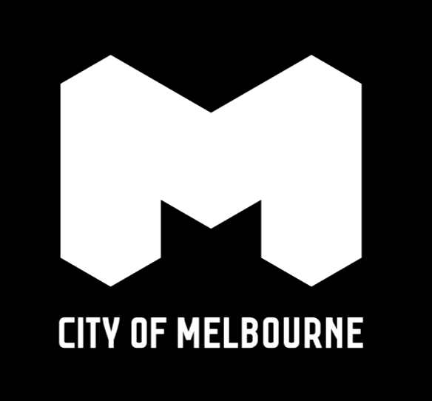

WE’RE PLANNING FOR HAWKE STREET
City of Melbourne is proposing to enhance the quality and function of public space in Hawke St, West Melbourne.
Hawke Street is a very wide paved road that runs between Railway Place and Victoria Street. It has two small parks with a substantial amount of parallel and median-strip parking along its length.
Between 26 March to 25 April 2021, City of Melbourne sought public feedback on a preliminary concept to reduce through-traffic, improve bicycle and pedestrian connectivity, and ‘green’ the entire length of Hawke Street.
Respondents could contribute by either by filling out an online survey, sending feedback in an email or letter, or by phoning to speak directly to the Transport and Amenity Program team. Over-the-phone language interpreters were available.
This consultation Summary provides a brief ‘snapshot’ of who was reached and what was heard. A detailed Report is available for download at participate.melbourne.vic.gov.au/hawke-street-linear-park.
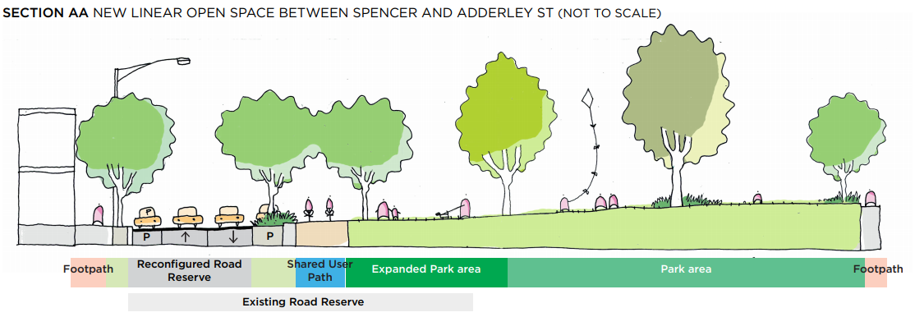
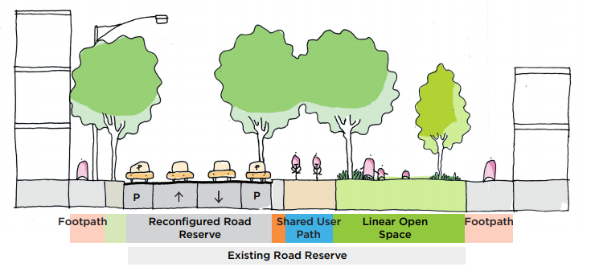
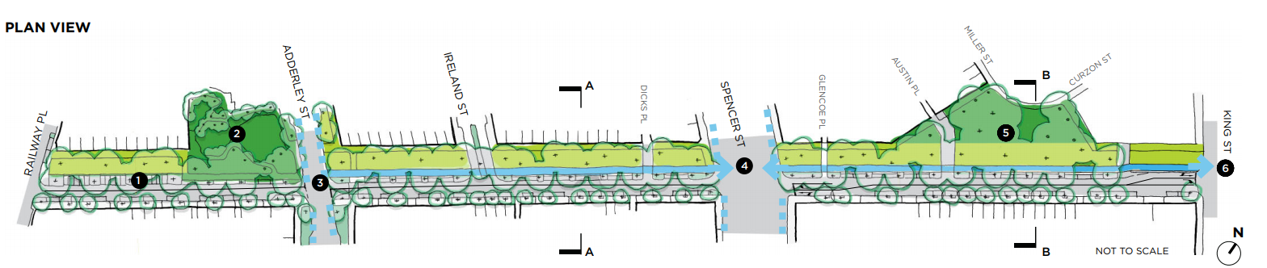

Who we engaged
In total, we reached at least 8000 people through posted letters, website visits and newsletter audiences. 153 community members provided feedback about our initial concept for Hawke Street enhancements via online survey, direct emails, letters and phone conversations.









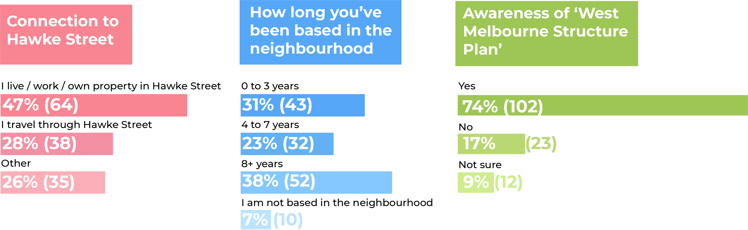
700  Website visitors | 1200  letters sent | 6400  e-newsletters sent | 137  Surveys completed | 10  Emails received | 4  Phone calls | 2  Letters received

Key topics and ideas

Across all responses collected, a range of similar themes and points were raised by the community regarding what they wanted for the area or issues they were concerned about:
Enhancing green space and trees in urban Melbourne is important – more greenery makes areas cooler, helps local wildlife, and has widespread mental and physical health benefits for the community.

People who support the proposal feel that it would calm and limit traffic and that this would make Hawke Street safer and more enjoyable to be in.

The linear park would create more of a community feel in the area and improve residents’ quality of life, making the area quieter and offering them a place to relax and spend time with their neighbours.

Safety for all users of the road – cyclists, drivers, and pedestrians – is a prominent issue for both groups. Careful design and measures to improve safety are necessary for what is commonly felt to be a dangerous traffic area.

Parking is a significant concern for people who oppose the proposal, and for a smaller number who otherwise support it. Residents and businesses already struggle to find parks, and the loss of more parking spaces will make this even harder.

Parking and easy access are particularly crucial for residents with disabilities, families with young children, and older residents, as well as affecting how businesses can operate.

People are concerned about the proposal’s effects on traffic, worrying that traffic jams could increase and traffic congestion may be created on the surrounding streets.

Overall level of support for the concept
Respondents were asked: Overall, how supportive are you of the concept of repurposing some road space along Hawke Street for green parkland?
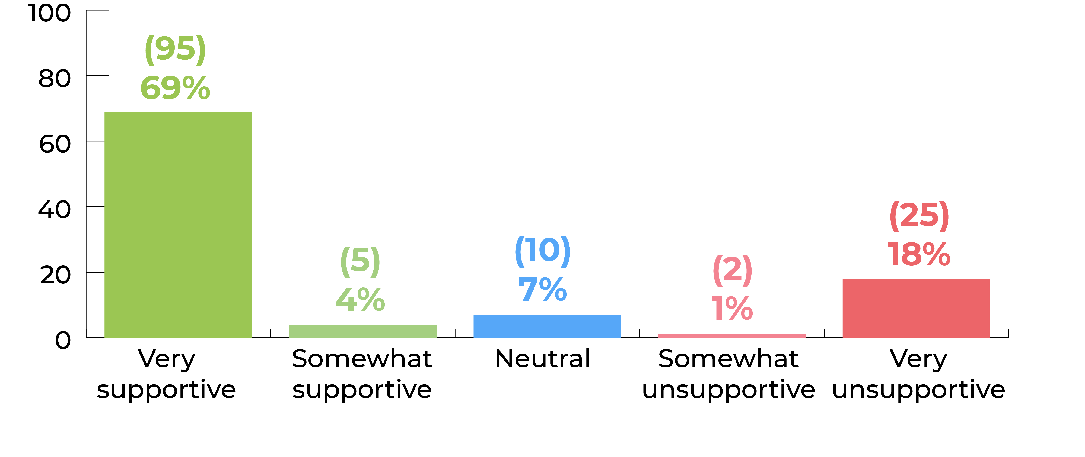
73%
very or somewhat supportive

*For simplicity of presentation, the percentages within these graphs have been rounded from their actual decimal places and may appear to equal slightly more or less than 100%.
- A strong majority (73%) supported the proposal, with most of those expressing high levels of support by selecting ‘very supportive’ (69%).
- Only 19% were unsupportive. The majority of those who objected to the proposal did so strongly, with 18% selecting ‘very unsupportive’.

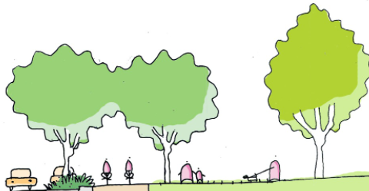
Reasons why you rated the concept this way
Respondents were then asked: Why do you feel this way about the concept?

We heard
- We want more trees and green space in West Melbourne. This will improve the look and feel of our area and bring health and environmental benefits as well.
- Traffic calming is welcomed. We want our streets to be quieter, safer, and more pleasant to be in.
- Our community’s quality of life will improve with the addition of a park on Hawke Street. People will spend more time outdoors, enjoying the space and meeting neighbours.
- It’s important to ensure there are sufficient on-street parking spaces for locals and business operations.
- Reducing traffic to one lane each way may exacerbate traffic congestion.
- We don’t want access to homes or businesses to be more difficult.
“Traffic on Hawke St near Spencer is currently a nightmare. Reducing lanes will reduce traffic and make it easier for residents to get around without more people passing through”

“We would like to see more green space. We have a small house and this solution would allow us to enjoy open green space at our doorstep”

“You have removed 49 car parks, where are we meant to park? We are a single car family reduced from 2 cars because parking is impossible”
You said

Your hopes for Hawke Street enhancements
Respondents were asked: What are the key outcomes that you hope Hawke Street enhancements could achieve?

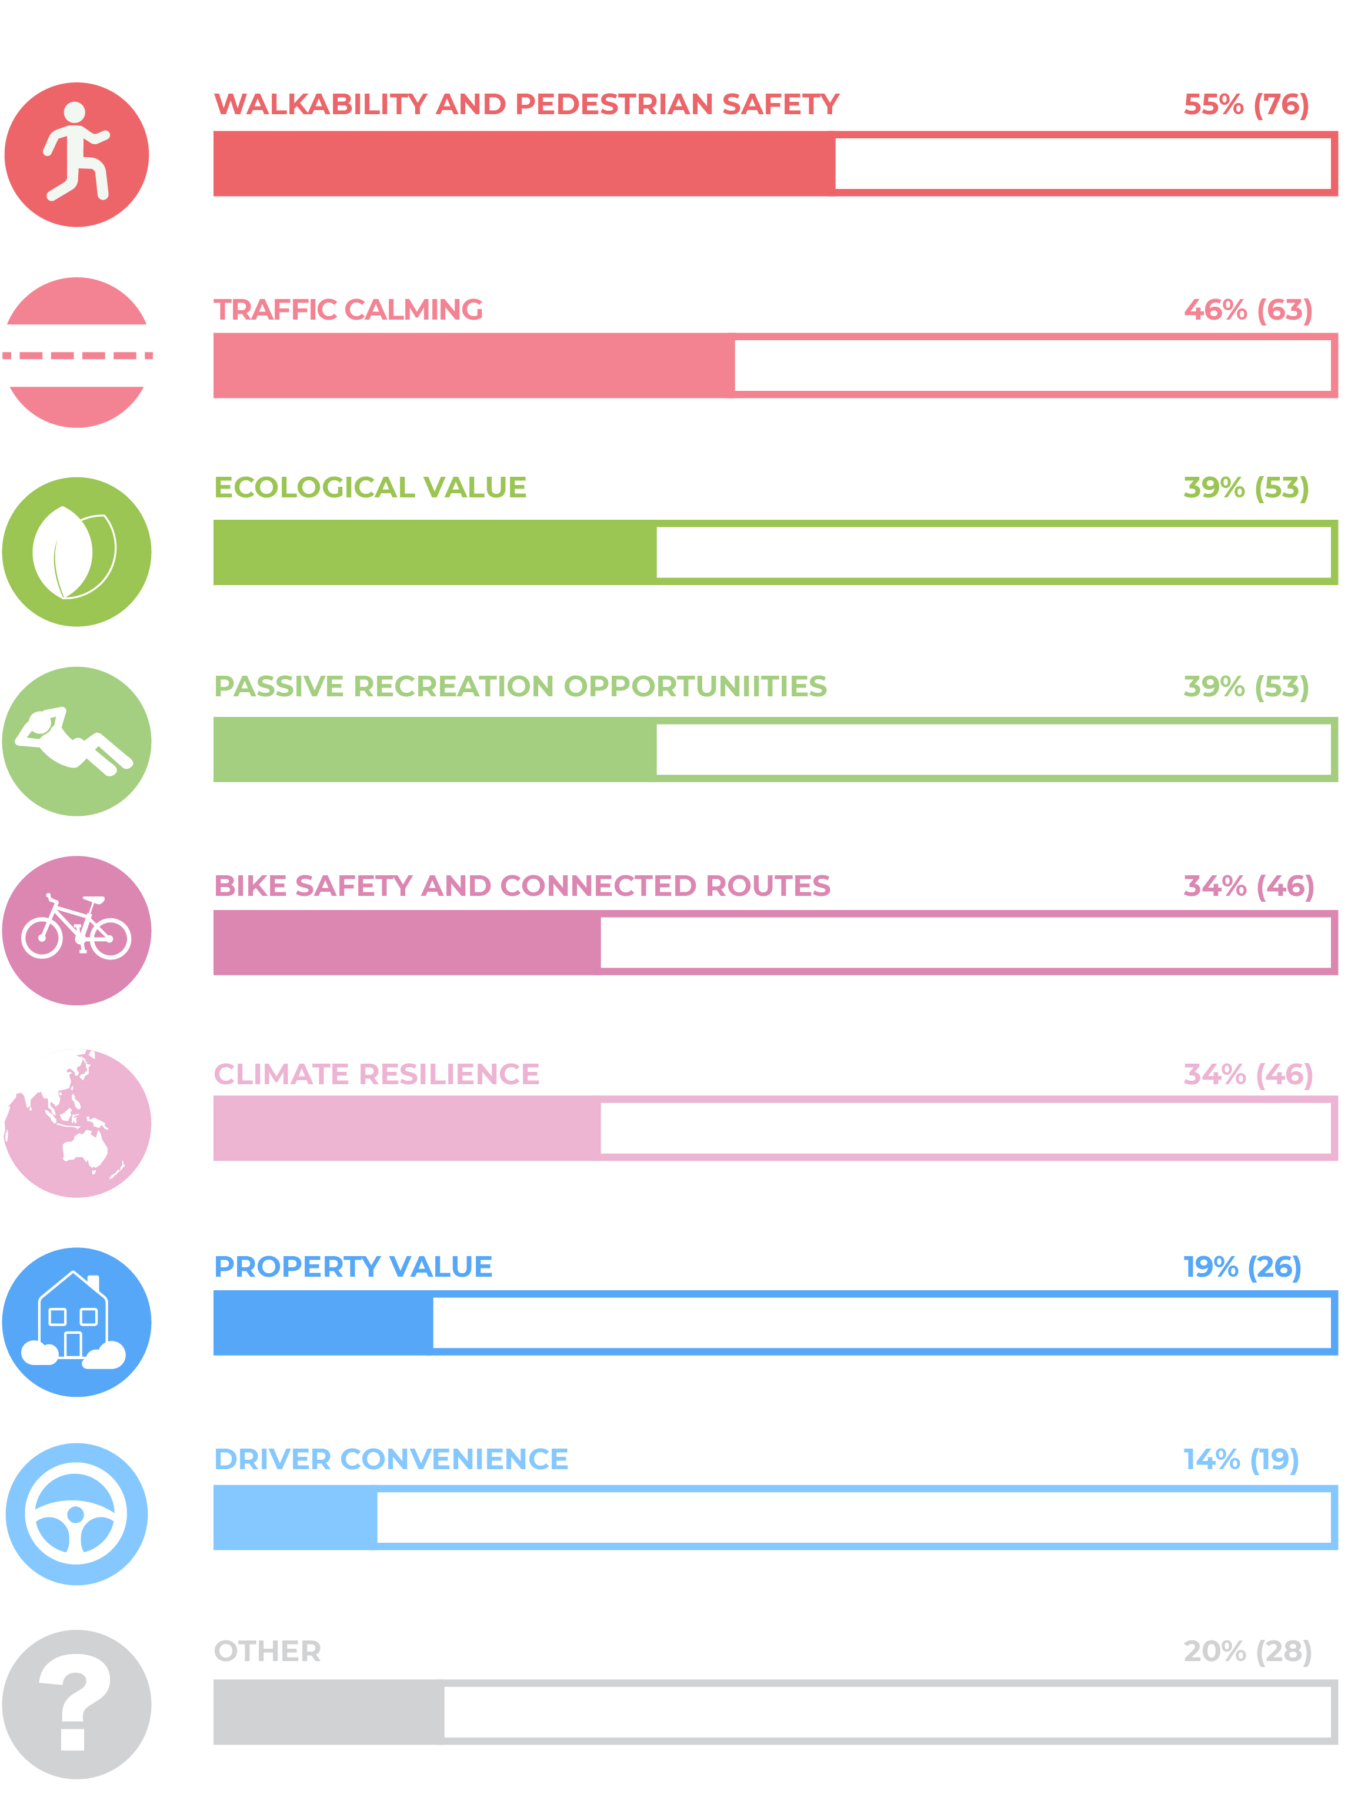
- Out of the 137 people who selected their ‘top three’ key outcomes, over half (55%) selected walkability and pedestrian safety as one of their top three.

- Traffic calming was the second most popular outcome (46%).

- Ecological value and passive recreation opportunities were both selected by 39% of respondents, making them the third most valued outcomes equally.

- Following closely in fourth place, bike safety and connected routes and climate resilience were chosen by 34% of respondents each.

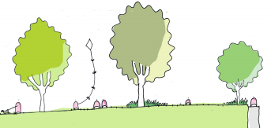
How proposed changes would influence your experience of the place
Respondents were asked: How would the proposed changes for Hawke Street influence your experience of the place?
You said


“For too long people have focused too strongly on everything being designed around cars. Sacrificing a small amount of spaces that are mostly unused to benefit the overall community is a fantastic concept”

We heard
- More of us felt that that the benefits of the linear park will outweigh possible negative effects.
- The linear park would calm and limit traffic, making the area quieter and safer for residents, pedestrians, and cyclists.
- More greenery, shade and space would cool the area and make Hawke Street a more appealing place for people to exercise, relax or socialise.
- Parking is already difficult for residents and businesses in the area and traffic jams are already common at peak times. We are worried the linear park would make these issues worse.

“An excellent proposal, which will make the street much more pleasant to use. Nice to pop out for a few minutes in the park, or to take the dog for a short walk, or to just enjoy the greenery and less traffic clogging the street”

“I will spend more time circling around the area to find a parking space, likely causing congestion and reducing road flow in the area”

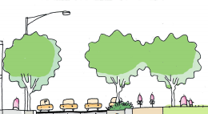
Other things we should consider
Respondents were asked: Is there anything else we should consider in our goal to enhance
Hawke Street?
You said


“Whilst it might be argued the Hawke St plan might stop some traffic, I argue it will simply place pressure on other streets where there is clearer access”
We heard
- Traffic management is a priority. Has City of Melbourne considered where traffic will be diverted to and how this will impact residents and businesses on Hawke Street and other nearby streets?
- We are concerned about the removal of parking and how this will impact residents and businesses on and around Hawke Street. Resident-only parking permits could be a solution.
- Accessible access from the street to people’s houses for older people, those with disabilities, or families with young children needs to be considered – especially when thinking about removing parking spaces.
- The design of the linear park should make the most of the possible benefits – both social and environmental. Amenities and plantings should ensure that everyone can enjoy this space, including residents, visitors, and local wildlife.

“I would like to request that native plants similar to those in the existing pocket parks are used so the linear park can be a habitat corridor for native species as well”

“Making it accessible to minority / disabled / disadvantaged groups”

HOW YOUR FEEDBACK WILL BE USED

Your values, priorities, ideas, and concerns relating to the Hawke Street Linear Park proposal have been clearly articulated to City of Melbourne through this initial consultation period. Your sentiments have been collated and analysed by independent social researchers and what was heard has been presented back in the form of a detailed Report, in addition to this synthesised Summary. These will be publicly available via www.participate.melbourne.vic.gov.au/hawke-street-linear-park, and briefed to Council.
The Enhancing Hawke Street team, including infrastructure planning, traffic engineering, and landscape design will review and consider your feedback to help develop a more detailed concept plan. A six-month Parking Review has been commissioned for Hawke Street, comparing weekday and weekend activity, to better understand street parking utilisation and behaviours. It will take into account the broader road network and the completion of future infrastructure projects.
We anticipate meeting with interested stakeholders in-person, to workshop more detailed design concepts and practical elements later this year.
Thank you to all participants in this planning journey, your local knowledge and experience of the area is crucial. We look forward to talking to you in the coming months and working towards some outstanding outcomes for West Melbourne residents, businesses and visitors.

